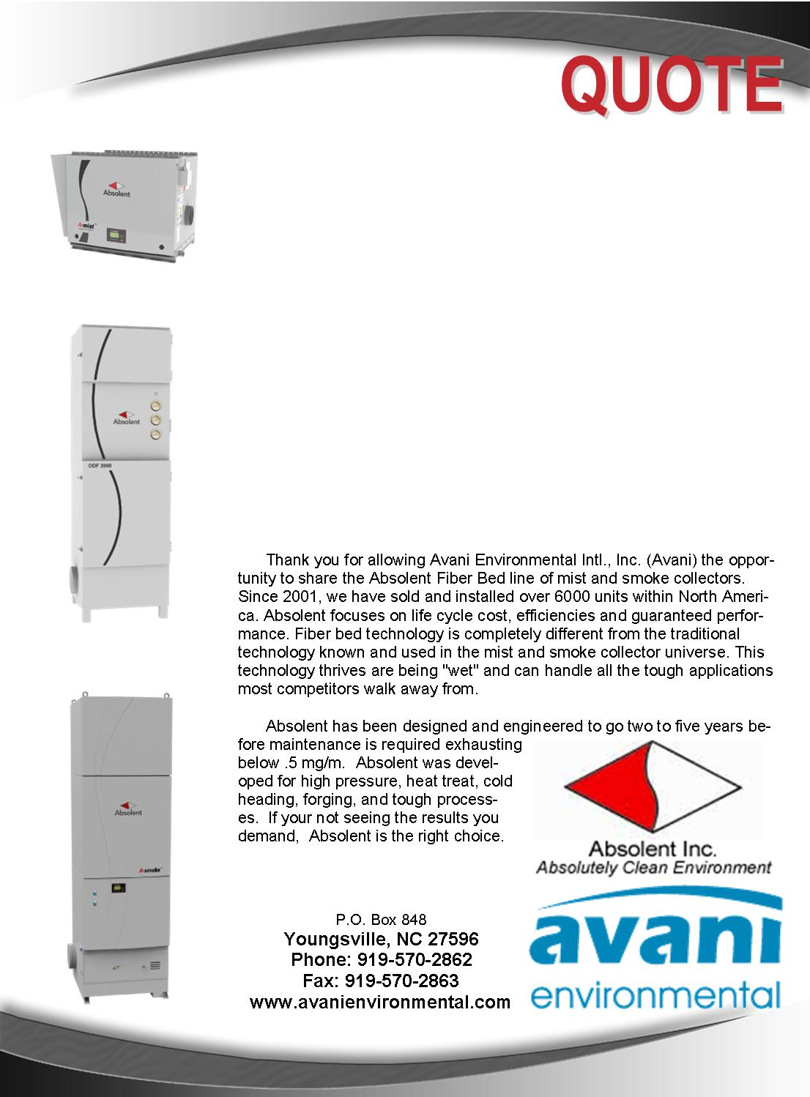

Avani Environmental Intl., Inc.
P.O. Box 848
Youngsville, NC 27596
Phone: 919-570-2862 Fax: 919-570-2863

Quote #: AE-005029 September 27, 2012
Quote by: Ed Sithes

Attn: Mark McClain,
President
markm@mcclaintool.com

McClain Tool and Technology, Inc.
106 Weldon Parkway
Maryland Heights, MO 63043

Dear Mark,

Thanks for this opportunity for Machine Labs in St. Louis. Based on the layout, site visit and recommended Absolent equipment, we propose the following:

Design Criteria:
Remove the current A-Smoke 20 (ODR-2000) and replace with (1) A-Smoke 40 (ODR-3000) in the same location for ducting layout. The A-Smoke 40 will be ducted to (8) Citizen machine centers using Jacobs tubing. Move the current A-Smoke 20 (ODR-2000) to address (3) Nomura machine centers. Leave the A-Smoke 20 (ODR-2000) located on the wall in its present location and duct to (1) Citizen and (2) Nomura machine centers.

Install (1) A-Mist 5 (ODF-800) on (3) Hitachi machine centers. Install (1) A-Mist 10 (ODF-1000C) on the Robo and (2) Haas and (2) Mori-Seiki machine centers. Install (1) A-Mist 20 (ODF-2000) on the Okuma MA-40.

Replace the current systems with A-Mist 10 (ODF-1000C) Systems:
- Nakamura WT-150
- Nakamura NTM-3
- Nakamura NTM-3
- Okuma LT-10
- Okuma LT-10
- Nakamura NTM-3
- Nakamura NTM-3

Install (1) A-Mist 20 (ODF-2000) per Nakamura Robotic machine center.

]

Product Name | Product Description | Product Picture | Quantity | Unit Price | Total Price
A-SMOKE 40  (ODR-3000)  Standard | Absolent A-Smoke 40 Standard (ODR-3000) Mist & Smoke Collector  Configuration: Vertical  Motor: 10 hp (direct drive fan)  Dimensions: L 44.9" x W 46.9" x H 140.8"  Inlet: 12.4" (bottom left or right)  Outlet: Top of the unit  Weight: 2205 lbs  Air Volume: 2350 CFM  Noise Level: 73 dba @ 3 meters  Electrical: 480/690v, 3-phase, 60 hz  Filtration: Fiber Bed 1: 258 sq. ft  Fiber Bed 2: 275 sq. ft  Absolute Filter: 607 sq. ft  Drainage: Inlet plenum with drain pump station (.85 hp)  Filter Access: Front Load  Control Panel: Control Panel & automatic pump back system with Brinkmann pump & float controls  auge  Warranty and Guarantees:  1) Manufacturer's Warranty: 1 year  2) Seperation degree: 99.97% |  | 1 | $24,633.00 | $24,633.00
Jacobs Duct | Jacobs Duct Package:  - Pipe, fittings, branches, elbows, gaskets, clamps for (1) A-Smoke 40 and (2) A-Smoke 20 Installation. Includes fire dampers. Butterfly valves quoted as an option below. |  | 1 | $17,952.00 | $17,952.00
A-Mist 5  (ODF-1000C) | ODF-1000C S3B1/TRSA 990 (AB-11001551) |  | 10 | $4,625.00 | $46,950.00
Jacobs Duct | Jacobs Duct Packages:  To connect A-Mist 5 to machine centers. |  | 10 | $660.00 | $6,600.00
A-Mist 20  (ODF-2000) | Absolent A-Mist 20 Mist Collector  Configuration: Vertical  Motor: 3.5 hp (direct drive fan)  Dimensions: L 24.4" x W 24.4" x H 81.1"  Inlet: 8"  Outlet: Top of the unit  Weight: 474 lbs  Air Volume: 1180 CFM  Noise Level: 70 dba @ 3 meters  Electrical: 254/480v, 3-phase, 60 hz  Filtration: Fiber Bed 1: 154 sq. ft  Fiber Bed 2: 138 sq. ft  Absolute Filter: 219 sq. ft  Drainage  Filter Access: Front Load  Gauge: Magnehelic  Warranty and Guarantees:  1) Manufacturer's Warranty: 1 year  2) Seperation degree: 99.97% | 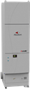 | 2 | $6,187.00 | $12,374.00
Jacobs Duct | Jacobs Duct  To connect A-Mist 20 and (2) Robotic machine centers. |  | 2 | $1,420.00 | $2,840.00
Flexible Hose | Flexible hose to connect inside the robotic cavity |  | 2 | $440.00 | $880.00
A-Mist 5  (ODF-800) | A-Mist 5 S3B1/TREA340 | 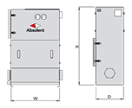 | 2 | $3,142.00 | $6,284.00
Jacobs Duct | Jacobs Duct to connect (3) A-Mist 5 units to machines. |  | 3 | $415.00 | $1,245.00
 |  |  |  | Grand Total: | $119,758.00
Total does not include shipping cost

Additional Product Options:
Name | Product Description | Quantity | Unit Price
Jacob Tubing | Butterfly Valves | 1 | $265.00

Let me know if you have any questions and when it would be convenient for you and your staff to begin discussing final terms of a contract.

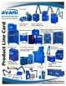 Feel Free to Review the Avani Product Line: CLICK HERE.

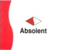 Feel Free to Learn about the Absolent Product Line: CLICK HERE

Sincerely,
Ed Sithes, President
Avani Environmental intl
Phone: (919) 570-2862, Email: esithes@avanienvironmental.com

Terms and Conditions
General:
- The price does not include sales tax, duties, custom fees or any other cost associated with the sale or delivery of this product.
- Payment terms: 35% with order, 35% upon shipment, 30% net 30 days.
- Quotation price does not include actual shipping costs. If requested by Buyer, Avani can supply an estimated shipping cost(s).
- There is a 20% restocking / cancellation fee for all Purchase Orders.
- Not responsible for shipping and handling costs for Warranty issues/items.
- Warranty only includes replacement parts not labor or any other cost associated with replacing warranty Items.
- All Products are FOB: Manufacturer

Installations:
- Price of installation does not include the following costs. Avani can quote these cost if need be but prices will be based upon a local contractor.
  - Electrical wiring, running wires, or anything associated with electrical work
  - Lifting equipment or any other heavy equipment required to install the equipment
  - Demolition work and cutting holes through concrete or metal.

Shipping and Delivery Time:
- Stock items will ship within 1 week; Non-Stock items will ship within 8-10 weeks. Custom Products could ship in 12-16 weeks. These times are estimates only and may be revised at anytime.
- All standard stock products will be shipped from Avani’s warehouse: Youngsville, NC 27596
- Unless otherwise stated we ship items in the best way.
- The delivery of the products will be ex-works: if requested by the Buyer, Avani will arrange delivery and insurance of the Products in transit at the Buyer’s expense.
- The Buyer is responsible for inspecting the Products immediately when they are delivered and must state upon delivery if the Product is damaged or has missing parts, if not the Products are acknowledged as being satisfactory quality and are not missing any parts.

