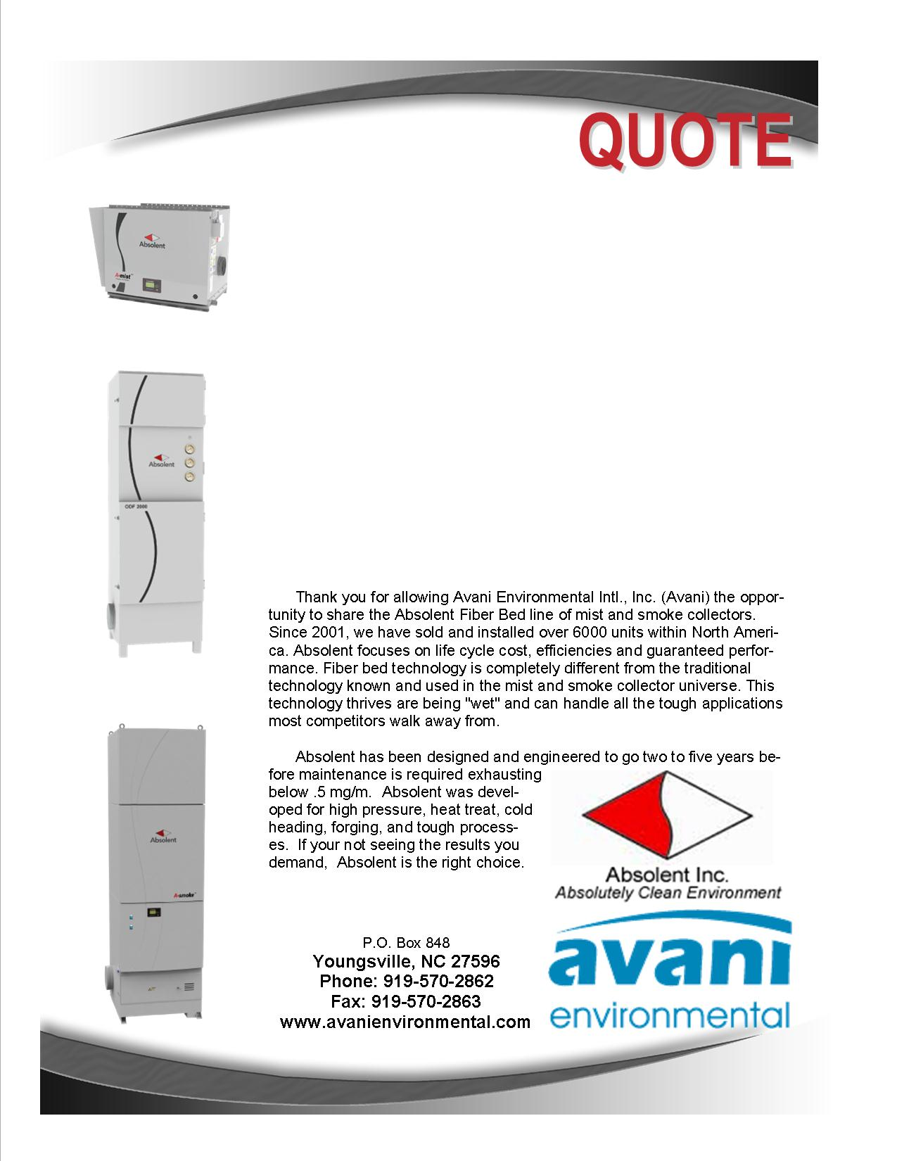

Attn: Bradley Yohn

**Bonney Forge Corporation**

**Quote #: AE-005140**

Quote by: **Mike Connors**

Email: mconnors@avanienvironmental.com

October 10, 2012

**Avani Environmental Intl., Inc.**

**P.O. Box 848**

**Youngsville, NC 27596**

Phone: 919-570-2862 Fax: 919-570-2863

**Quote #: AE-005140** October 10, 2012

Quote by: **Mike Connors**

Attn: Bradley Yohn, , byohn@bonneyforge.com

**Bonney Forge Corporation**

Kathy Mullen, Mount Union, PA 17066

Dear Bradley,

Review quote below.

|  |  |  |  |  |  |
| --- | --- | --- | --- | --- | --- |
| **Product Name** | **Product Description** | **Product Picture** | **Quantity** | **Unit Price** | **Total Price** |
| Jacobs Duct | Jacobs Duct: Please refer to the attachment or description for details. |  | 1 | $2,589.00 | $2,589.00 |
| Installation - Avani | Mechanical Installation: Labor to install and assemble.  (Excludes: lift rental, electrical wiring, drain plumbing, fire suppression, demolition work or holiday work - unless otherwise stated) |  | 1 | $450.00 | $450.00 |
|  |  |  |  |  |  |
|  |  |  |  | **Grand Total:** | **$3,039.00** |

**Total does not include shipping cost**

Additional Product Options:

|  |  |  |  |  |
| --- | --- | --- | --- | --- |
| **Name** | **Product Description** | **Quantity** | **Unit Price** | |
|  |  |  |  | |
|  |  |  |  | |
|  |  |  |  |

Let me know if you have any questions and when it would be convenient for you and your staff to begin discussing final terms of a contract.

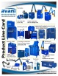 Feel Free to Review the Avani Product Line: [CLICK HERE](http://issuu.com/avanienvironmental/docs/product_line_card_new_2011?mode=window&backgroundColor=%23222222).

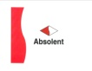 Feel Free to Learn about the Absolent Product Line: [CLICK HERE](http://miststop.com/)

Sincerely,

**Mike Connors,** Sales Manager

Avani Environmental intl

Phone: (919) 570-2862, Email: mconnors@avanienvironmental.com

**Terms and Conditions**

*General:*

1. The price does not include sales tax, duties, custom fees or any other cost associated with the sale or delivery of this product.
2. Payment terms: 40% with order, 40% upon shipment, 20% net 30 days.
3. New customers or dealers must pay 35% down with Purchase Order(s).
4. Quotation price does not include actual shipping costs. If requested by Buyer, Avani can supply an estimated shipping cost(s).
5. There is a 20% restocking / cancellation fee for all Purchase Orders.
6. Not responsible for shipping and handling costs for Warranty issues/items.
7. Warranty only includes replacement parts not labor or any other cost associated with replacing warranty Items.
8. All Products are FOB: Manufacturer

*Installations:*

1. Price of installation does not include the following costs. Avani can quote these cost if need be but prices will be based upon a local contractor.
   1. Electrical wiring, running wires, or anything associated with electrical work
   2. Lifting equipment or any other heavy equipment required to install the equipment
   3. Demolition work and cutting holes through concrete or metal.

*Demo Units:*

1. Available for up to 30 days.
2. Must pay for shipping to your facility and back to Avani’s warehouse; if returning the product(s).
3. If there is filter media in the product all filter media must be paid for if the product(s) is returned.
4. If product is returned; the product must return in the same condition as when shipped from Avani’s warehouse, if scratched or damaged additional charges will be applied.
5. To obtain a Demo unit. First, talk with an Avani representative for approval and availability. Second, send in a Purchase Order, just like you would be purchasing the unit, and put DEMO UNIT on the Purchase Order.
6. After the Demo trial period is over payment is due upon receipt of Invoice.

*Shipping and Delivery Time:*

1. Stock items will ship within 1 week; Non-Stock items will ship within 8-10 weeks. Custom Products could ship in 12-16 weeks. These times are estimates only and may be revised at anytime.
2. All standard stock products will be shipped from Avani’s warehouse: Youngsville, NC 27596
3. Unless otherwise stated we ship items in the best way.
4. The delivery of the products will be ex-works: if requested by the Buyer, Avani will arrange delivery and insurance of the Products in transit at the Buyer’s expense.
5. The Buyer is responsible for inspecting the Products immediately when they are delivered and must state upon delivery if the Product is damaged or has missing parts, if not the Products are acknowledged as being satisfactory quality and are not missing any parts.