**Wolf-tec Collector Cartridge count:**

Grinding room model: EB-19x18x12

No of collectors: 4 sets

Cartridge filter spec.: Cartridge Filter: Ø380 x 660mmL (Ø15” x 26”)

****Material: 80/20 Fr.

Part Number: FM-20252

No of cartridges per collector: 4pcs

Total number of cartridges: 16pcs

Grinding room model: EB-25x18x12

No of collectors: 5 sets

Cartridge filter spec.: Cartridge Filter: Ø380 x 660mmL (Ø15” x 26”)

****Material: 80/20 Fr.

Part Number: FM-20252

No of cartridges per collector: 4pcs

Total number of cartridges: 20pcs

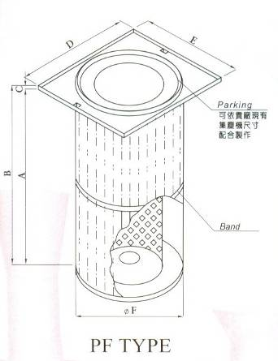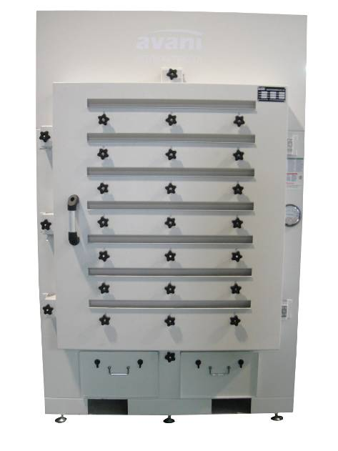 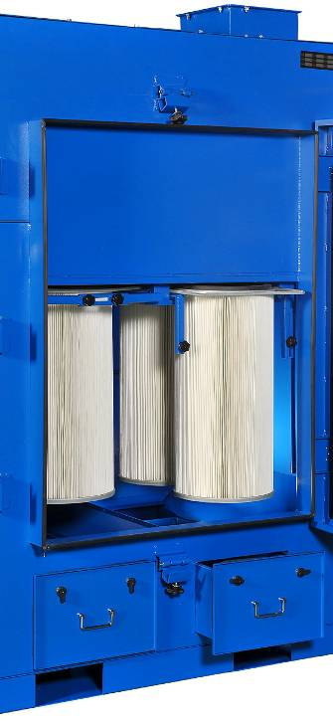

| Reference Number | Description | Part Number | Quantity |
| --- | --- | --- | --- |
| 2 | Cartridge Filter | AVANI-EB-L-5-4-2 | 4 |

PF TYPE (Measurement m/m)

|  |  |  |  |  |  |  |  |  |  |
| --- | --- | --- | --- | --- | --- | --- | --- | --- | --- |
| Diameter | Fold Depth | A | B | C | D | E | F | Weight  kg | Filtering Area  M2 |
| 380 | 48 | 660 | 673 | 12 | 421.4 | 459.2 | 380 | － | 25 |