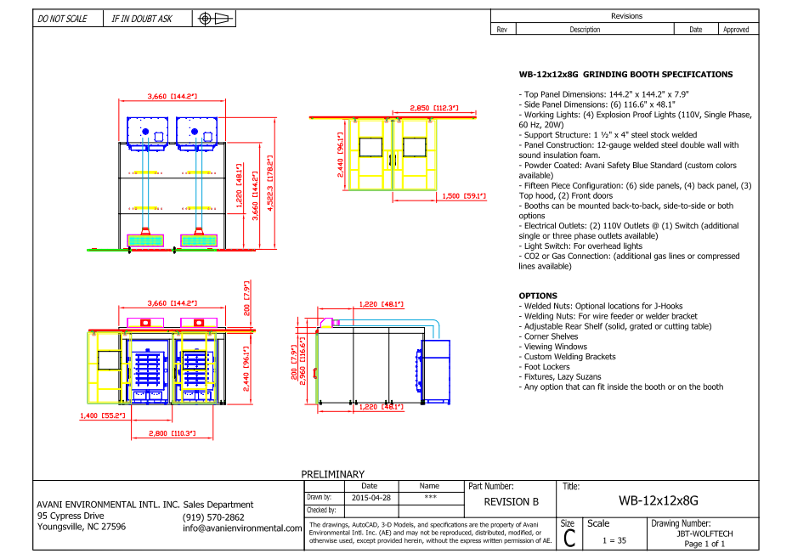

WB-12x12x8G unit cost: US$26,535 x 1 = US$26,535.-

**TOTAL PROJECT COST: USD26,535.-**

**\*Estimated shipping: 75% of a 40’HQ container**