Customer: Wake Tech
9101 Fayetteville Rd.
Raleigh, NC 27603-5696
Contact: Christopher Gitthens
Phone: 919-866-5167
Email: cggitthens@waketech.edu

Date: 11/19/12

Project #:
Sales Order #: Warranty
Serial #:
Model #: WB-3000

Crew: Mike Connors/Cynthia Bendiksby

SCOPE OF PROJECT: Determine source of debris on room air filters and find solution for excess noise

Upon initial arrival we were shown the dirty air filters for the air conditioning units. The filters had been changed within the previous 2 weeks.

We observed students welding and witnessed no smoke escaping from the welding booths while the dust collectors were operating on Manual Pulse. We then switched the collectors to automatic pulsing, with no loss of smoke. It appears the booths capture 99% of the smoke when stick welding.

With 10 dust collectors serving 20 booths, the noise level is considerable. The pulse valves and collectors are operating within the specified parameters.

Solutions:

Noise levels would be decreased by the centralization of the dust collection system to the roof or exterior of the building. Pulse valve firing and recharging noise can be slightly diminished by cleaning and repairing worn pulse valves.

Vacuum the dust trays to reduce dust circulating around the filters. We recommend a manual pulse to clean the filters once the fan is turned off.

We observed metal dust evident on all equipment from the plasma cutter to the doorway. Upon further inspection of the ductwork around the plasma cutter, it appears that the return air plenum has metal dust lining the bird screen and interior walls. See attached pictures. In our opinion, the return air from the roof is returning the dirty air from the exhausted plasma cutter and is the primary source for the debris on the HVAC filters.

We recommend sending a trial of paper 80/20 prekoted filters for 1 unit to determine if that improves the filtration of welding smoke and an inspection of all pulse valves and gaskets for leaks.

Please feel free to call me at any time if you have any questions or concerns with the units.

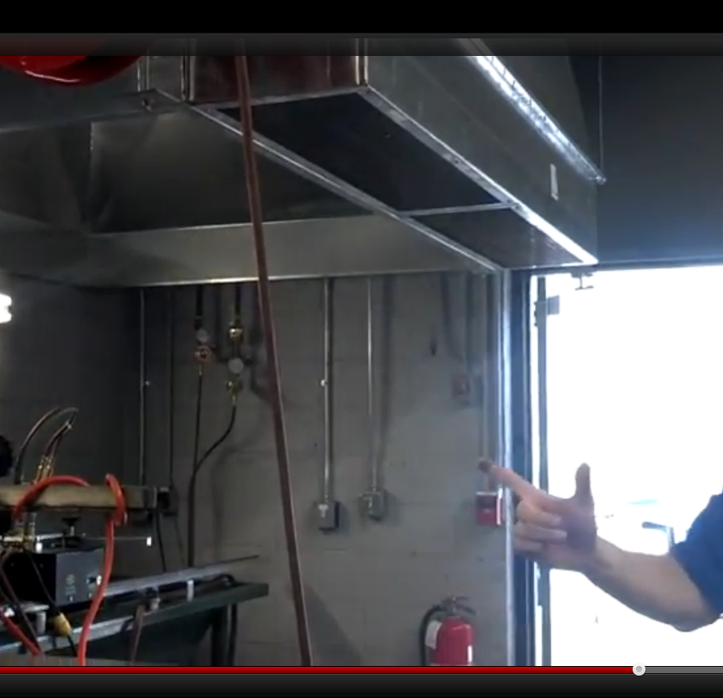

Thanks,

Cynthia Bendiksby
Cynthia Bendiksby
Engineering Manager – cell (919) 606-3424
E-mail cbendiksby@avanienvironmental.com

CUST0MER REMARKS: _____________________________________________________________________________________________________________________________________________________________________________________________________________________________________________________________________________________________________________________________________________________________________________________________________________________
Customer Signature: _________________________________________Date:___________________
Title or Department: ________________________________________________________________

