March 3, 2011
General (Assumptions/Decisions):
Key points:
- Minimum air velocity in the exhaust piping of 15-20 M/sec. To prevent soot build up on the piping walls
- Pressure of -15000pa
- 800 cubic Meters/Hour flow
Duty Cycle: Continuous Duty 24/7 operation
Operators / openings: 8 (12 if counting chamber exhaust openings on needle machine)
Remote on / off
No exhaust in cleanroom
Exhaust / vacuum system location - Mezzanine / outside clean room
Flow sensor and location for filter condition monitoring?
Noise level for exhaust?
Spare (backup) system?
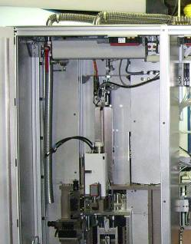
Needle Assembly:
4 welds – opening / exhaust for each weld point
4 station / chamber – opening for each station / chamber
Weld chamber exhaust is not control / monitored. The
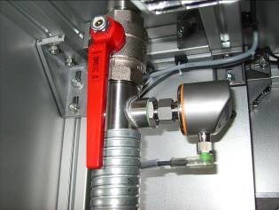
laser / process exhaust can be controlled manually and the
flow is measured by a sensor IFM SI5002. At every station
the chamber exhaust tube and the laser / process exhaust
tube is combined at the top of the station to one stainless
steel tube with outer diameter of 40 mm.
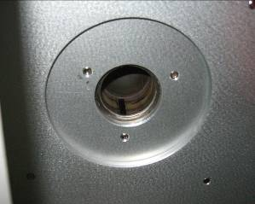
VG Setting (Injector):
3 welds – Opening / exhaust for each weld point
Opening diameters:
- St40: 16mm
- St70 and 90: 20mm
From the point of use ~ 1m steel pipe then flex tubing (type: Superflextract - soft 41mm):
- St40: ~1.8m
- St70: ~1.5m
- St90: ~1m
The valve at the top of the station used to regulate flow: IFM SD9000 DN40/PN16
Fitting size of the valve: PN16
March, 2011 – possible two additional pickup points for tray cleaning/blow off.
- Amtech, A C E 3/3/2011
- Ruwac 3/10/2011
Final Assembly (Injector):
1 Laser marking - Opening / exhaust

