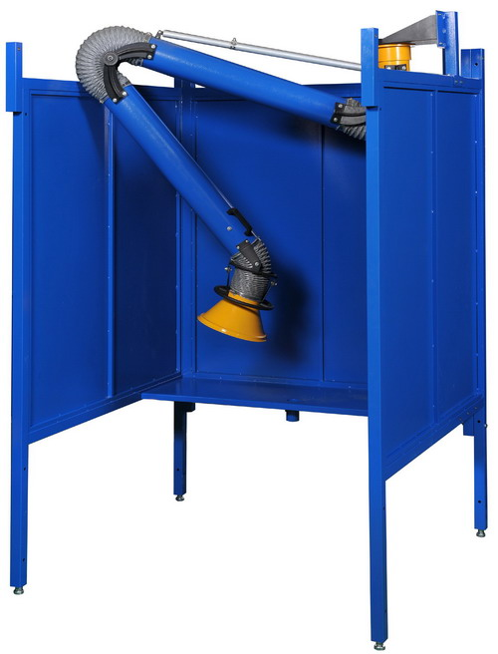

Customer:
Customer PO#:
AVANI SO#: |  | Tested By:
Serial #: | 121601 ~ 121610
Ship Date / Install Date:

TABLE OF CONTENT
Submittal Dimensions (in mm/inches) 3
Assembly Label Configuration 4
Assembly Procedure 5
Assembly Hardware 8
Repair Parts List 9
Contact Information 10

Submittal Dimensions (in mm/inches)

Assembly Label Configuration

Assembly Procedure

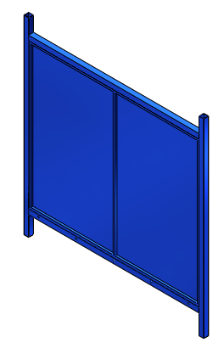
1.
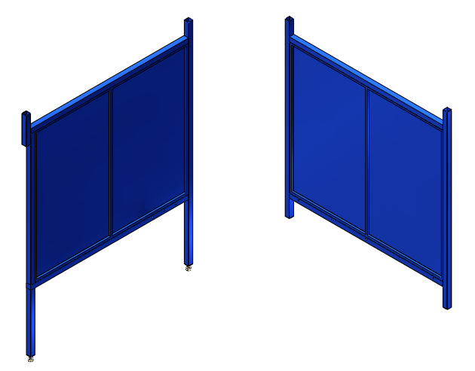
2.
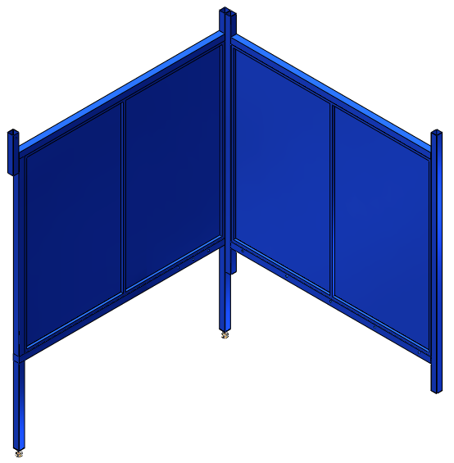
3.
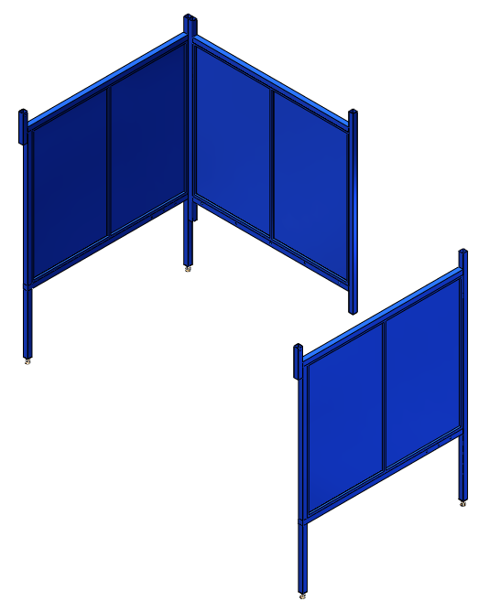
4.
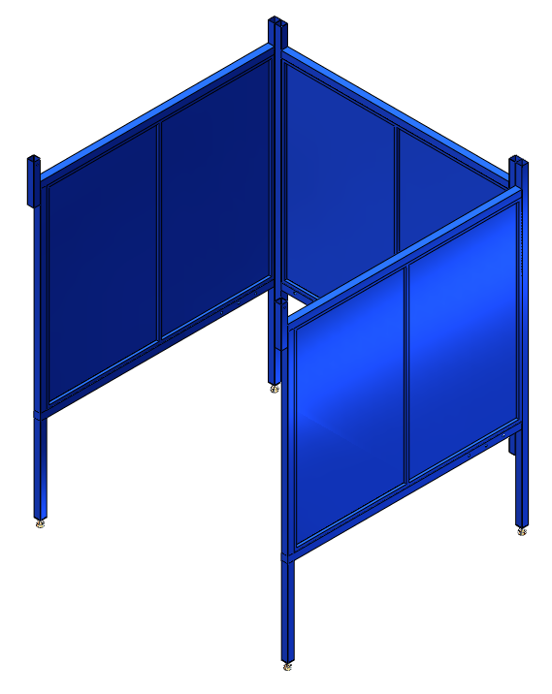
5.
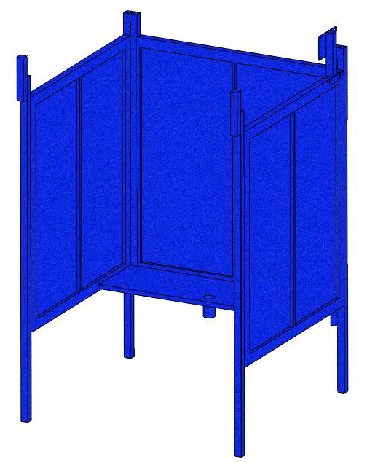
6.
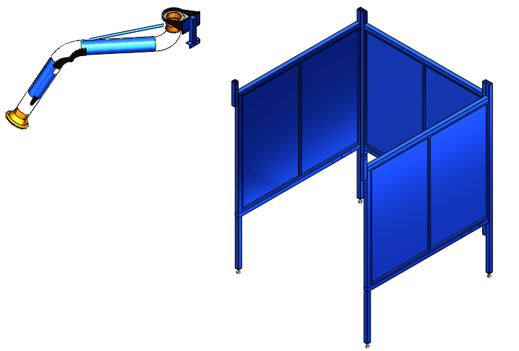
7.
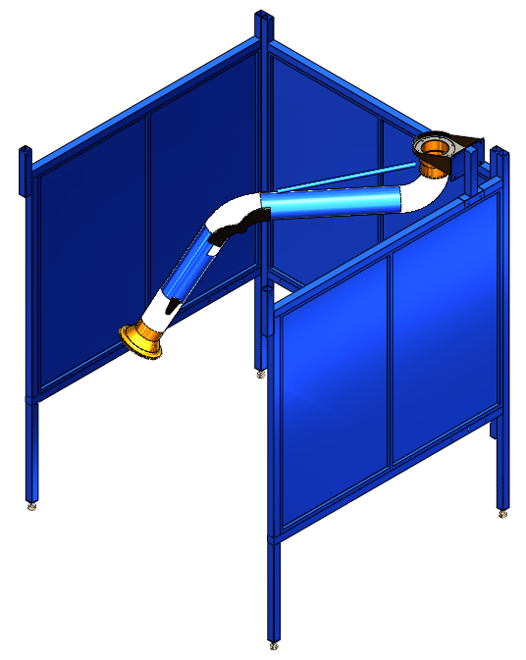
8.
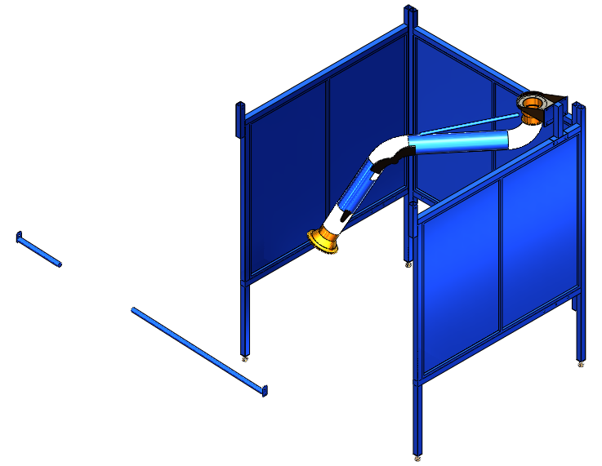
9.
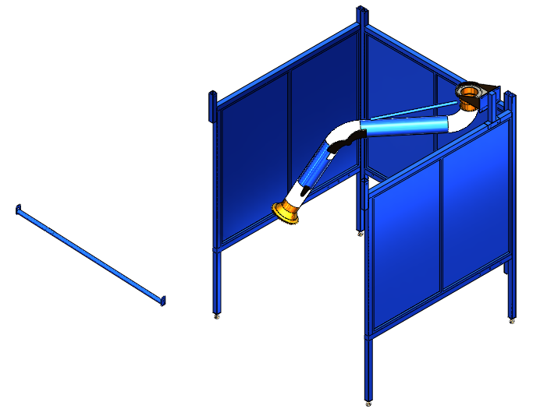
10.
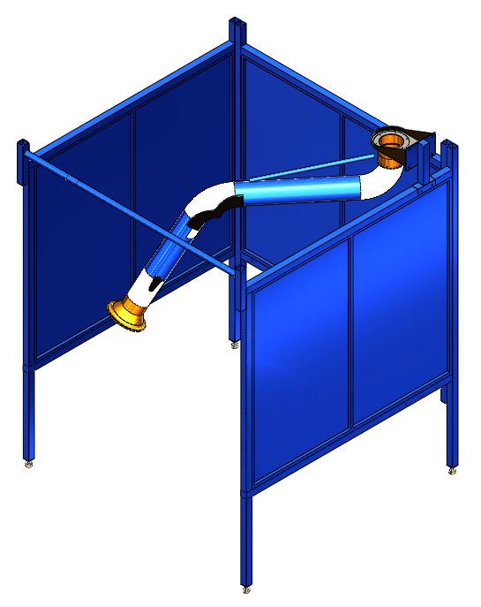
11.
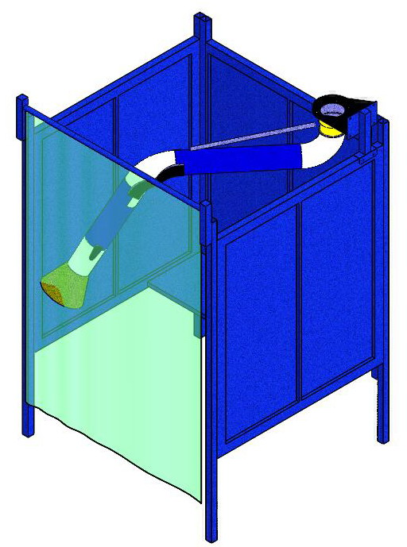
12. Assembly Completed.

Assembly Hardware

Repair Parts List
Repair Parts List for Welding Booth

Reference Number | Description | Part Number | Quantity
1 | Hex Screw (5/16"*3") | OS06-01-WB-5x5S-1 | 4
2 | Flat Washer (5/16"*OD23*2t) | OS06-01-WB-5x5S-2 | 4
3 | Back Panel | OS06-01-WB-5x5S-3 | 1
4 | Side Panel | OS06-01-WB-5x5S-4 | 2
5 | Adjustable Feet | OS06-01-WB-5x5S-5 | 4
6 | Table | OS06-01-WB-5x5S-6 | 1
7 | Hex Screw (5/16"*3/4") | OS06-01-WB-5x5S-7 | 8
8 | Flat Washer (5/16"*OD18*2t) | OS06-01-WB-5x5S-8 | 8
9 | Knob (5/16"*3/4") | OS06-01-WB-5x5S-9 | 1
10 | Curtain Bar (short) | OS06-01-WB-5x5S-10 | 1
11 | Curtain Bar (long) | OS06-01-WB-5x5S-11 | 1
12 | Hex Screw (5/16"*3/4") | OS06-01-WB-5x5S-12 | 2
13 | Flat Washer (5/16"*OD23*2t) | OS06-01-WB-5x5S-13 | 2
14 | Hex Screw (5/16"*3/4") | OS06-01-WB-5x5S-14 | 4
15 | Flat Washer (5/16"*OD23*2t) | OS06-01-WB-5x5S-15 | 4
16 | Arm Support | OS06-01-WB-5x5S-16 | 1
17 | Hex Screw (5/16"*1") | OS06-01-WB-5x5S-17 | 4
18 | Flat Washer (5/16"*OD23*2t) | OS06-01-WB-5x5S-18 | 8
19 | Hex Nut (5/16") | OS06-01-WB-5x5S-19 | 4

Contact Information

Avani Environmental Intl. Inc.
95 Cypress Drive,
Youngsville, NC 27596
Email: info@avanienvironmental.com
www.avanienvironmental.com

Customer Service: info@avanienvironmental.com
Tel: 919-570-2862 ext. 208

Engineering Service: engineering@avanienvironmental.com
Tel: 919-570-2862 ext. 203

