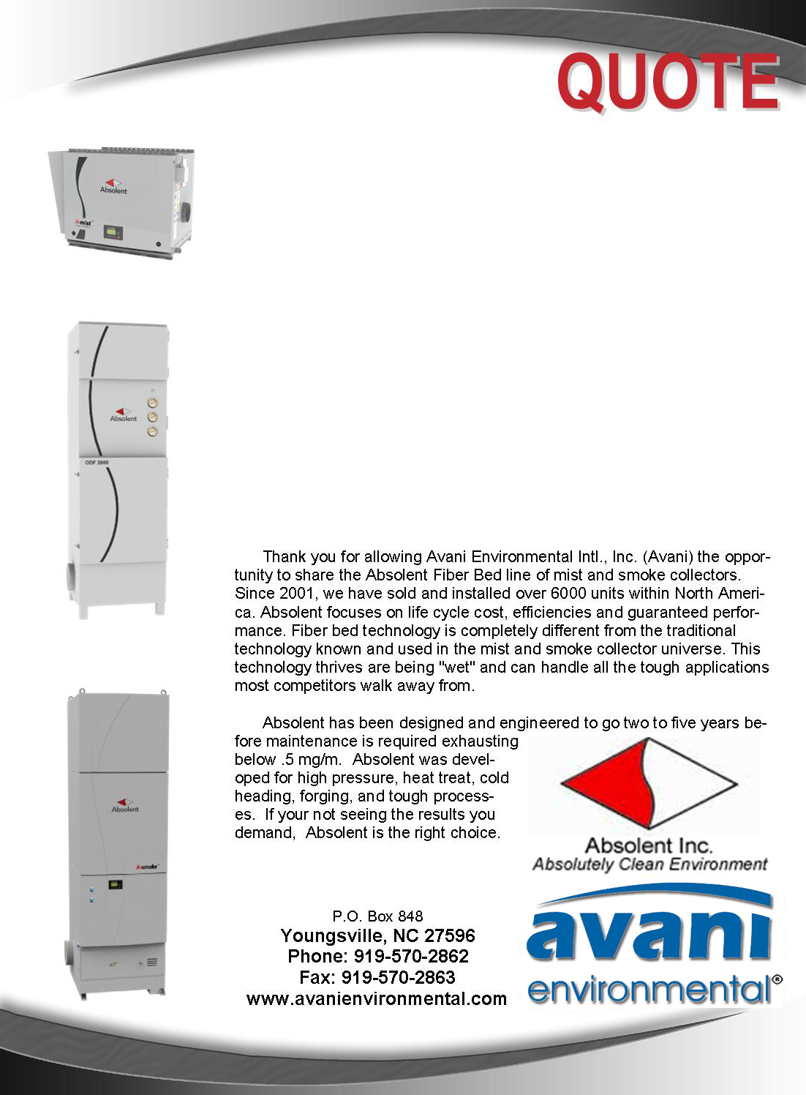

Avani Environmental Intl., Inc. ®
P.O. Box 848
Youngsville, NC 27596
Phone: 919-570-2862 Fax: 919-570-2863

Quote #: AE-010060 June 12, 2014
Quote by: Ed Sithes

Attn: Rafael Sandoval Ruiz
rafaelantonio.sandovalruiz@schaeffler.com

SchaefflerMexico de RL de CV
Av. Rio San Lorenzo #888
Parque Tecnoindustrial Castro del Rio
Irapuato, 36815

Dear Rafael,

The following proposal is to address three lines and a total of twelve pick-ups. All drops will have throttle valves and two drops will have a fire damper (oil based coolant), and Jacobs tubing to guarantee no leaks. Please review quote below with items detailed in your set of specifications:

Product Name | Product Description | Product Picture | Quantity | Unit Price | Total Price
AB-A Smoke 40 | A-Smoke 40 (Standard)  Continuous duty coalescing fiber bed smoke & mist collection system c/w 10HP direct drive centrifugal fan, sound attenuated fan chamber, filtration includes coalescing fiber bed filter stage one, coalescing fiber bed filter stage two, final HEPA safety filter, digital differential pressure gauge, hinged access doors, inlet plenum w/mounting legs & sloped bottom, FPT drain outlet, automatic Brinkmann® pump back system c/w float controls & pump, custom electrical control panel w/pump interface, fabricated with heavy-gauge steel, robotically welded and finished with a durable powder coat paint finish RAL 7035. Performance rated for 2,350 CFM @ maximum saturation. Additional specifications are attached |  | 2 | $25,629.00 | $51,258.00
AB-A Smoke 20 | Continuous duty coalescing fiber bed smoke & mist collection system c/w 3HP direct drive centrifugal fan, sound attenuated fan chamber, filtration includes coalescing fiber bed filter stage one, coalescing fiber bed filter stage two, final HEPA safety filter, digital differential pressure gauge, hinged access doors, inlet plenum w/mounting legs & sloped bottom, FPT drain outlet, fabricated with heavy-gauge steel, robotically welded and finished with a durable powder coat paint finish RAL 7035. Performance rated for 1,180CFM @ maximum saturation. Additional specifications are attached |  | 1 | $11,700.00 | $11,700.00
Jacobs Duct | Pre-fabricated Jacob Tubing kit complete with straight flanged tubing, flanged branch transitions, flanged elbow/bends, inline volume control dampers (where required), connecting clamps with special U-shaped gasket, hanger brackets, flanged slip tubes, adapters, and related components. Jacob Tubing is laser welded and the standard material gauge is 19/11-gauge and includes a durable powder coated paint finish (stainless steel tubing is also available; pricing upon request). Jacob Tubing is ideal for mist collection applications and high-temperature applications. Infinitely adjustable, easy to install, and breaks down for cleaning where required. | 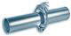 | 1 | $22,890.00 | $22,890.00
Jacobs Fire Dampers | Jacobs Fire Dampers |  | 2 | $450.00 | $900.00
Mechanical Materials | Mechancial Materials |  | 3 | $200.00 | $600.00
Installation - Avani | Mechanical installation, labor, travel, expenses and insurance.  Install (2) A-Smoke40’s, (1) A-Smoke20, connect with Jacobs piping.  Exclusions: electrical wiring, compressed air piping or drain plumbing (as required), concrete pad supply & installation (where required), utility upgrades where required by others, scissors lift or crane/equipment, offloading or storage, permits (where required), final roof sealant or wall flashing (where required), and services outside of scope shall be supplied by customer or others. |  | 1 | $22,440.00 | $22,440.00
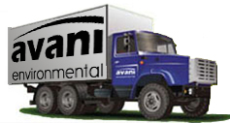 | NOT INCLUDED:  Freight and transportation charges  Customs, duties & taxes  Material handling equipment  Installation equipment (Cranes, forklift, scissor loft or jig) |  |  | Grand Total: | $109,330.00

Ed Sithes
President
Avani Environmental intl
Email: esithes@avanienvironmental.com
Phone: (919) 488-5191
Websites:
www.avanienvironmental.com
www.weldingbooths.com
www.miststop.com
Service-Disabled Veteran-Owned Small Business (SDVOSB)

Additional Product Options:
Product Name | Works for which models | List Price | Product Description | Product Picture
PF-10000  (fits 6”, 8”, 10”) | A mist 20  A mist 40 | $640.00 | MistStop Prefilter: Stop chips, swarf & Particulate prior to your Mist Collector.  Dual aluminum mesh filters, flanged (inlet/outlet), drain line, 10 gauge welded steel. Easy Install. | 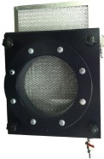
PF-16000  (fits 12”, 14”, 16”) | A mist 60 | $746.00
PF-18000  (fits 18”) | A mist 80 | $809.00
MP-400 | All Absolent Units | $955.00 | MistStop Pump: MP-400. Avani's premier universal mist pump. 1/6hp, 1-phase, 110-v, removable screen and powder coated steel. | 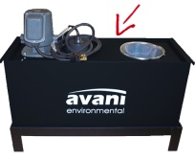
XA-400-MPS | All Absolent Units | $150.00 | MistStop Stand: Self-supporting stand for MistStop Pump. | 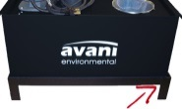
CP-SS-2.5 | A-mist 6  A-mist 10  A-mist 10C | $374.00 | Start-Stop Control Package: Simple On/Off Control Package with Manual Starter & IP64 Enclosure | 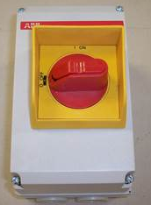
CP-SS-6.3 | A-mist 20  A-mist 60  A-smoke 20 | $385.00
CP-SS-10 | A-mist 40TF | $398.00
CP-SS-16 | A-mist 80TF  A-smoke 40 | $421.00
CP-SS-32 | A-smoke 80TF | $569.00
STX-FSK-30T | A-mist 6C | $512.00 | Stat-X Thermal Kits:  Stat-X Thermal activated generator specifically sized per unit, thermal actuation device and mounting bracket | 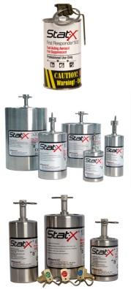
STX-FSK-60T | A-mist 10  A-mist 20  A-smoke 20 | $638.00
STX-FSK-250T | A-mist 40T  A-mist 40TF  A-mist 60  A-smoke 40 | $1,377.00
STX-FSK-500T | A-mist 80T  A-mist 80TF  A-smoke 80T  A-smoke 120 | $1,722.00
STX-FSK-1000T | A-smoke 160T | $2,512.00
STX-FSK-InstallT |  | $500.00 | Installation Services
STX-FSK-30E | A-mist 6C | $2,218.00 | Stat-X Electrical Kits:  Stat-X Electrical activated generator; specifically sized per unit, Solo panel, 110VAC; battery; linear heat detection cable; cable adaptor; terminal box and mounting bracket.
STX-FSK-60E | A-mist 10  A-mist 20  A-smoke 20 | $2,329.00
STX-FSK-250E | A-mist 40T  A-mist 40TF  A-mist 60  A-smoke 40 | $2,953.00
STX-FSK-500E | A-mist 80T  A-mist 80TF  A-smoke 80T  A-smoke 120 | $3,148.00
STX-FSK-1000E | A-smoke 160T | $3,831.00
STX-FSK-InstallE |  | $750.00 | Installation Services

Terms and Conditions

General:
- The price does not include sales tax, duties, custom fees or any other cost associated with the sale or delivery of this product.
- Payment Terms: Net 30
- All quoted prices and payments are in US dollars.
- Quotation price does not include actual shipping costs. All products are shipped FOB from manufacturer. If requested by Buyer, Avani can supply an estimated shipping cost(s). The estimated shipping cost is only an estimate and actual charges can be different from estimated charges.
- Late payments and any charges associated with the Late payment begin incurring charges 30 days after standard payment terms are due.
- Avani Environmental standard installation crew is quoted out per day based on the above drawings and approvals. Any changes, modifications, downtime, or inability to perform our work above and beyond the control of Avani Environmental will charge an additional $1,000 per work day (5 or more hours) per crew above what was initially quoted.

Shipping and Delivery Time:
- All products are FOB Manufacturer
- Shipping times: Stock items – 1 week, Non-stock items –8-12 weeks, Customized products –12-16 weeks. If deposits and/or signed drawings are required for specific job; shipping time begins after Avani has received these items. These times are estimates only and may be revised at any time.
- Unless otherwise stated on the purchase order Avani will ship Best Way Prepay and Add.
- All products that are shipped via Truck will be shipped with standard pallets and shipping material. If needed or requested by the buyer the product(s) can be completely crated for an additional cost.
- The Buyer is responsible for inspecting the Product(s) immediately when they are delivered and must state upon delivery if the Product(s) is damaged or has missing parts. If not, the Product(s) are acknowledged as being complete and satisfactory.

Warranty and Return:
- All New Products come with a standard 1 year warranty. Other warranties and terms are available and must be approved by an Avani personnel.
  - Warranty covers replacement parts for 1 year.
  - Does not cover labor or charges incurred for removing and installing new parts.
  - Not responsible for loss of use or downtime.
- Returns product(s) must be approved by Avani before being sent back.
  - Must have an RGA and Case # when the product(s) is shipped back.

Installation/Projects: Exclusions (Avani Environmental is not responsible for the below items):
- Demolition (cement walls, roof penetration, sealing, etc.), electrical or other work that requires special permits or licensing is not included in the price.
- All rental equipment: such as but not limited to forklifts, cranes, scissor lifts, jig, etc.
- Electrical wiring, compressed airlines or other components that connect to the equipment.
- Any type of permits required for installation, testing or running the equipment.
- Unloading of the product when it arrives.
- Storage and any loss or damaged product as a result of being stored.

