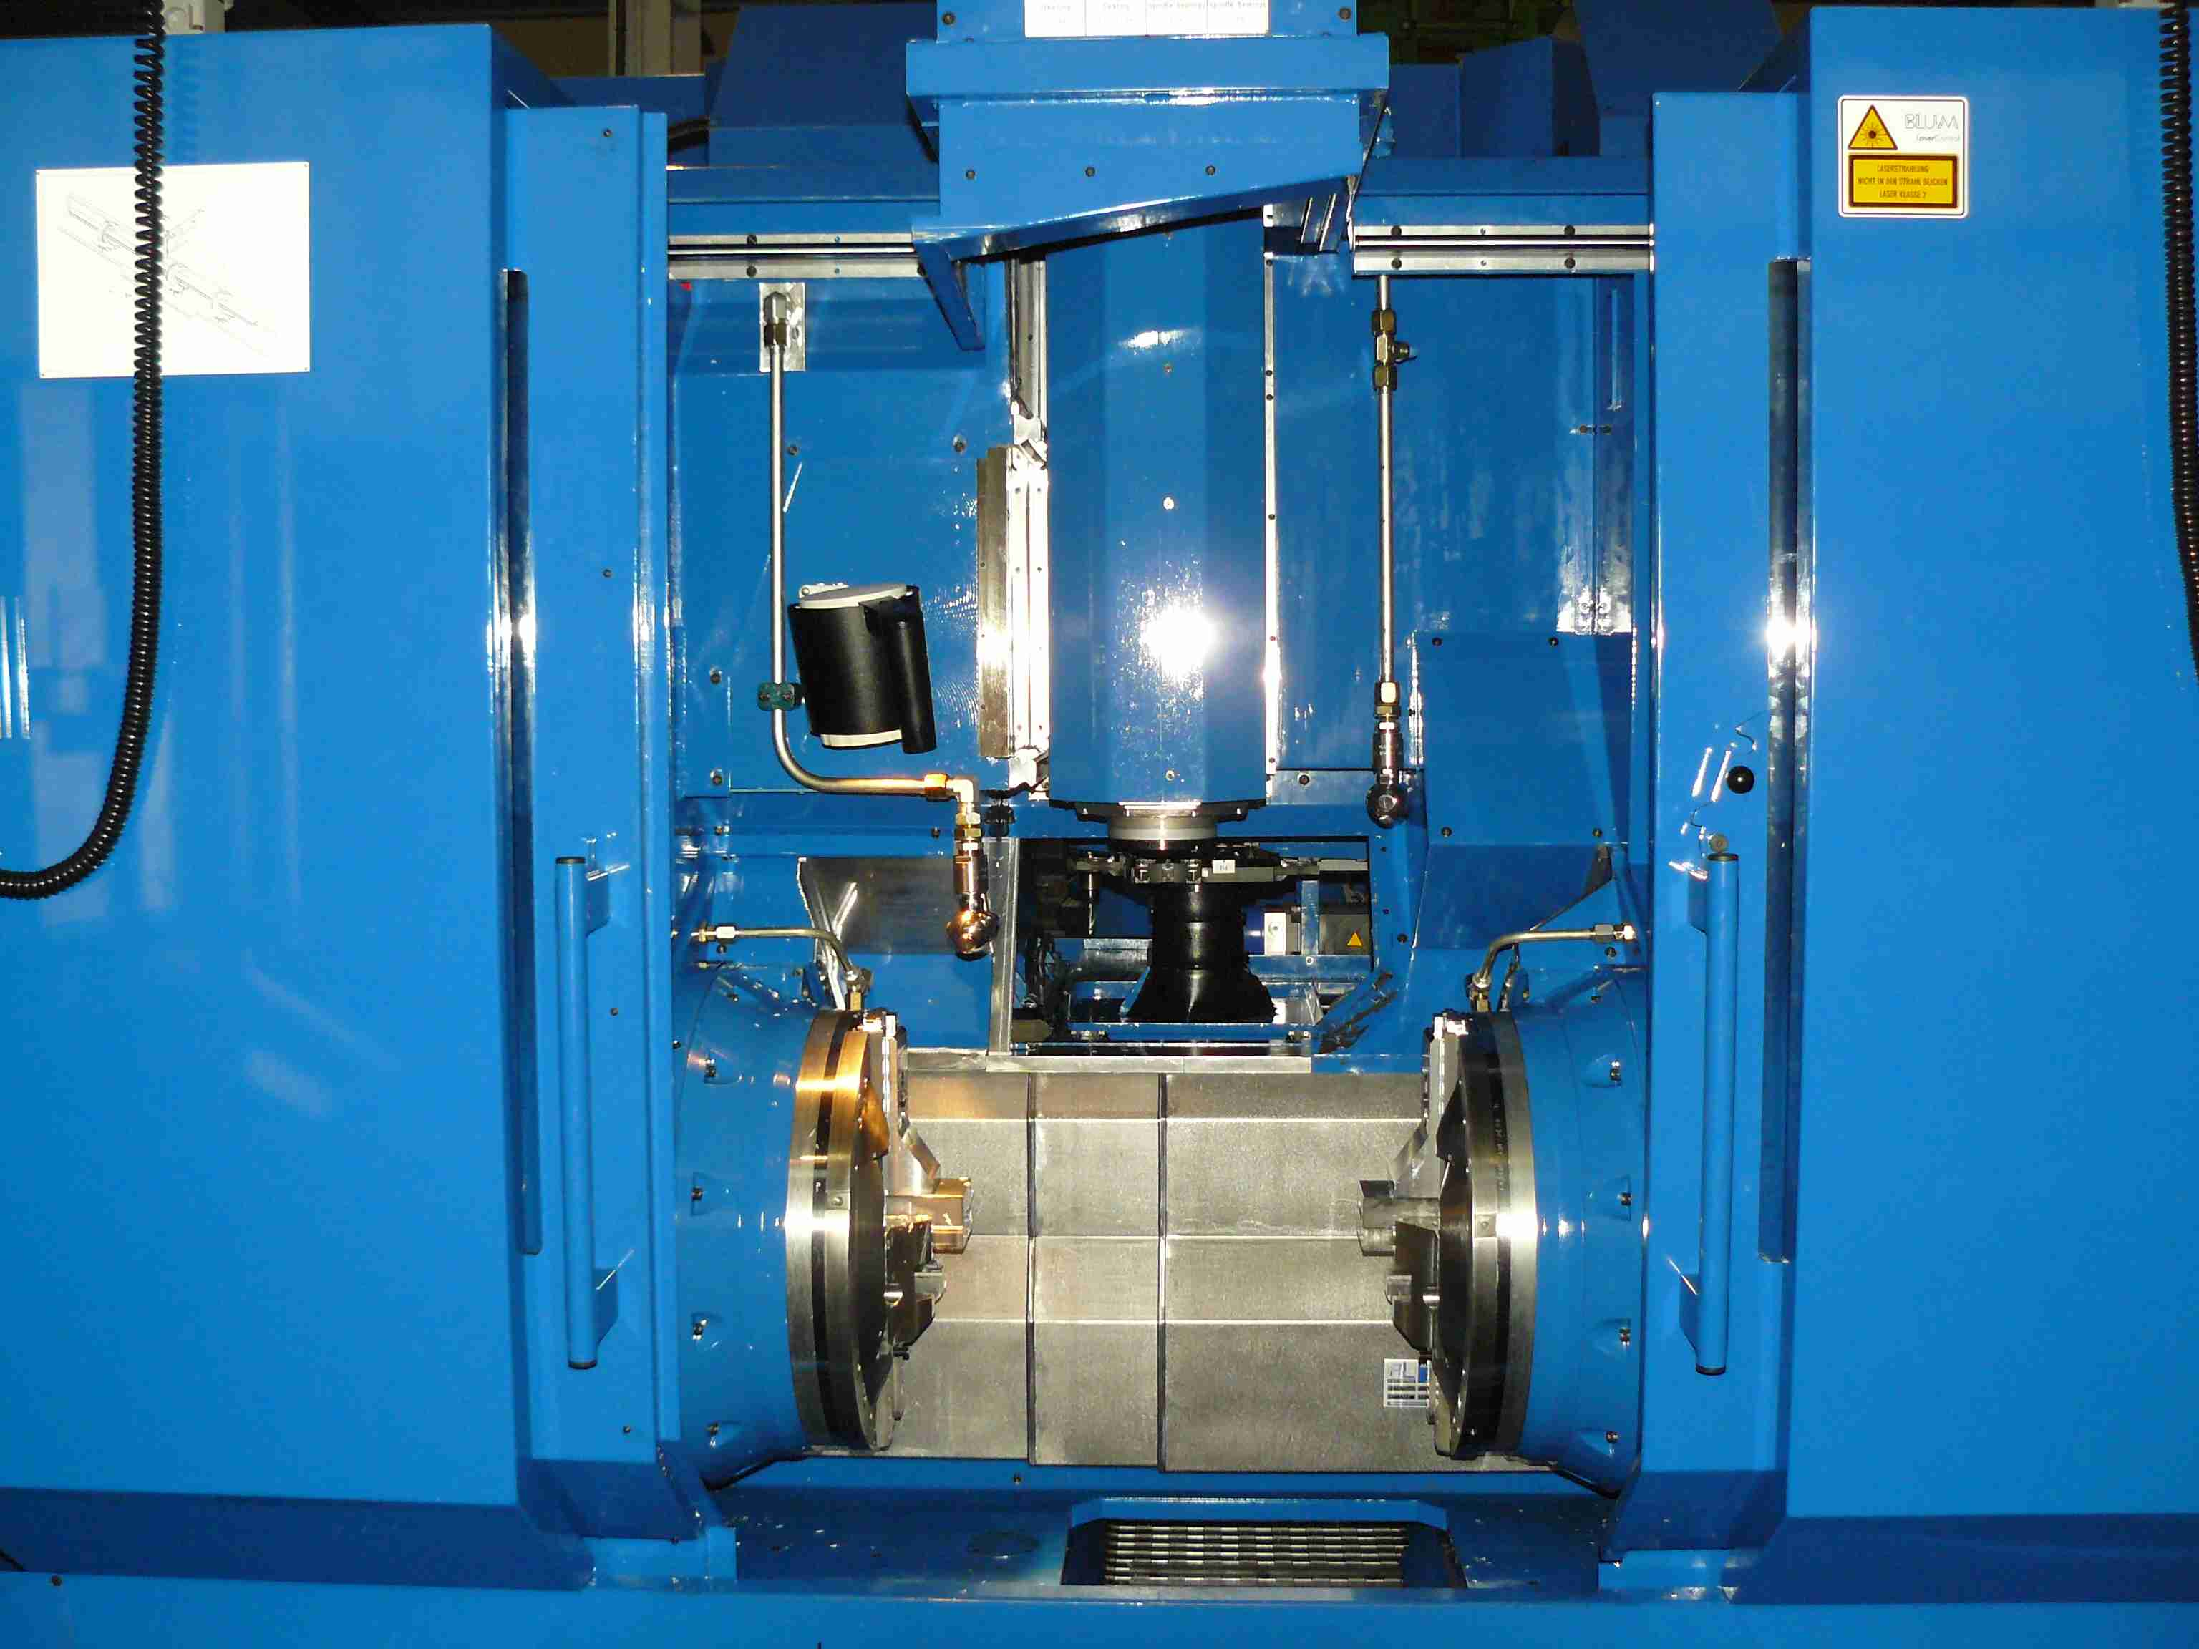
Central Machining Area: Arrows show extraction will pass under chucks

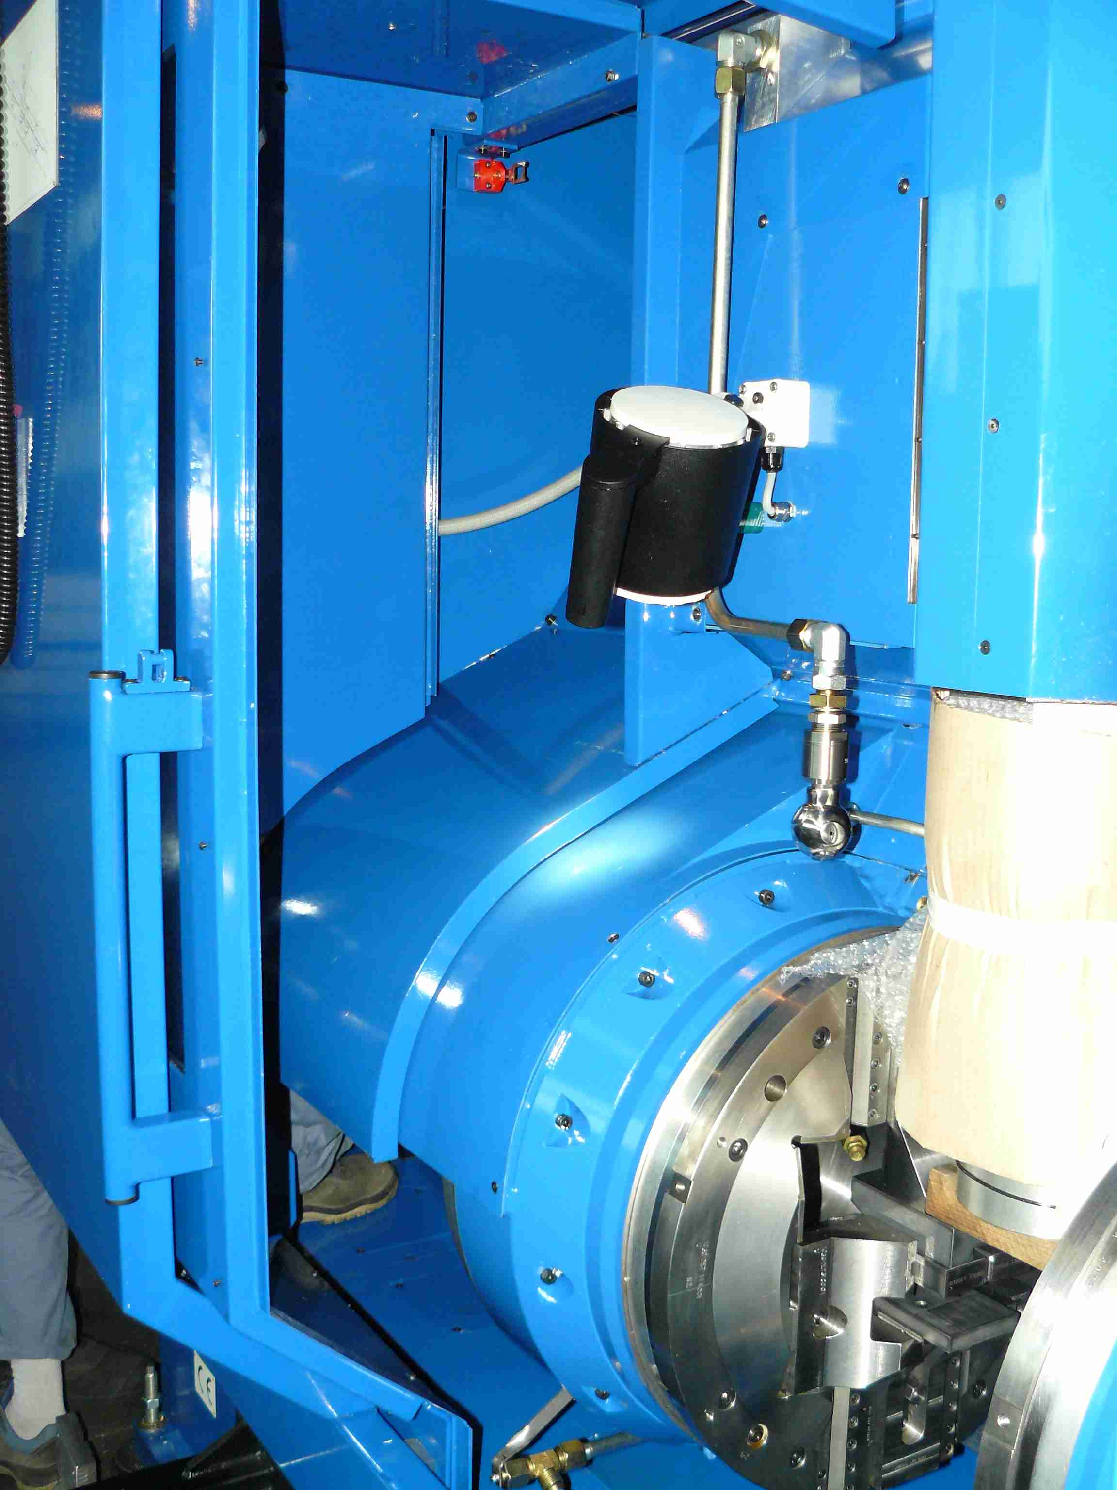
LH Extraction Area: Arrows show extraction path

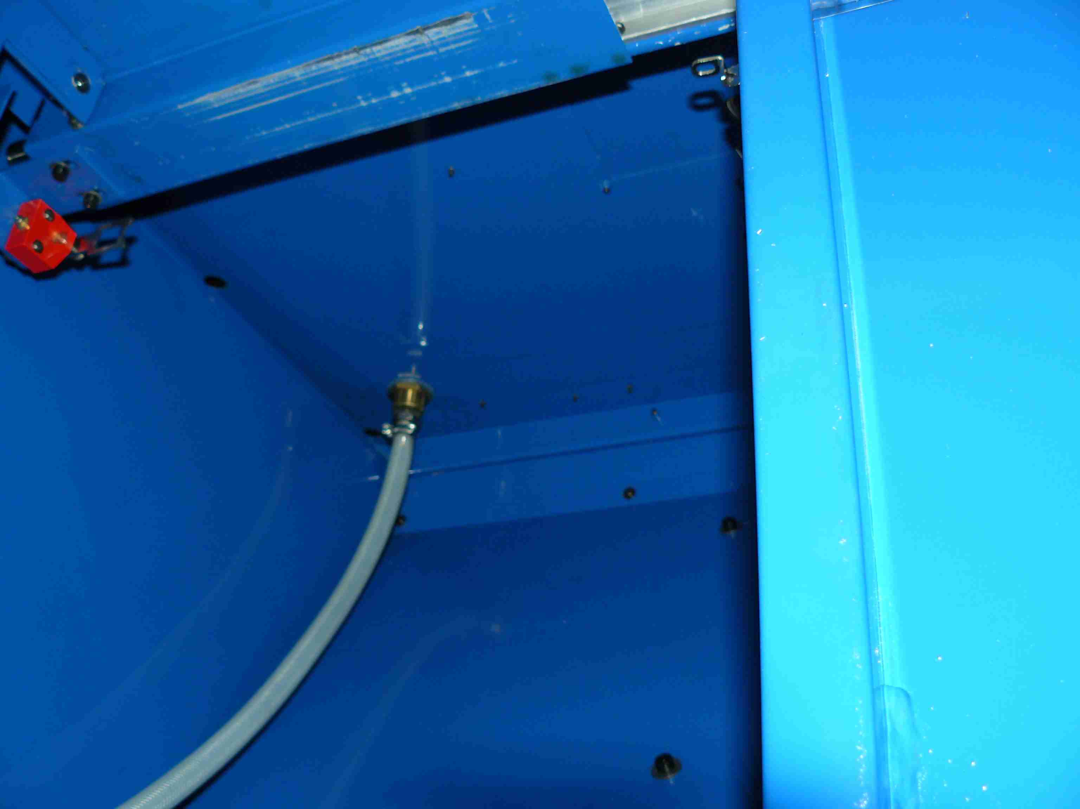
LH Extraction Area: Circle shows extraction point to create.

