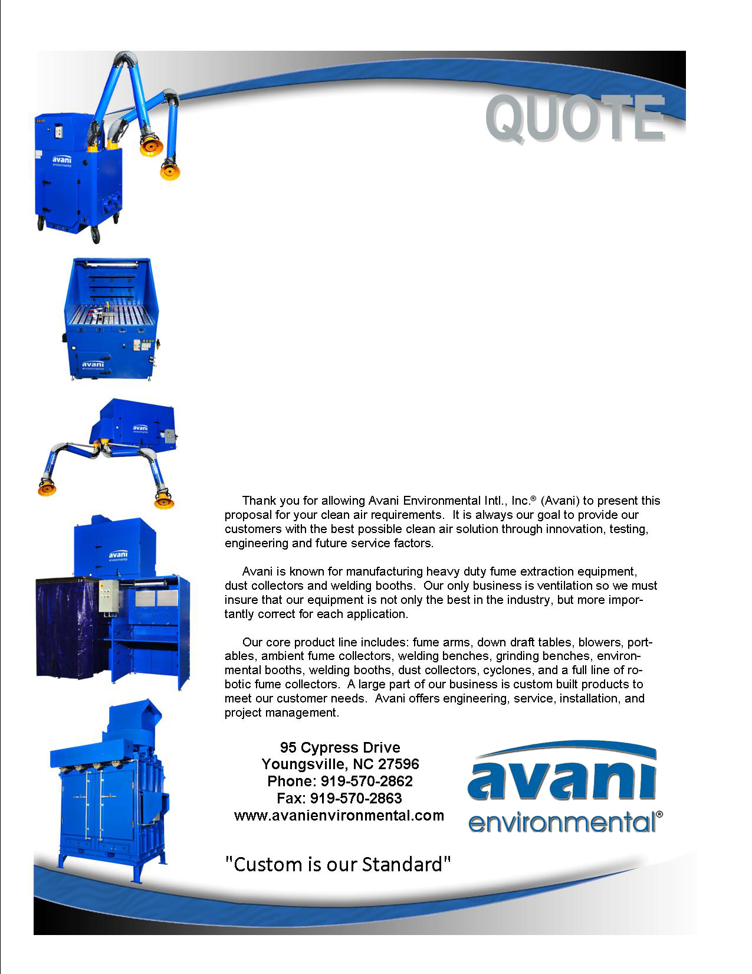

Attn: Brian Grimes

**Sampson Construction, Inc.**

**(Job Name: Kelly Walsh High School)**

**Quote #: AE-011676-REV-2**

**Quote by: Kirke Blenkhorn; Educational Sales**

**E-Mail:**

education@avanienvironmental.com

**May 06, 2015**

**Avani Environmental Intl., Inc.®**

**95 Cypress Drive**

**Youngsville**, **NC 27596**

Phone: 919-570-2862 Fax: 919-570-2863

**Quote #: AE-011676-REV-2 May 06, 2015, Quote by: Education Sales**

Attn: Brian Grimes, Ph: 402-434-5419, E-Mail: brian.grimes@sampson-construction.com

**(Revised Quote; Freight and State of WY Sales Tax is Noted)**

**Sampson Contruction Company, Inc.**

3730 South 14th Street

Lincoln, NE 68502

Brian; Please find the pricing requested re the project that is pending at Kelly Walsh High School.

|  |  |  |  |  |  |  |  |
| --- | --- | --- | --- | --- | --- | --- | --- |
| **Product Name** | **Product Description** | **Product Picture** | | **Quantity** | | **Unit Price** | **Total Price** |
| Booth Option #2:  WB-1055 | **Welding Booth; WB-1000 Series**  **Model: WB-1055**  Steel Panel: 12-Gauge  Framing: 2.0-Inch Square Tube  Panel Construction: Stitch-welded steel with 1" welded square cross bracing  Fume Arm Stanchion for BR-006 fume arm bracket  Rear Panel Shelf; 3-Postion, Adjustable; 28”, 32” and 36”  Adjustable Feet for Leveling  Weld Curtain Bar Assembly  Finish: Industrial Powder Coat; Blue  **(NOTE: Fume Arm and Bracket in photo are not included)** |  | 18 | | $1,920.00 | | $34,560.00 |
| Welding Booth Curtain | Standard curtain is a 1-ply, single-piece of flame retardant vinyl with a grommetted top for ring hardware; 6’ W x 5’ H; Color: Dark Blue. (Curtain is required for operation); **NOTE:** An optional strip-type curtain is available |  | 18 | | $107.00 | | $1,926.00 |
| ARM 1620 and BR-006 Wall-Mount Bracket | Industrial Hanging Fume Arm:  Dimensions: 6” Dia x 7’ L. All external adjustment friction joints, tension spring w/safety cover, cast aluminum joint connections for upper and central joints, inline volume control damper, 200 Deg F rated metal helix supported hose joints, powder coated 25-gauge steel tube sections and 13-inch hood with deflector and 360-degree ring handle. Fits Bracket Assembly Model BR-006; Bracket is pictured |  | **Qty-18**  1620  BR-006 | | **(Price Each):**  $764.00  $88.00 | | **(Price Per Qty-18):**  $18,752.00  $1,584.00  **Total: $20,336.00** |
| Grinding Booth;  6’ W x 6’ D | Avani Model: GB-6066. Open style booth with curtain front. **NOTE: This booth does not feature a collector; the GB-6066 is a ducted model designed to be connected to the fan of an existing system** | (NOTE: “DD” Model with Optional Double Door Package is Pictured) | | 2 | | $8,390.00 | $16,780.00 |
| Truck Shipping | Freight from Avani to Customer; Items ship palletized by truck/LTL; booths ship flat-packed and require assembly.  Shipping can be quoted with a confirmation of the items to ship and the destination zip code |  | | 1 | |  | $4,738.00 |
| State of Wyoming Sales Tax; 5% | Tax is applied to materials and shipping as requested |  | | 1 | |  | $3,917.00 |
|  | **NOT INCLUDED: Freight and transportation charges**  **relating to customs, duties & taxes,**  **material handling equipment and**  **installation equipment (Cranes, forklift, scissor lift or jig)** |  | |  | | **Total:** | **$82,257.00** |
| Optional Door Package for 6 x 6 Grinding Booths | Steel doors for Avani Grinding Booth Model GB-6066; Double door arrangement; doors provide better draw than working with a curtain |  | | 2 | | $1,800.00 | $3,600.00 |
| System Ductwork | Pricing does not include ductwork for the ventilation system required. Ductwork can be quoted per request |  | |  | |  |  |
| System Collector | Pricing does not iinclude a cartridge collector; Avani manufactures collectors and can quote a unit with fan per request |  | |  | |  |  |
| Installation | Pricing does not include installation; Avani can quote installation if this pricing is required |  | |  | |  |  |
| Product Lead Time | Lead time for this equipment package will 8-to-10 weeks after deposit is processed. We can confirm actual lead time prior to your order. |  | |  | |  |  |

**Avani Environmental Intl., Inc.®**

**95 Cypress Drive**

**Youngsville**, **NC 27596**

Phone: 919-570-2862 Fax: 919-570-2863

**Quote #: AE-011676-REV-2 May 06, 2015, Quote by: Education Sales**

Attn: Brian Grimes, Ph: 402-434-5419, E-Mail: brian.grimes@sampson-construction.com

Brian,

Thank you for looking to Avani as a resource for welding booths and related equipment. Please note that pricing does not include installation; we can quote installation upon request.

**Please note that our terms require a 35% deposit in order to put this equipment into production; deposits are based on the material total.**

Please be in touch with any questions. We look forward to working with you.

Sincerely,

Kirke

**Ed Sithes; Director of Sales**

**Kirke Blenkhorn; Educational Sales**

95 Cypress Drive

Youngsville, NC 27596

**Desk;** 919-488-5194, **Email:** education@avanienvironmental.com

Main Phone: 919-570-2862, Fax: 919-570-2863

**Websites:**

[www.avanienvironmental.com](http://www.avanienvironmental.com)

[www.weldingbooths.com](http://www.weldingbooths.com)

[www.miststop.com](http://www.miststop.com)

Avani Logo 2013 Registered 2

**An Absolent Group Company;** [**http://www.absolent.com/**](http://www.absolent.com/)

**Terms and Conditions**

**General:**

1. The price does not include sales tax, duties, custom fees or any other cost associated with the sale or delivery of this product.
2. Payment Terms: All quoted prices and payments are in US dollars.

**Projects & Custom Orders:** 35% down with PO, 35% upon delivery and 30% net 30 within the continental USA. (Outside the continental USA – 50% down with PO and 50% prior to shipment.

Unless otherwise approved by Ed Sithes, President.

1. Quotation price does not include actual shipping costs. All products are shipped FOB from manufacturer. If requested by Buyer, Avani can supply an estimated shipping cost(s). The estimated shipping cost is only an estimate and actual charges can be different from estimated charges.
2. Late payments and any charges associated with the Late payment begin incurring charges 30 days after standard payment terms are due.

**Shipping and Delivery Time:**

1. All products are FOB Manufacturer
2. Shipping times: Stock items – 1 week, Non-stock items –8-12 weeks, Customized products –12-16 weeks. If deposits and/or signed drawings are required for specific job; shipping time begins after Avani has received these items. These times are estimates only and may be revised at any time.
3. Unless otherwise stated on the purchase order Avani will ship Best Way Prepay and Add.
4. All products that are shipped via Truck will be shipped with standard pallets and shipping material. If needed or requested by the buyer the product(s) can be completely crated for an additional cost.
5. The Buyer is responsible for inspecting the Product(s) immediately when they are delivered and must state upon delivery if the Product(s) is damaged or has missing parts. If not, the Product(s) are acknowledged as being complete and satisfactory.
6. Avani Environmental products are shipped via LTL carrier or common carrier. It is the responsibility of the customer/consignee to provide a material handling equipment. If additional requirements are necessary please contact your Avani sales rep.

**Warranty and Return:**

1. All New Products come with a standard 1 year warranty. Other warranties and terms are available and must be approved by an Avani personnel.
   1. Warranty covers replacement parts for 1 year.
   2. Does not cover labor or charges incurred for removing and installing new parts.
   3. Not responsible for loss of use or downtime.
2. Returns product(s) must be approved by Avani before being sent back.
   1. Must have an RGA and Case # when the product(s) is shipped back.

**Installation/Projects: Exclusions (Avani Environmental is not responsible for the below items):**

1. Demolition (cement walls, roof penetration, sealing, etc.), electrical or other work that requires special permits or licensing is not included in the price.
2. All rental equipment: such as but not limited to forklifts, cranes, scissor lifts, jig, etc.
3. Electrical wiring, compressed airlines or other components that connect to the equipment.
4. Any type of permits required for installation, testing or running the equipment.
5. Unloading of the product when it arrives.
6. Storage and any loss or damaged product as a result of being stored.