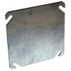 4”x 4” Junction Box Cover

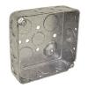 4”x 4” Junction Box

For all electrical conduits on top of the booth we need the conduit to terminate in a 4”x 4” junction box with cover.
Except for the one (E) that is wired to the light switch.

