OSKAR – AVANI ENVIRONMENTAL, INC.

The Column Grid Arrangement for the SDC-30x2-40 Collector
is shown below:

Reference Drawing: #SV-5000-0225-01

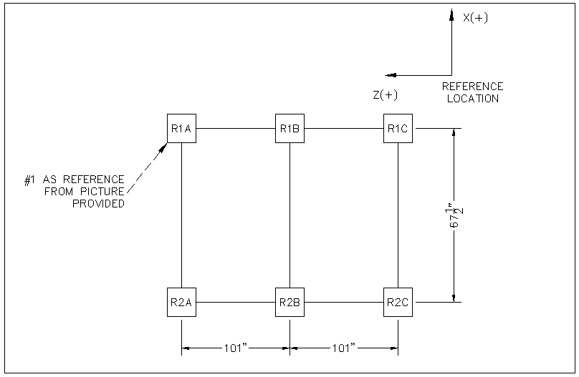

COLUMN FOUNDATION ARRANGEMENT
SDC-30x2-40 SYSTEM

***
(+) Indicates Downward (Positive) Force (Y+)
(-) Indicates Upward (Negative) Force (Y-)

Loadings (MAX & MIN ONLY)
Column |  | X (kips) | Load Case | Y (kips) | Load Case | Z (kips) | Load Case
R1A | max | 0.1 | 2 | 2.7 | 6 | 0.1 | 2
R1A | min | -0.1 | 7 | 1.5 | 7 | -0.2 | 8
R1B | max | 0.0 | 2 | 3.0 | 6 | 0.0 | 7
R1B | min | -0.2 | 7 | 1.5 | 7 | -0.1 | 4
R1C | max | 0.0 | 8 | 3.0 | 6 | 0.1 | 5
R1C | min | -0.2 | 3 | 1.1 | 7 | -0.2 | 8
R2A | max | -0.1 | 8 | 2.7 | 5 | 0.0 | 1
R2A | min | -0.3 | 3 | 0.8 | 8 | -0.3 | 4
R2B | max | 0.0 | 8 | 3.6 | 2 | 0.0 | 7
R2B | min | -0.2 | 3 | 1.6 | 8 | -0.1 | 4
R2C | max | 0.2 | 6 | 2.9 | 2 | 0.0 | 7
R2C | min | 0.0 | 7 | 1.0 | 8 | -0.3 | 4

Dead Load (LC 1)
Column | X (kips) | Y (kips) | Z (kips)
R2B | 0.0 | 3.1 | 0.0
R2C | 0.2 | 2.6 | 0.0
R1B | 0.0 | 2.5 | 0.0
R2A | -0.2 | 2.3 | 0.0
R1C | -0.1 | 2.2 | 0.0
R1A | 0.1 | 2.0 | 0.0
Totals: | 0.0 | 14.7 | 0.0

Load Cases Used
Load Cases |  | Factor |  | Factor |  | Factor
1: ASCE 1 (a) | DL | 1
2: ASCE 2 (a) | DL | 1 | LL | 1
3: ASCE 5 (b) (a) | DL | 1 | SX*SF | 0.7
4: ASCE 5 (b) (b) | DL | 1 | SZ*SF | 0.7
5: ASCE 6 (b) (a) | DL | 1 | SX*SF | 0.525 | LL | 0.75
6: ASCE 6 (b) (b) | DL | 1 | SZ*SF | 0.525 | LL | 0.75
7: ASCE 8 (a) | DL | 0.6 | SX*SF | 0.7
8: ASCE 8 (b) | DL | 0.6 | SZ*SF | 0.7
Note:
DL: Dead Load
LL: Live Load
SX: Seismic Load in X Direction
SZ: Seismic Load in Z Direction
*SF Denotes an internal Scaling Factor calculated by RISA.
**Seismic Loads calculated in accordance with ASCE 7-05 ASD (Section 2.4)
***Assumption: Site Classification D

- The maximum column compression loading is 3.6kips and occurs at column R2B.

- The maximum shear in the X direction is 0.3kips and occurs at column R2A.

- The maximum shear in the Z direction is 0.3kips and occurs at column R2A.

Note:
- These results are being provided based on the information provided and were generated using RISA-3-D Version 9.0.0 software program. Any certification of the reactions must be done by a certified Structural Engineer.

