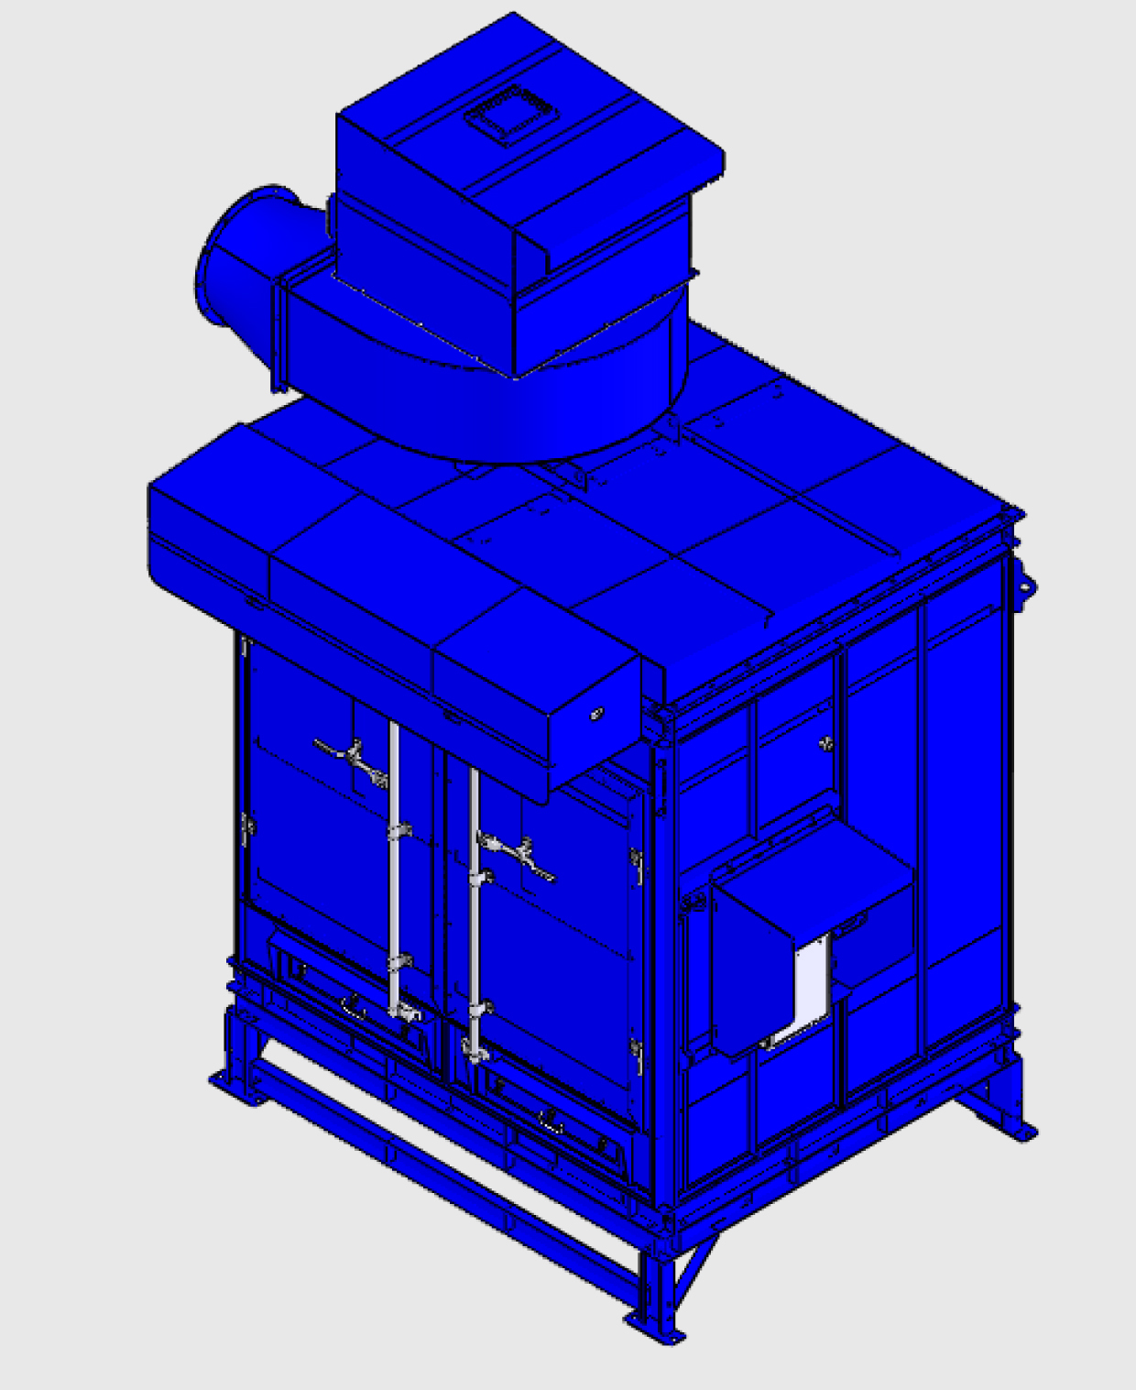
- Installations for the unit for SDC-30-16MDF.
- Take out the number: LG-L and LG-R
- Installations for the unit for SDC-30-16MDF.
- Put LG-L and LG-R on the ground.

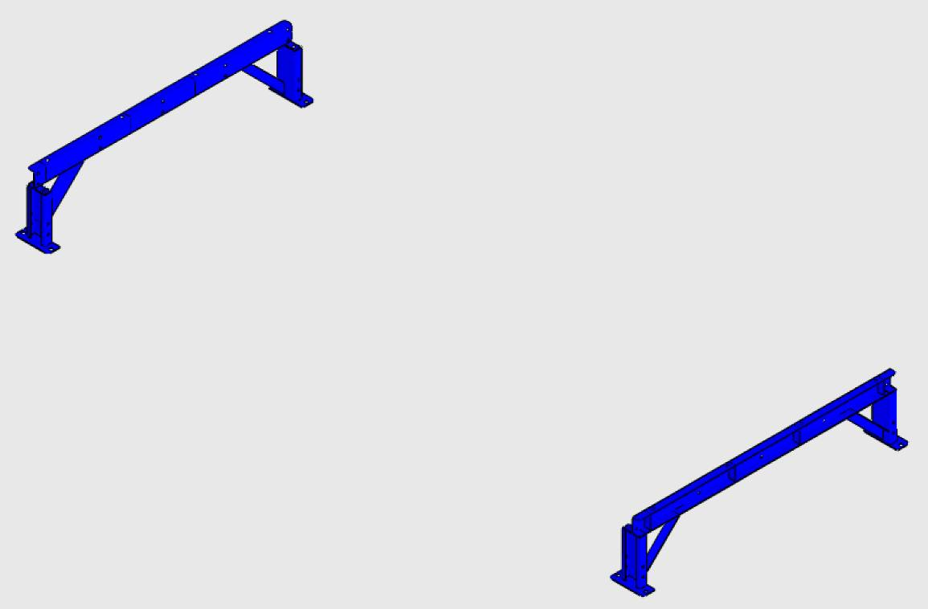
LG-L
LG-R
- Take out the number: LG-M-1 and LG-M-5.
- Installations for the unit for SDC-30-16MDF.
- Fasten LG-M-1 and LG-M-5 to LG-L and LG-R with:
Hardware 8
Part name | Description | Photo | Q’ty | Grainger  Model #
Hex Screw | 1/2” x 1” | 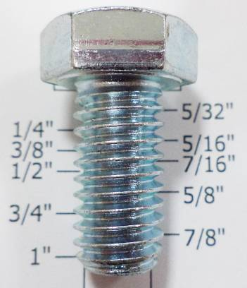 | 12 | 1YU61
Flat Washer | 1/2” x OD25 x 2T | 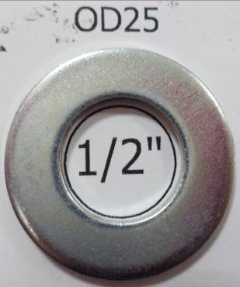 | 24 | *1JY35
Hex Nut | 1/2” | 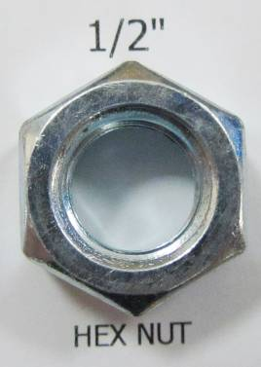 | 12 | 2FE67
(*) Hardware item at similar spec available locally.

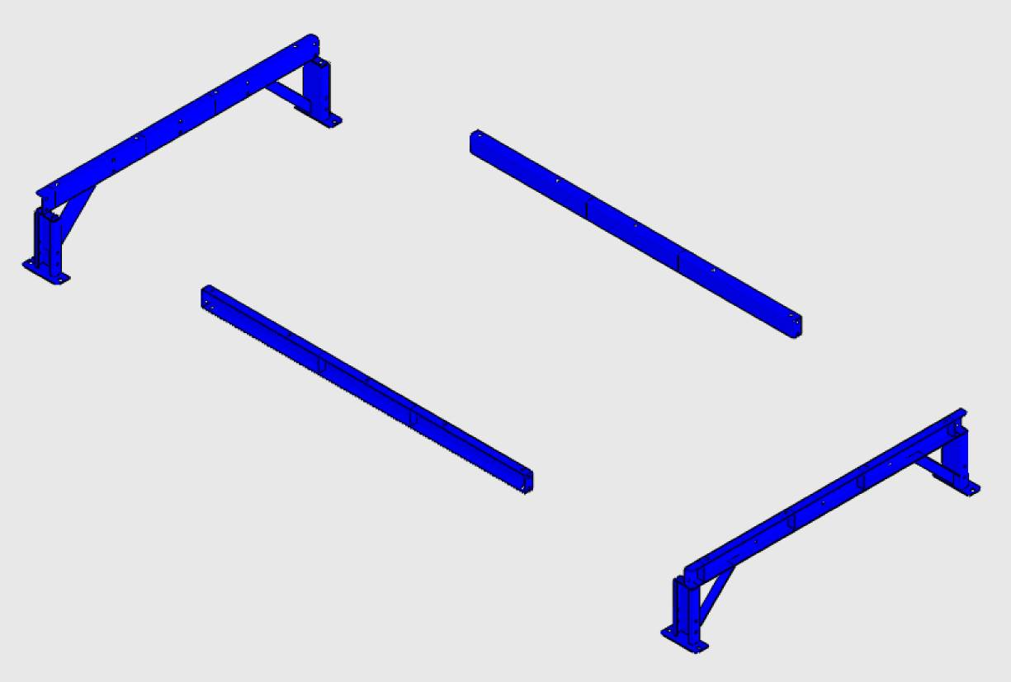
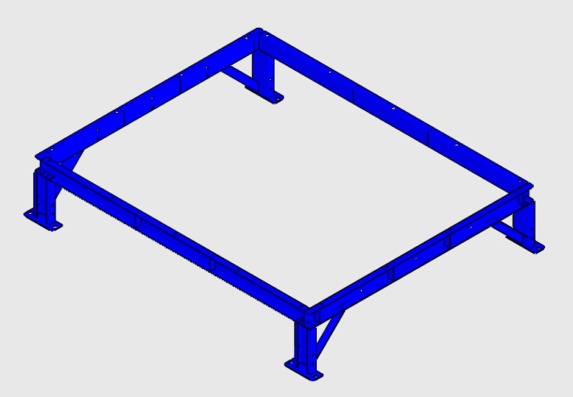
- Installations for the unit for SDC-30-16MDF.
LG-L
LG-R
LG-M-1
LG-M-5
LG-L
LG-R
LG-M-1
LG-M-5
- Take out the number: LG-M-2, LG-M-3 and LG-M-4.
- Installations for the unit for SDC-30-16MDF.
- Fasten LG-M-2, LG-M-3 and LG-M-4 to LG-L and LG-R with:
Hardware 8
Part name | Description | Photo | Q’ty | Grainger  Model #
Hex Screw | 1/2” x 1” |  | 12 | 1YU61
Flat Washer | 1/2” x OD25 x 2T |  | 24 | *1JY35
Hex Nut | 1/2” |  | 12 | 2FE67
(*) Hardware item at similar spec available locally.

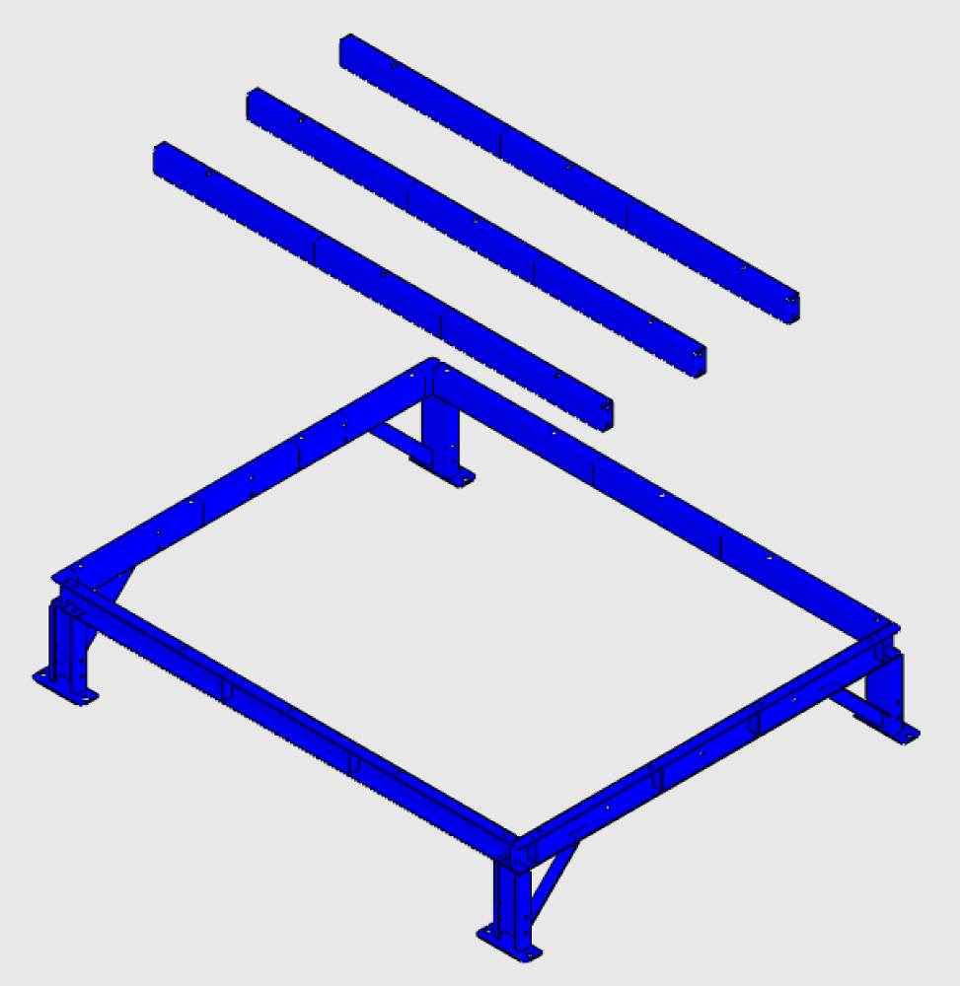
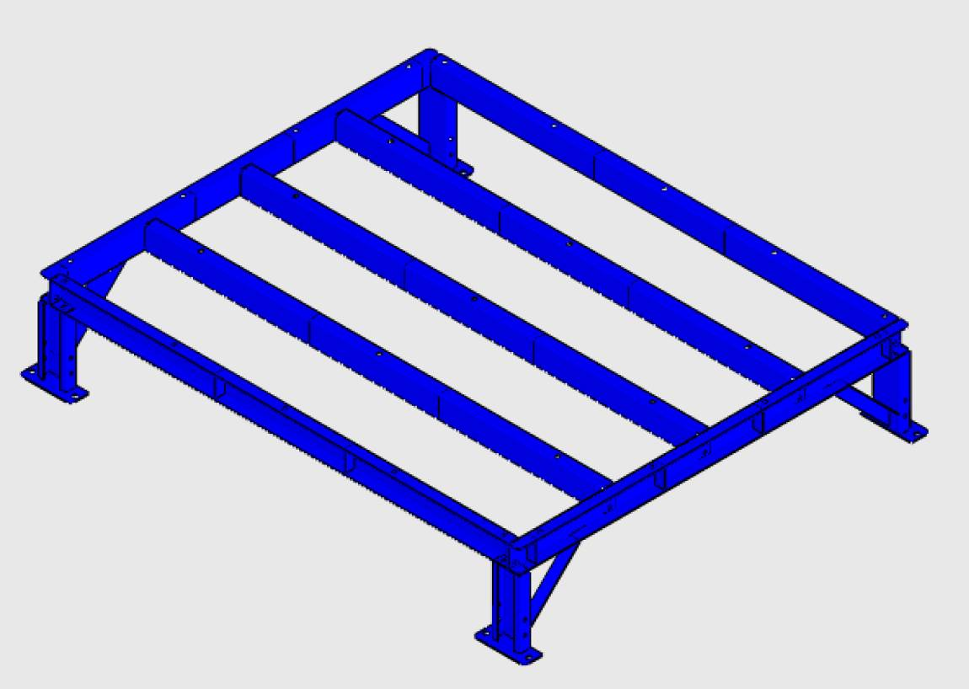
- Installations for the unit for SDC-30-16MDF.
LG-L
LG-R
LG-M-2
LG-M-5
LG-M-1
LG-M-4
LG-M-3
LG-L
LG-R
LG-M-2
LG-M-5
LG-M-1
LG-M-3
LG-M-4
- Take out the number: LG-MD-1 and LG-MD-2.
- Installations for the unit for SDC-30-16MDF.
- Fasten LG-MD-1 and LG-MD-2 to LG-L and LG-R with:
Hardware 8
Part name | Description | Photo | Q’ty | Grainger  Model #
Hex Screw | 1/2” x 1” |  | 8 | 1YU61
Flat Washer | 1/2” x OD25 x 2T |  | 16 | *1JY35
Hex Nut | 1/2” |  | 8 | 2FE67
(*) Hardware item at similar spec available locally.

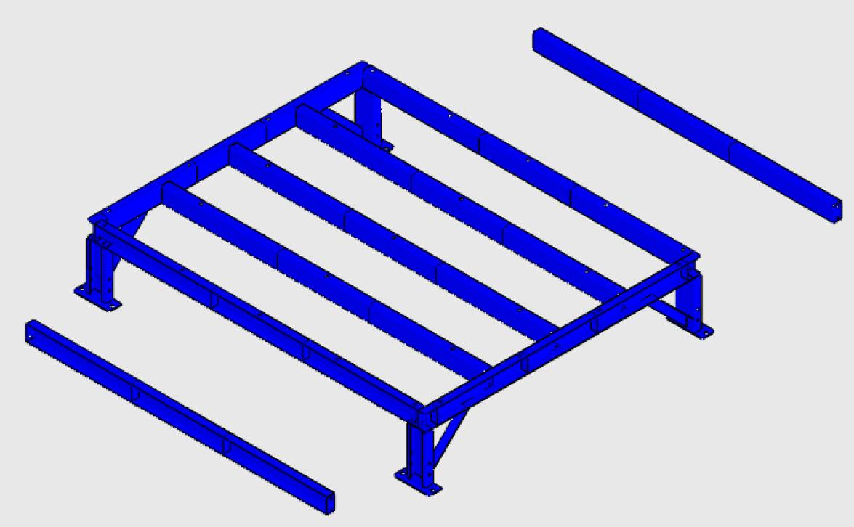
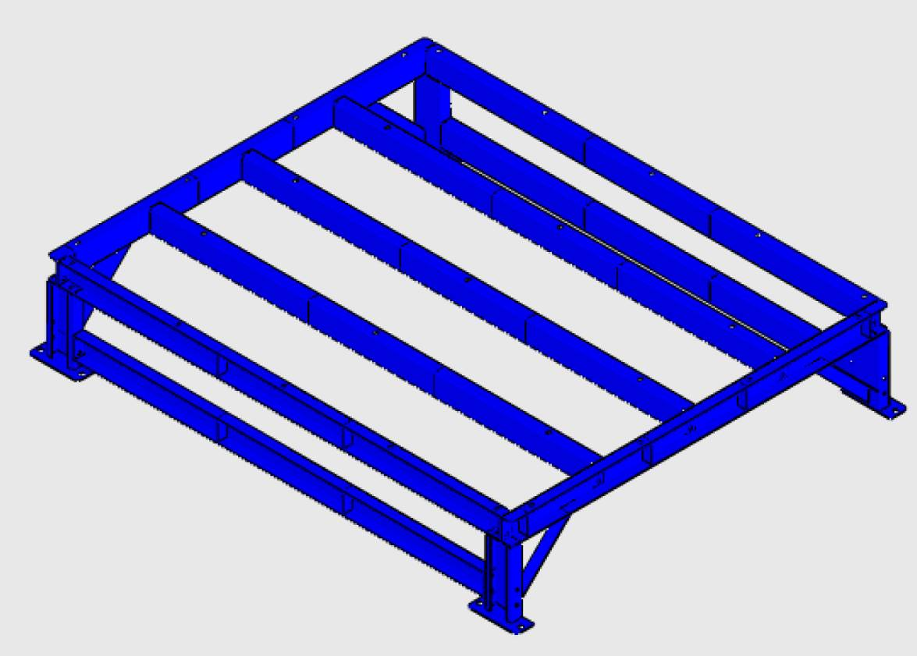
- Installations for the unit for SDC-30-16MDF.
LG-L
LG-R
LG-MD-2
LG-MD-1
LG-L
LG-R
LG-MD-2
LG-MD-1
- Fasten unit to LG-L, LG-M-1~5 and LG-R with:
- Installations for the unit for SDC-30-16MDF.
Hardware 9
Part name | Description | Photo | Q’ty | Grainger  Model #
Hex Screw | 3/8” x 1” | 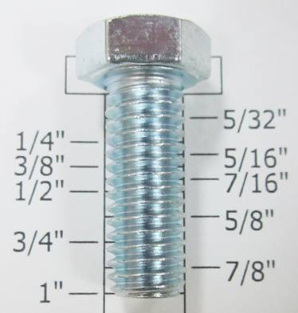 | 28 | 1YU43
Flat Washer | 3/8” x OD23 x 2T | 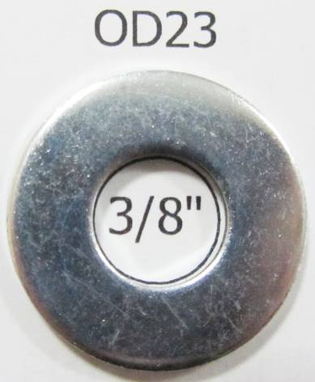 | 56 | *1JY33
Hex Nut | 3/8” | 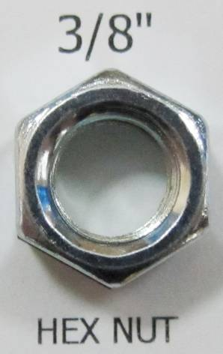 | 28 | 2FE57
(*) Hardware item at similar spec available locally.

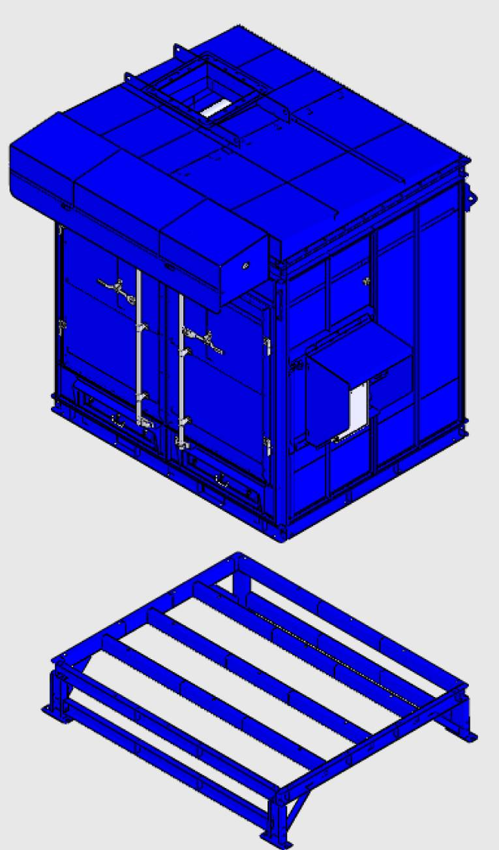
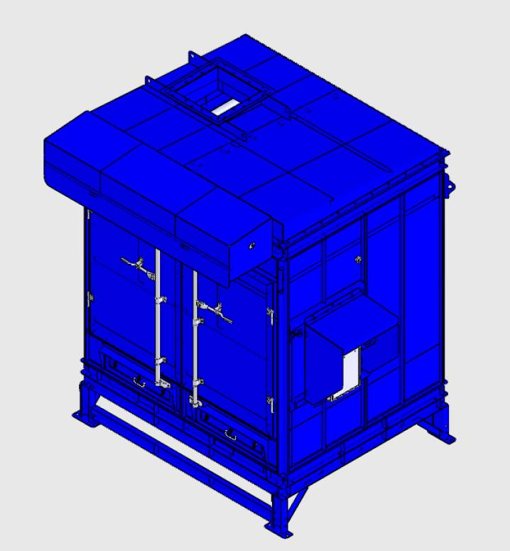
- Installations for the unit for SDC-30-16MDF.
LG-L
LG-M-1
LG-R
LG-M-2
LG-M-3
LG-M-4
LG-M-5
Unit
Unit
- Assemble Blower square to round to the Blower with:
- Installations for the unit for SDC-30-16MDF.
Hardware 2
Part name | Description | Photo | Q’ty | Grainger  Model #
Hex Screw | 3/8” x 1” | 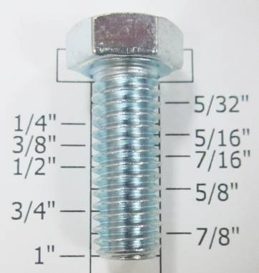 | 14 | 1YU43
Flat Washer | 3/8” x OD23 x 2T | 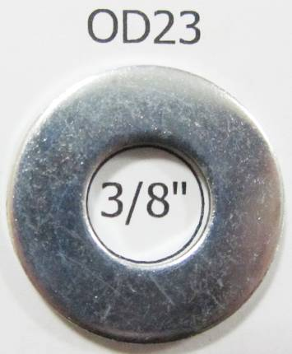 | 28 | *1JY33
Hex Nut | 3/8” |  | 14 | 2FE57
(*) Hardware item at similar spec available locally.

- Installations for the unit for SDC-30-16MDF.
Blower
Blower square to round
Blower
- Assemble blower to the base with:
- Installations for the unit for SDC-30-16MDF.
Hardware 2
Part name | Description | Photo | Q’ty | Grainger  Model #
Hex Screw | 1/2” x 1” | 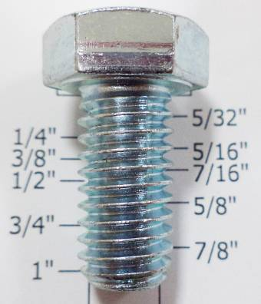 | 12 | 1YU61
Flat Washer | 1/2” x OD25 x 2T |  | 24 | *1JY35
Spilt Lock Washer | 1/2” | 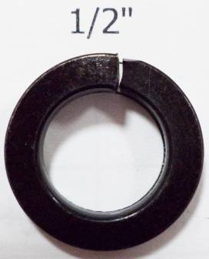 | 12 | 6FYC3
Hex Nut | 1/2” |  | 12 | 2FE67
(*) Hardware item at similar spec available locally.

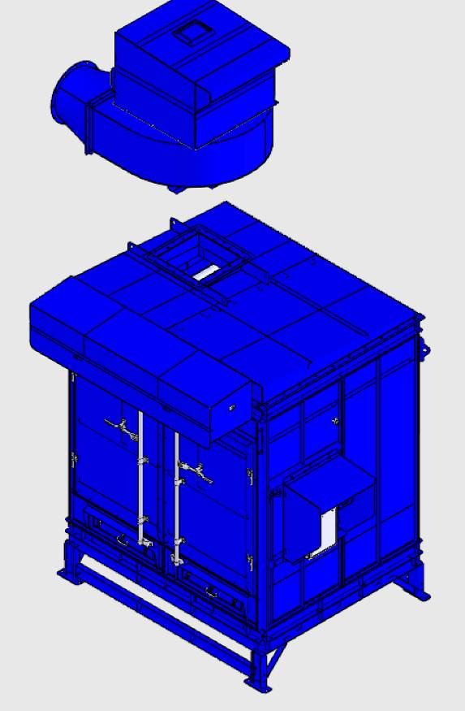
- Installations for the unit for SDC-30-16MDF.
Blower
Blower base
Blower
Blower base

