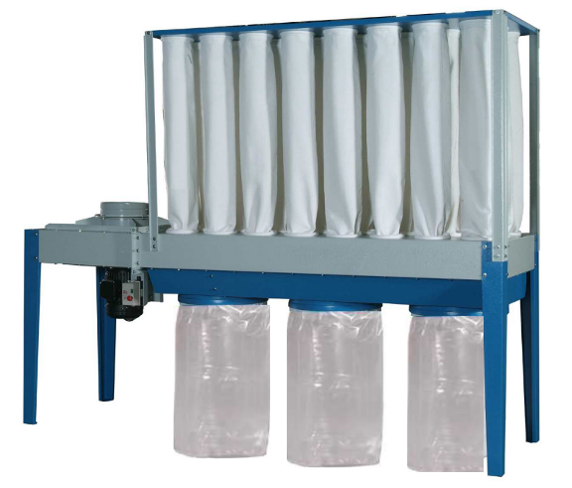

Customer:
Customer PO#:
AVANI SO#: |  | Tested By:
Serial #: | PO NO. 6894 . Serial #: 134301  PO NO. 6895 . Serial #: 134302
Ship Date / Install Date:

General Safety Information

MACHINE WARNING SIGNS
 | Indicates an imminently hazardous situation which, if not avoided, will result in death or serious injury.
 | Indicates a potentially hazardous situation which, if not avoided, could result in death or serious injury.
Indicates a potentially hazardous situation which, if not avoided, may result in minor or moderate injury.
Figure 1
Used without the safety alert symbol ( ) indicates potentially hazardous situation which, if not avoided, may result in
property damage.
 | Warning of electric shock
 | Do not expose the equipment to rain or use in damp locations.

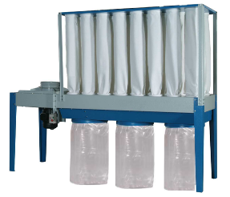
 | Do not use the equipment around flammable products, if not avoided, sparks can ignite vapors from flammable products.
 | Read and understand all warnings and operating instructions before using this equipment. Failure to follow all instructions may result in electric shock, fire, and/or serious personal injury or property damage.

TABLE OF CONTENT
MACHINE WARNING SIGNS 2
Control Panel Explanation 3
Repair Parts List 6
Technical Data for Repair Parts 17

Specifications

Motor Specs: | 10 HP | Manufacturer: | SmartVent
Electrical Specs: | 460V / 60Hz / 3Ph | Manufacturer: | SmartVent
Air Volume: | 5500 CFM (9344.5 m3/hr)
Inlet Size: | 14” x 1 hole (dia. 360 mm)
Packing Size:  (L x W x H) | 44.5” x 37.4” x 29.9” 96.5” x 41.7” x 3.9”  (113 x 95 x 76 cm) (245 x 106 x 10 cm)
N.W. (machine): | 308.6 lbs (140 kgs) 352.7 lbs (160 kgs)
G.W. (machine): | 330.7 lbs (150 kgs) 352.7 lbs (160 kgs)

Filter Area | filtering area: 19 m2 (204 ft2)
Top Filter Bag | Part# A02-01-SMT-5500-15
Plastic Collector bag | Part# A02-01-SMT-5500-65

Control Panel Explanation
Individual UL Certified Control Box

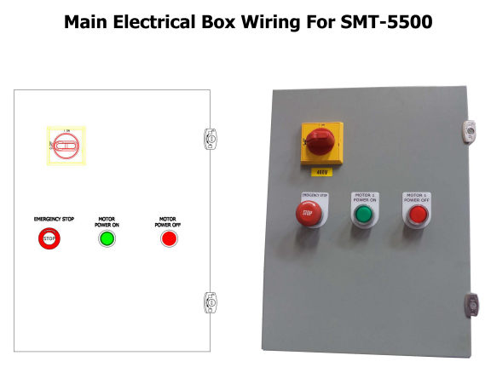

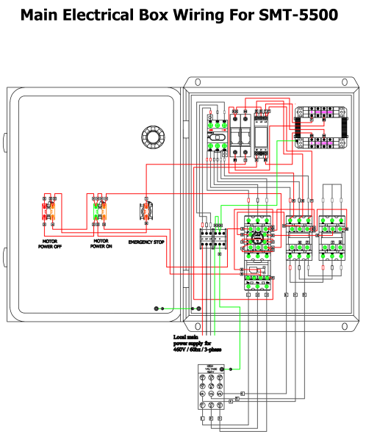

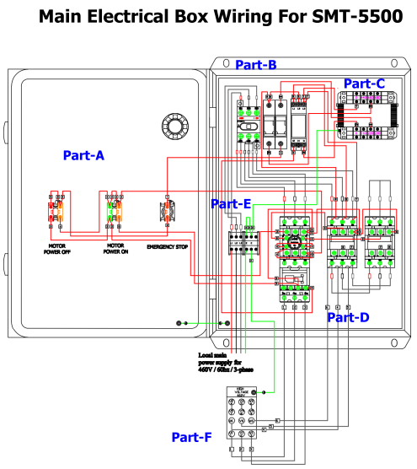

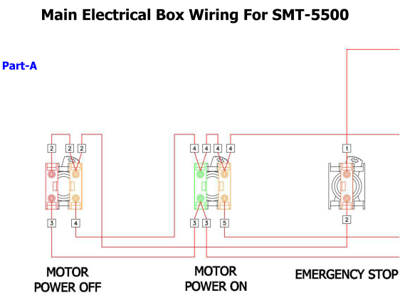

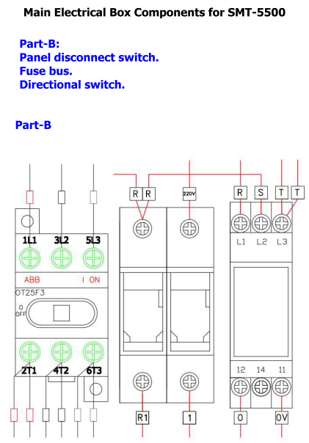
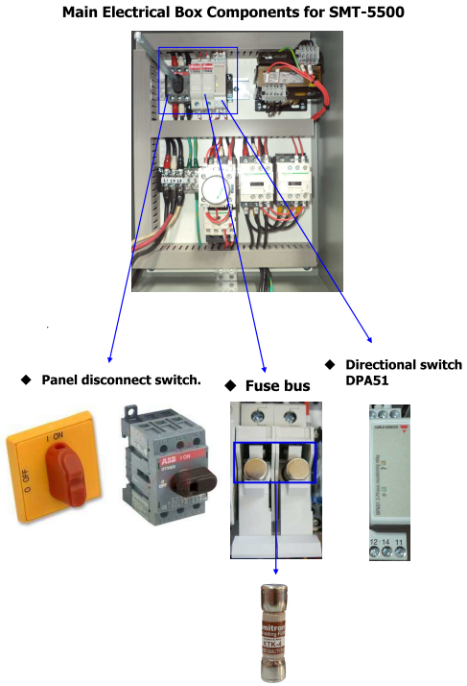
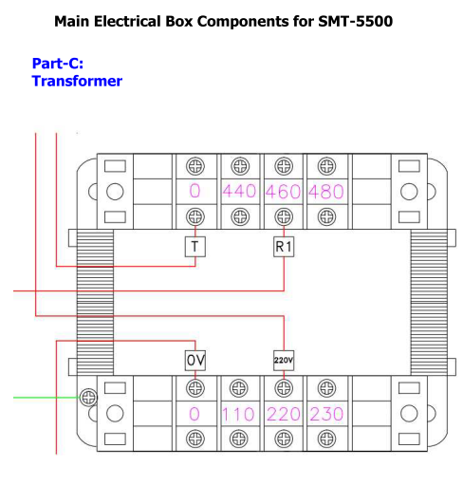
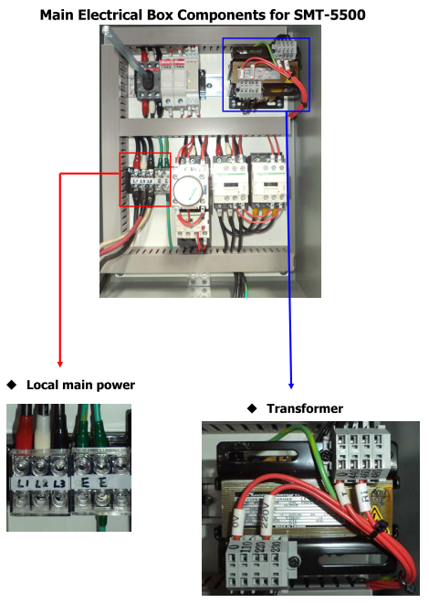
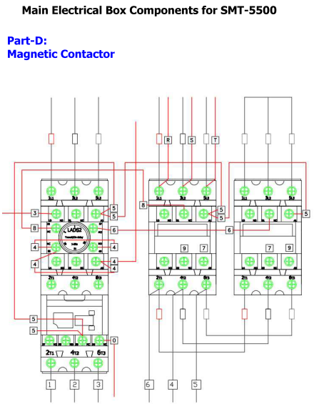
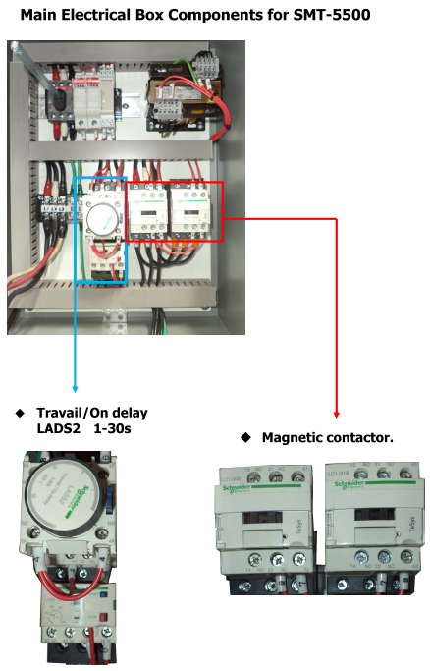
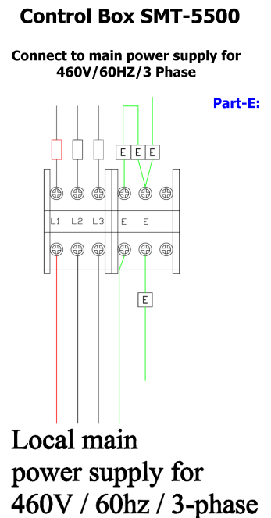
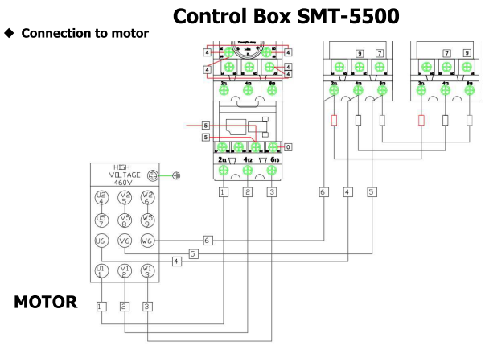

Repair Parts Illustration
For Repair Parts, call +1-919-570-2862
24 hours a day – 365 days a year
Please provide following information:
-Model number
-Serial number (if any)
-Part description and number as shown in parts list
Figure 3
Figure 3

Repair Parts List
Repair Parts List for Type I Dust Collector

Reference Number | Description | Part Number | Quantity
1 | FRAME | A02-01-SMT-5500-1 | 1
2 | HEX NUT (5/16") | A02-01-SMT-5500-2 | 2
3 | HEX HD SCREW(5/16"*3/4") | A02-01-SMT-5500-3 | 2
4 | FLAT WASHER(5/16"*OD18*2t) | A02-01-SMT-5500-4 | 4
5 | SUPPORTER-1 | A02-01-SMT-5500-5 | 2
6 | HEX HD SCREW(3/8"*1") | A02-01-SMT-5500-6 | 4
7 | FLAT WASHER(3/8"*OD23*2t) | A02-01-SMT-5500-7 | 4
8 | HEX NUT(5/16") | A02-01-SMT-5500-8 | 4
9 | FLAT WASHER(5/16"*OD18*2t) | A02-01-SMT-5500-9 | 8
10 | HEX HD SCREW(5/16"*3/4") | A02-01-SMT-5500-10 | 4
11 | SUPPORTER-2 | A02-01-SMT-5500-11 | 2
12 | HEX HD SCREW(3/8"*1") | A02-01-SMT-5500-12 | 8
13 | FLAT WASHER(3/8"*OD23*2t) | A02-01-SMT-5500-13 | 8
14 | LEG STAND-BACK | A02-01-SMT-5500-14 | 2
15 | FILTER BAG 5MICRON ψ8"*1300mm | A02-01-SMT-5500-15 | 24
16 | DUST BOX BOARD(UPPER) | A02-01-SMT-5500-16 | 1
17 | HEX HD SCREW(3/8"*1") | A02-01-SMT-5500-17 | 8
18 | FLAT WASHER(3/8"*OD23*2t) | A02-01-SMT-5500-18 | 16
19 | INLET LID (14") | A02-01-SMT-5500-19 | 1
20 | INLET(14") | A02-01-SMT-5500-20 | 1
21 | HEX HD SCREW(1/2"*3/4") | A02-01-SMT-5500-21 | 12
22 | FLAT WASHER(1/2"*OD28*3t) | A02-01-SMT-5500-22 | 12
23 | HEX NUT(3/8") | A02-01-SMT-5500-23 | 8
25 | BLOWER BOARD-A | A02-01-SMT-5500-25 | 2
26 | HEX HD SCREW(3/8"*3/4") | A02-01-SMT-5500-26 | 30
27 | FLAT WASHER(3/8"*OD23*2t) | A02-01-SMT-5500-27 | 30
28 | GASKET(3*6*10M) | A02-01-SMT-5500-28 | 1
29 | BLOWER | A02-01-SMT-5500-29 | 1
30 | BLOWER BOARD-B | A02-01-SMT-5500-30 | 1
32 | FLAT WASHER(3/8"*OD23*2t) | A02-01-SMT-5500-32 | 16
33 | HEX HD SCREW(3/8"*1") | A02-01-SMT-5500-33 | 16
34 | LEG STAND-FRONT | A02-01-SMT-5500-34 | 2
35 | SPECIAL NUT(1-1/16") | A02-01-SMT-5500-35 | 1
36 | SPECIAL WASHER  (1-1/16"*OD58*3t) | A02-01-SMT-5500-36 | 1
37 | 22" IMPELLER | A02-01-SMT-5500-37 | 1
38 | MOTER GASKET  3 x 25mm x 1.5M | A02-01-SMT-5500-38 | 1
39 | FLAT WASHER(5/8"*OD40*2.5t) | A02-01-SMT-5500-39 | 4
40 | SPRING WASHER (5/8") | A02-01-SMT-5500-40 | 4
41 | HEX NUT (5/8") | A02-01-SMT-5500-41 | 4
42 | HEX HD SCREW(1/2"*1-3/4") | A02-01-SMT-5500-42 | 4
43 | 10HP MOTOR | A02-01-SMT-5500-43 | 1
44 | FLAT WASHER(1/2"*OD34*2.5t) | A02-01-SMT-5500-44 | 8
45 | SPRING WASHER(1/2") | A02-01-SMT-5500-45 | 4
46 | HEX NUT(1/2") | A02-01-SMT-5500-46 | 4
47 | HEX HD SCREW(3/8"*3/4") | A02-01-SMT-5500-47 | 15
48 | FLAT WASHER(3/8"*OD23*2t) | A02-01-SMT-5500-48 | 30
49 | LOCK NUT(3/8") | A02-01-SMT-5500-49 | 15
51 | FLANGE | A02-01-SMT-5500-51 | 1
52 | HEX HD SCREW(3/8"*1") | A02-01-SMT-5500-52 | 16
53 | FLAT WASHER(3/8"*OD23*2t) | A02-01-SMT-5500-53 | 32
54 | LOCK NUT(3/8") | A02-01-SMT-5500-54 | 16
55 | DEFLECTOR-BACK | A02-01-SMT-5500-55 | 1
56 | DUST BOX BOARD(LOWER) | A02-01-SMT-5500-56 | 1
57 | HEX HD SCREW(3/8"*3/4") | A02-01-SMT-5500-57 | 4
58 | HEX NUT(3/8") | A02-01-SMT-5500-58 | 4
59 | FLAT WASHER(3/8"*OD23*2t) | A02-01-SMT-5500-59 | 8
60 | DEFLECTOR-FRONT | A02-01-SMT-5500-60 | 1
61 | HEX NUT(3/8") | A02-01-SMT-5500-61 | 13
62 | FLAT WASHER(3/8"*OD23*2t) | A02-01-SMT-5500-62 | 26
63 | HEX HD SCREW(3/8"*1") | A02-01-SMT-5500-63 | 13
64 | FLAT WASHER(5/16"*OD23*2t) | A02-01-SMT-5500-64 | 29
65 | PLASTIC COLLECTOR BAG  (ψ610x1.3M) | A02-01-SMT-5500-65 | 29
66 | LOCK NUT(3/8") | A02-01-SMT-5500-66 | 3
67 | FLAT WASHER(3/8"*OD23*2t) | A02-01-SMT-5500-67 | 9
68 | HEX HD SCREW(3/8"*1") | A02-01-SMT-5500-68 | 9
69 | BAG CLAMP(ψ600) | A02-01-SMT-5500-69 | 3

Contact Information

Avani Environmental Intl. Inc.
95 Cypress Drive,
Youngsville, NC 27596
Email: info@avanienvironmental.com
www.avanienvironmental.com

Customer Service: info@avanienvironmental.com
Tel: 919-570-2862 ext. 5167

Engineering Service: engineering@avanienvironmental.com
Tel: 919-570-2862 ext. 5162

