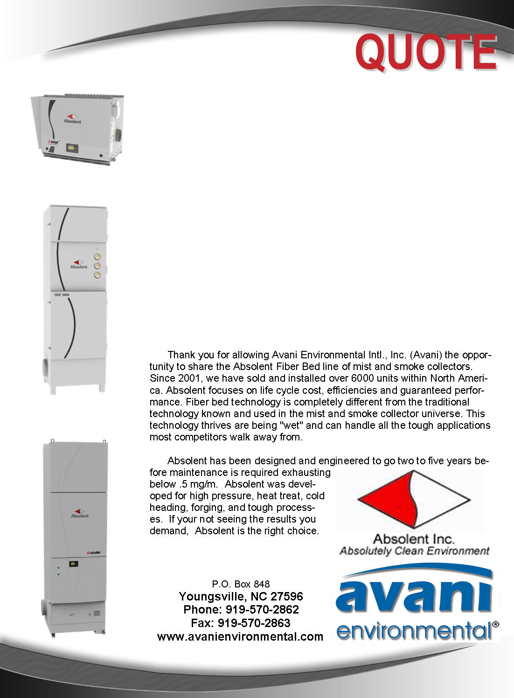

Avani Environmental Intl., Inc. ®
P.O. Box 848
Youngsville, NC 27596
Phone: 919-570-2862 Fax: 919-570-2863

Quote #: AE-009640-01 September 2, 2014
Quote by: Ed Sithes
Richard King

Attn: David Alvarez
david_alvarez2@fmi.com

Freeport - McMoran
897 Hawkins Blvd.
El Paso, Texas 79915

Dear David,

Please review quote below with items detailed in your set of specifications:

Product Name | Product Description | Product Picture | Quantity | Unit Price | Total Price
AB-A Smoke 40B (Basic)  Mill Machines (4)  Pinch Rolls  Shear  Milling Heads | Continuous duty coalescing fiber bed smoke & mist collection system c/w 10HP direct drive centrifugal fan, sound attenuated fan chamber, filtration includes coalescing fiber bed filter stage one, coalescing fiber bed filter stage two, final HEPA safety filter, digital differential pressure gauge, hinged access doors, inlet plenum w/mounting legs & sloped bottom, FPT drain outlet, fabricated with heavy-gauge steel, robotically welded and finished with a durable powder coat paint finish RAL 7035. Performance rated for 2,350CFM @ maximum saturation. Additional specifications are attached | 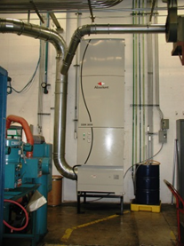 | 4 | $21,200.00 | $84,800.00
VFD System | Disconnect at every unit wired into VFD (Variable Frequency Drive) with SOG start with control panel enclosure with Lock out Tag Out fuseable disconnect. | 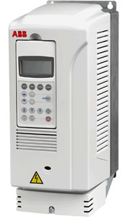 | 1 | $6,500.00 | $6,500.00
Floor Stand | Absolent A-Smoke40 Floor Stand | 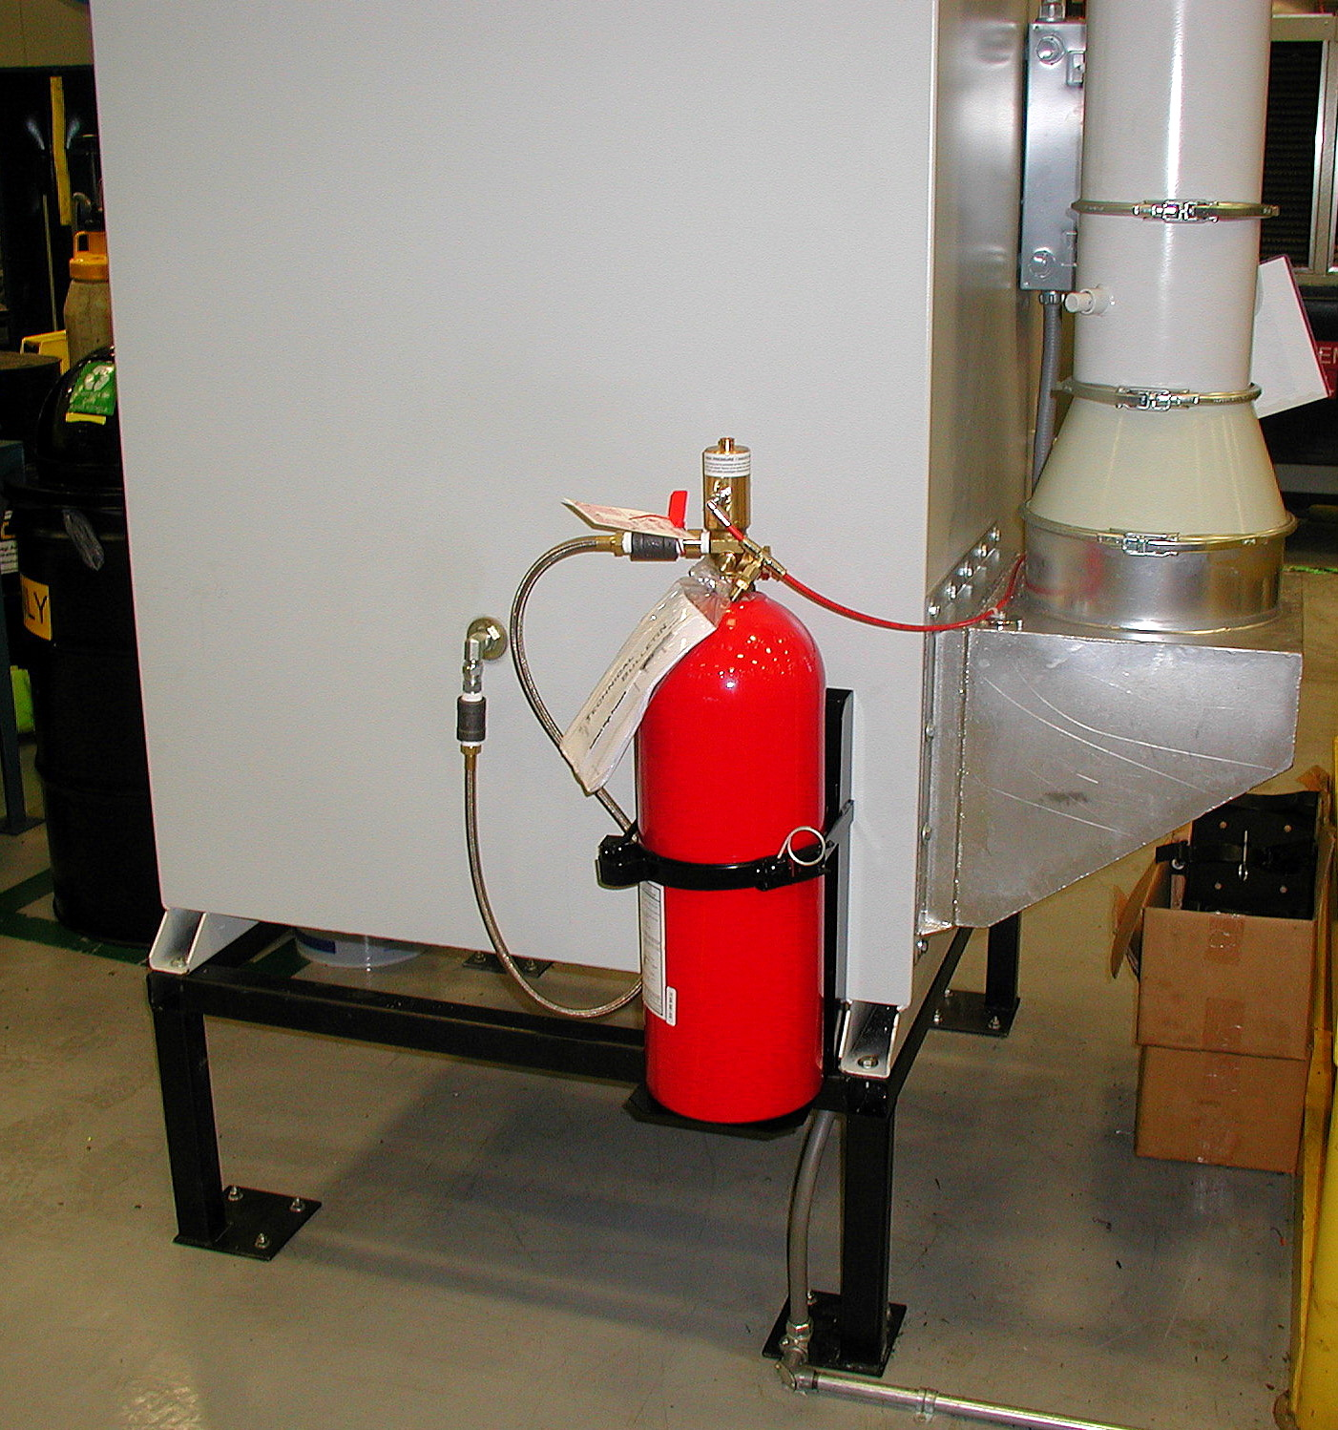 | 4 | $880.00 | $3,520.00
BM-8010  (1) Full Boom Extensions | Extension Boom: 8"dia x 10' long. Entire boom is constructed from heavy gauge steel and powder coated. Boom comes complete with a 3' high base with wall mounted hooks, 8"dia outlet, flexible pipe and hose (attached to top side of boom), 8"dia fume arm bracket, reinforced support and section connection for longer boom options.  ***Boom length does not include base length, average base length is 2 feet*** | 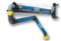 | 1 | $2,973.00 | $2,973.00
ARM-2030 | 8"dia x 10' Fume Arm (internal structure) Standing/Portable |  | 1 | $1,144.00 | $1,144.00
Custom Fume Arm Aluminum Slotted Hood | Avani Custom Fume Arm Hood  - 6” x 40” Overall Dimensions  - 3.5” x 36” Fume Arm Slot  - 8” connection |  | 1 | $380.00 | $380.00
Ducting | Pre-fabricated galvanized ductwork complete with straight duct sections, adjustable sleeves, clamps with gaskets, branch transitions, elbows, bends, adapters, inline volume control dampers (as required), flexible hose & clamps (where required), mounting Gripple® hangers, and related accessories. | 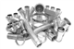 | 1 | $11,500.00 | $11,500.00
Duct Mounting Hardware | Includes plenums, gripple, and duct stands. | 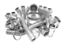 | 1 | $4,170.00 | $4,170.00
Avani  Installation | Mechanical installation to assemble and mount collection equipment, pre-fabricated ductwork, suspension hardware, and related assembly services to complete basic installation. Mechanical Contractor to do cut outs in milling machines and reinforce stands. Scissor Lift rental  Exclusions: electrical wiring, compressed air piping or drain plumbing (as required), concrete pad supply & installation (where required), utility upgrades where required by others, offloading or storage, permits (where required), final roof sealant or wall flashing (where required), and services outside of scope shall be supplied by customer or others |  | 1 | $18,000.00 | $18,000.00
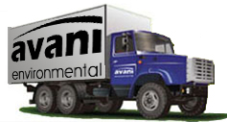 | Freight and transportation charges are additional and not included with our costs; FOB mfg. facility to the job site. |  |  | Grand Total: | $132,987.00

Sincerely,
Ed Sithes
President
Avani Environmental intl
Email: esithes@avanienvironmental.com
Phone: (919) 488-5191
Websites:
www.avanienvironmental.com
www.weldingbooths.com
www.miststop.com
Service-Disabled Veteran-Owned Small Business (SDVOSB)

Terms and Conditions

General:
- The price does not include sales tax, duties, custom fees or any other cost associated with the sale or delivery of this product.
- Payment Terms: 35% down/ 35% upon shipment/ 30 net 30All quoted prices and payments are in US dollars.
- Quotation price does not include actual shipping costs. All products are shipped FOB from manufacturer. If requested by Buyer, Avani can supply an estimated shipping cost(s). The estimated shipping cost is only an estimate and actual charges can be different from estimated charges.
- Late payments and any charges associated with the Late payment begin incurring charges 30 days after standard payment terms are due.
- Avani Environmental standard installation crew is quoted out per day based on the above drawings and approvals. Any changes, modifications, downtime, or inability to perform our work above and beyond the control of Avani Environmental will charge an additional $1,000 per work day (5 or more hours) per crew above what was initially quoted.

Shipping and Delivery Time:
- All products are FOB Manufacturer
- Shipping times: Stock items – 1 week, Non-stock items –8-12 weeks, Customized products –12-16 weeks. If deposits and/or signed drawings are required for specific job; shipping time begins after Avani has received these items. These times are estimates only and may be revised at any time.
- Unless otherwise stated on the purchase order Avani will ship Best Way Prepay and Add.
- All products that are shipped via Truck will be shipped with standard pallets and shipping material. If needed or requested by the buyer the product(s) can be completely crated for an additional cost.
- The Buyer is responsible for inspecting the Product(s) immediately when they are delivered and must state upon delivery if the Product(s) is damaged or has missing parts. If not, the Product(s) are acknowledged as being complete and satisfactory.

Warranty and Return:
- All New Products come with a standard 1 year warranty. Other warranties and terms are available and must be approved by an Avani personnel.
  - Warranty covers replacement parts for 1 year.
  - Does not cover labor or charges incurred for removing and installing new parts.
  - Not responsible for loss of use or downtime.
- Returns product(s) must be approved by Avani before being sent back.
  - Must have an RGA and Case # when the product(s) is shipped back.

