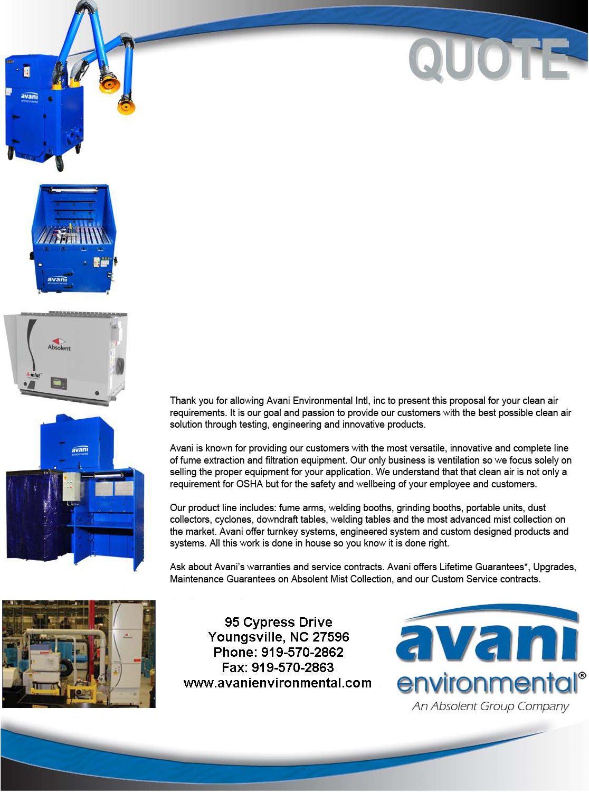

Avani Environmental Intl., Inc.®
95 Cypress Drive
Youngsville, NC 27596
Phone: 919-570-2862 Fax: 919-570-2863

Quote #: AE-013281 July 22, 2015
Quote by: Ed Sithes

Attn: Marc Lehmann

LTA Luftiechnik GmbH
JunkerstraBe
77787 Nordrach

Dear Marc,

The quote below is for the four lines per the new drawings and specifications. Each line will have duct hangers, threaded rod and seismic rated cables connected per the drawing. The first quote included no hardware except for gripples, while this quote includes all the hardware that includes the correct seismic cables and bracing. Per our meeting, we made a comment that the installation price would come down and as you can see, is about $100K less in total.

Please review quote below with items detailed in your set of specifications:

Product Name | Product Description | Product Picture | Quantity | Unit Price | Total Price
Scissor Lift | Dry Line – 14 Days  Grinding – 12 Days  Drilling – 14 Days  Emulsion – 14 Days  The Scissor Lift Rental is about $3,500 Per Week, so this price WILL and CAN Very. No other equipment is included and the scissor lift charges may very from this quotation. |  | 4 | $4,400.00 | $17,600.00
Dry Line | Dry Line  - Duct Hangers  - Seismic Hangers (single and doubles)  - Threaded Rod/ Hardware |  | 1 | $55,490.00 | $55,490.00
Grinding LIne | Dry Line  - Duct Hangers  - Seismic Hangers (single and doubles)  Threaded Rod/ Hardware |  | 1 | $47,325.00 | $47,325.00
Drilling Line | Dry Line  - Duct Hangers  - Seismic Hangers (single and doubles)  Threaded Rod/ Hardware |  | 1 | $56,100.00 | $56,100.00
Emulsion | Dry Line  - Duct Hangers  - Seismic Hangers (single and doubles)  Threaded Rod/ Hardware |  | 1 | $53,250.00 | $53,250.00
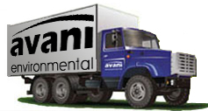 | NOT INCLUDED:  Freight and transportation charges  Customs, duties & taxes  Material handling equipment  Installation equipment (Cranes, forklift, or jig) Scissor Lifts are quoted above. |  |  | Grand Total: | $229,765.00

Additional Product Options:
Product Number | Product Description | Quantity | Unit Price

Sincerely,
Ed Sithes
Director of Sales
Avani Environmental intl
Email: esithes@avanienvironmental.com
Phone: (919) 488-5161
Websites:
www.avanienvironmental.com
www.weldingbooths.com
www.absolent.com

Avani is not responsible for the equipment, ducting and components other than quoted above. Any delays from outside vendors and sources that result in additional time and labor may result in a change order. If Avani has to pick up parts (i.e. Jacobs Tubing), will result in an additional charge.

Terms and Conditions (Per Line)

Deposit: 35% (Due with purchase order)
Progress Payment: 35% (Once the job is started)
Final Payment: Net 30 Upon Completion

