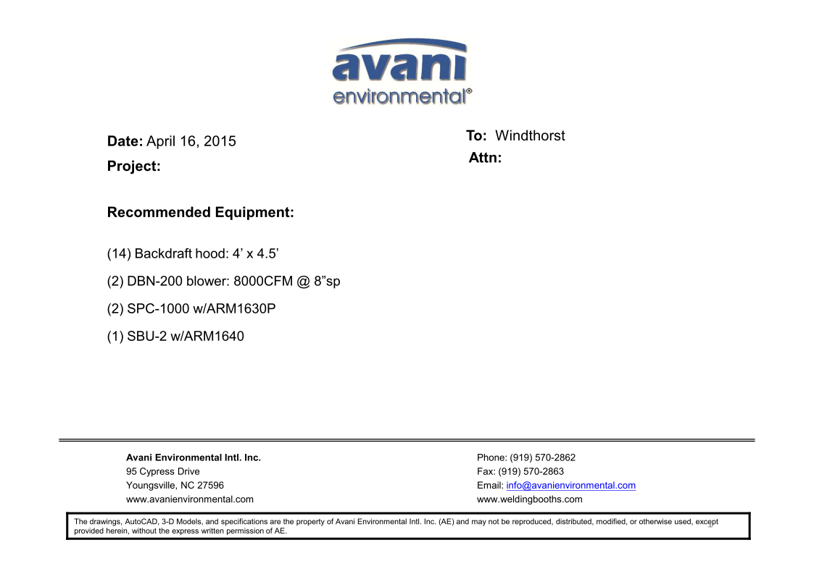

Backdraft Hood cost: US$850 x 14 = US$11,900.-

DBN-200 unit cost: US$ 3,900 x 2 = US$7,800.-

DBN-200-C unit cost: US$1,000 x 2 = US$2,000.-

Silencers for DBN-200 cost: US$350 x 2 = US$700.-

SPC-1000 unit cost: US$1,090 x 2 = US$2,180.-

ARM 1630P cost: US$353 x 2 = US$706.-

SBU-2 unit cost:US$585 x 1 = US$585.-

ARM 1640 cost: US$397 x 1 = US$397.-

**TOTAL PROJECT COST: USD26,268.-**