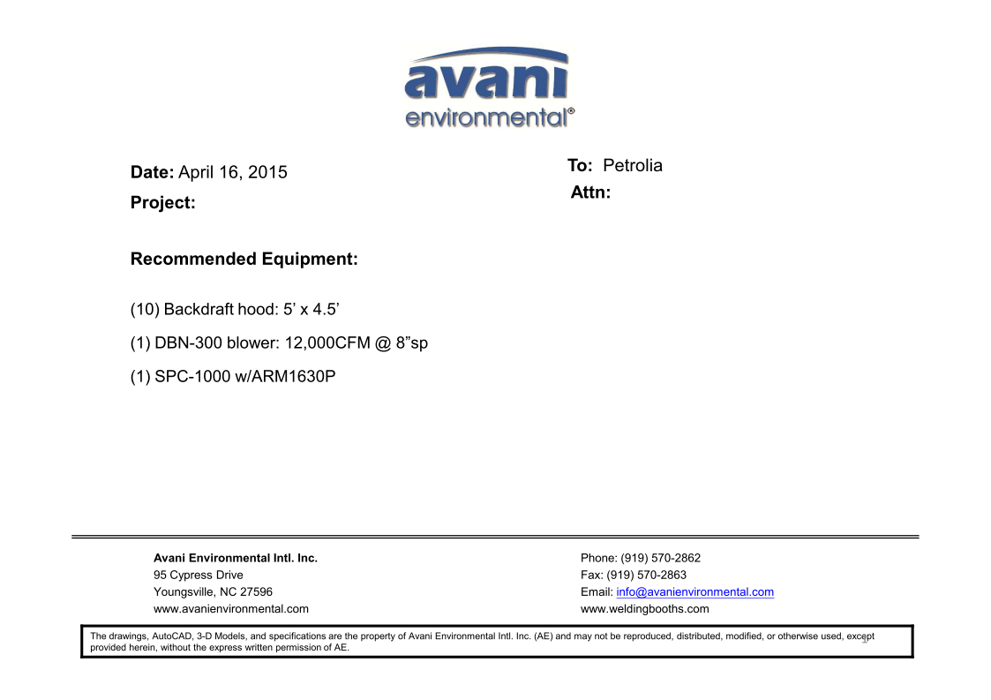

Backdraft Hood cost: US$955 x 10 = US$9,550.-

DBN-300 unit cost: US$ 5,200 x 1 = US$5,200.-

DBN-300-C unit cost: US$1,200 x 1 = US$1,200.-

Silencers for DBN-300 cost: US$370 x 1 = US$370.-

SPC-1000 unit cost: US$1,090 x 1 = US$1,090.-

ARM 1630P unit cost: US$353 x 1 = US$353.-

**TOTAL PROJECT COST: USD17,763.-**