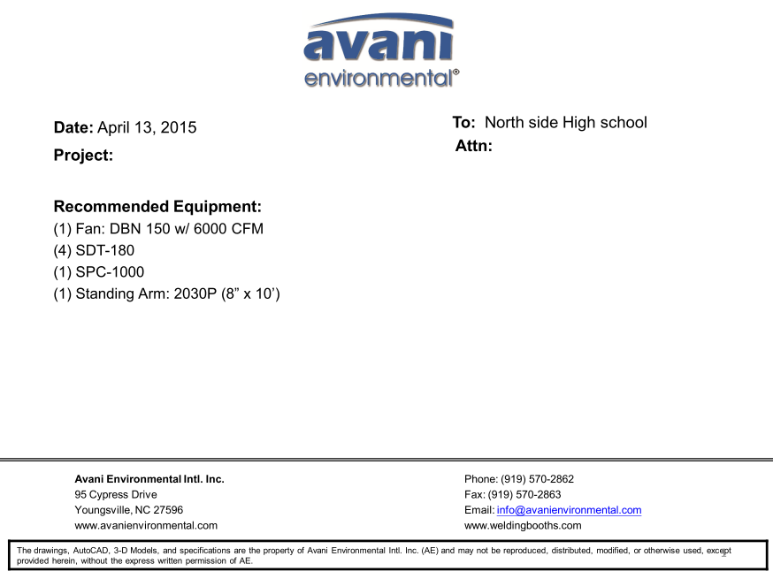

DBN-150 unit cost: US$3,400 x 1 = US$3,400.-

DBN-150-C unit cost: US$900 x 1 = US$900.-

Silencer for DBN-150 unit cost: U$350 x 1 = US$350.-

SDT-180-8 unit cost: US$700 x 4 = US$2,800.-

SPC-1000 unit cost:US$1,090 x 1 = US$1,090.-

ARM 2030P unit cost: US$458 x 1 = US$458.-

**TOTAL PROJECT COST: USD8,998.-**