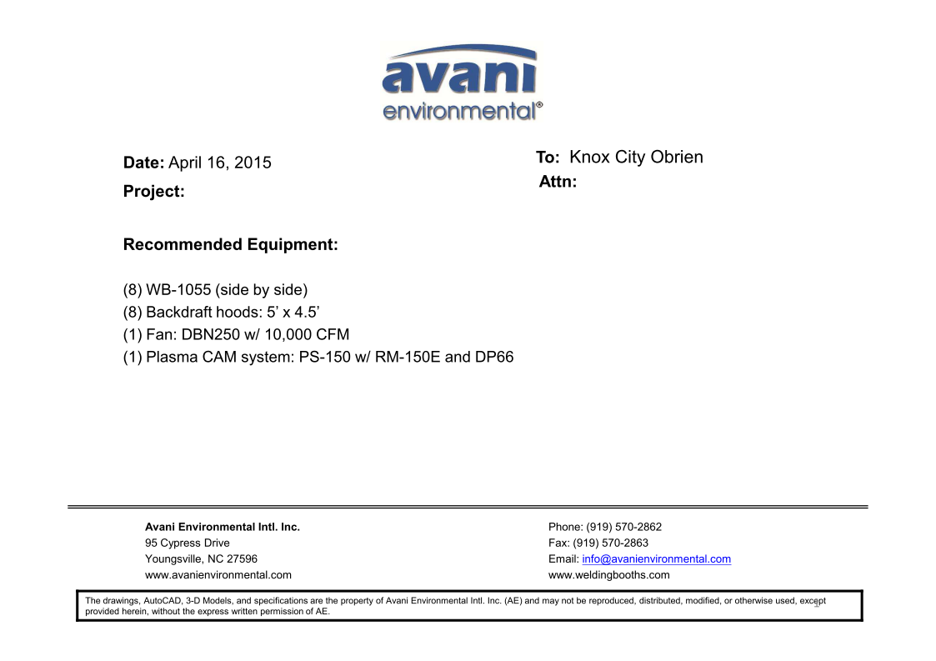

WB-1055 unit cost: US$1,225x 8= US$9,800.-

Backdraft hoods cost: US$955x 8= US$7,640.-

DBN-250 unit cost: US$ 4,300 x 1 = US$4,300.-

DBN-250-C unit cost: US$1,100 x 1 = US$1,100.-

Silencer for DBN-250 cost: US$370 x 1 = US$370.

***Plasma Cam System:***

(SPC-2000+RE-150ME + DDT-PC66) unit cost: US$2,960 x 1 = US$2,960

**TOTAL PROJECT COST: USD26,170.-**