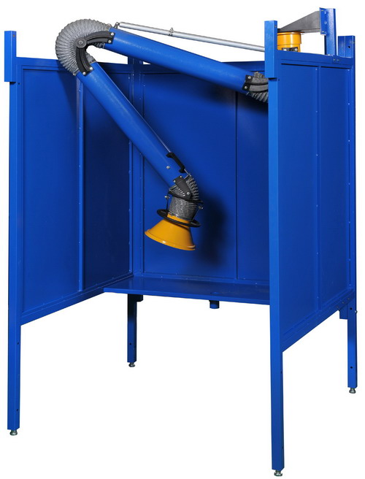

Customer:
Customer PO#:
AVANI SO#: |  | Tested By:
Serial #:
Ship Date / Install Date:

TABLE OF CONTENT
Assembly Label Configuration 4
Assembly Procedure 6
Assembly Hardware 20
Repair Parts List 21
Contact Information 22

Submittal Dimensions (in mm/inches)
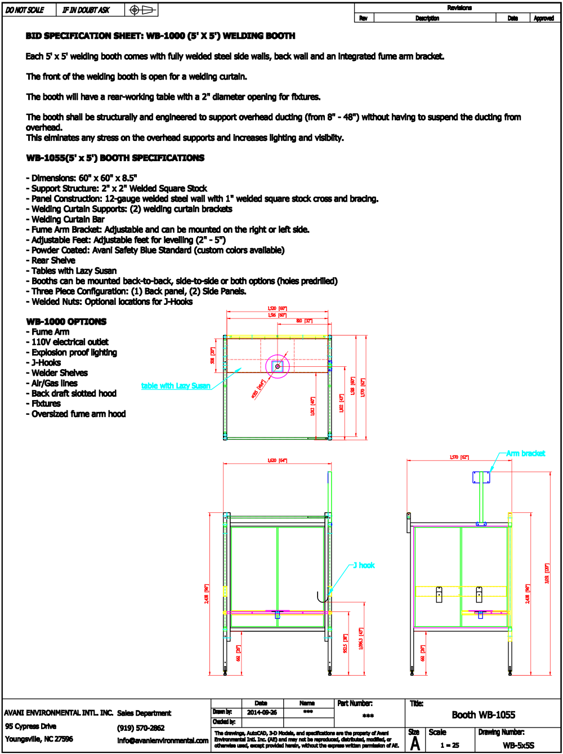

Assembly Procedure
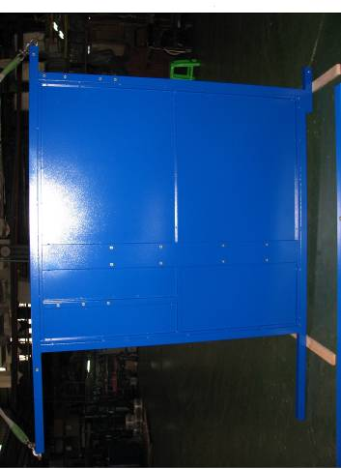
1.
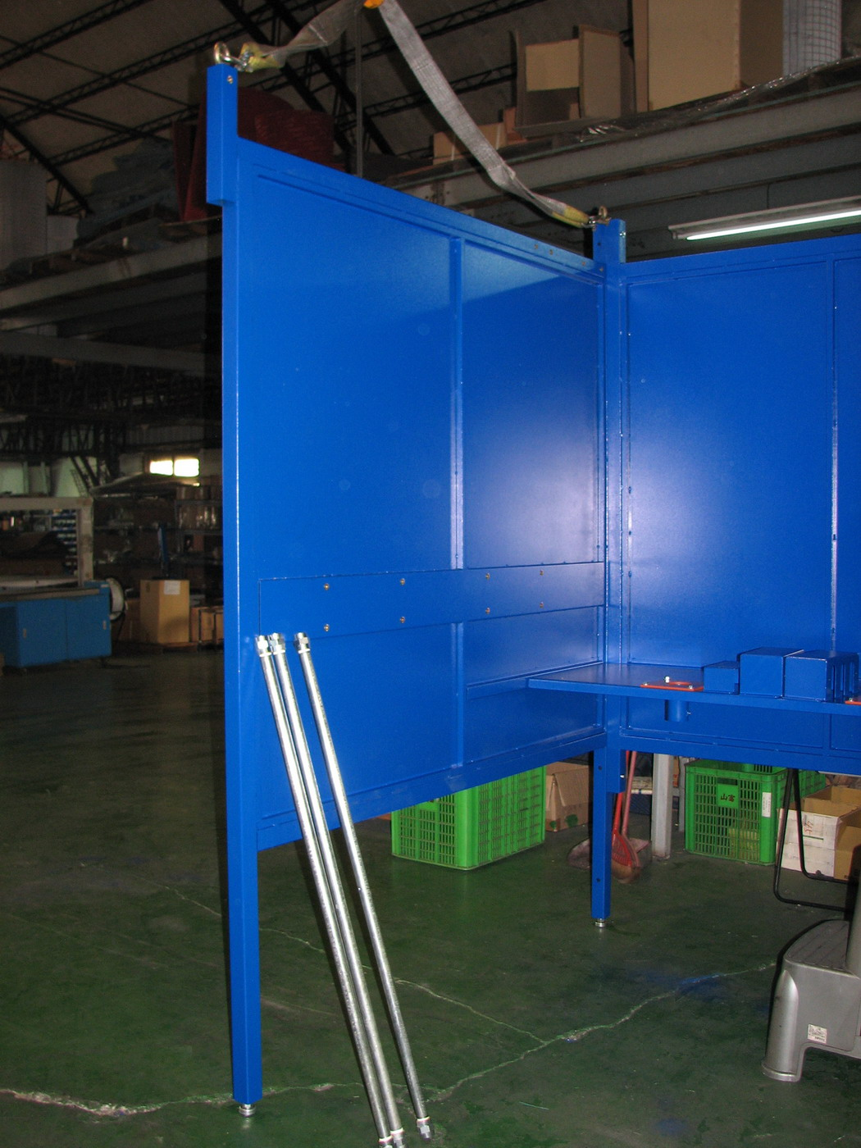
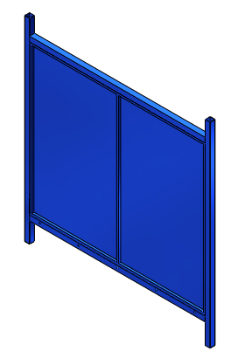2. 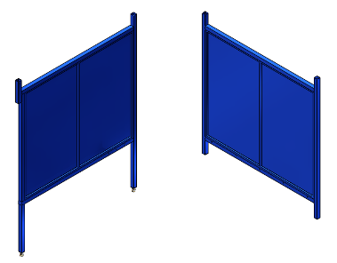
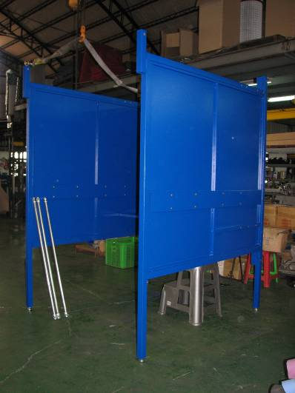

3.
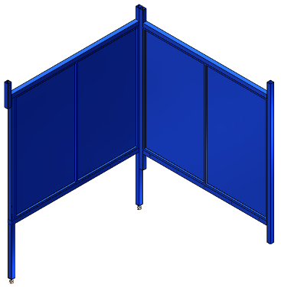
.

DO NOT FASTEN BOLTS ON BOOTH BEFORE ADJUSTING WELDING BOOTH FEET TO LEVEL OUT BOOTH WITH GROUND.
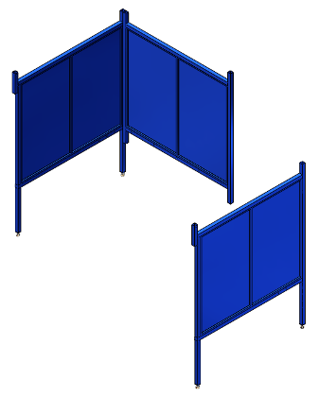
4.

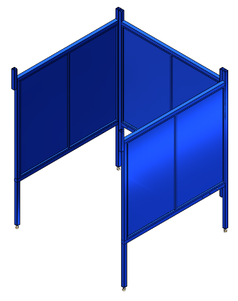

5.
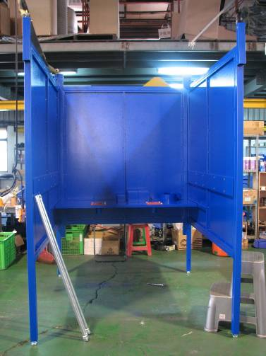
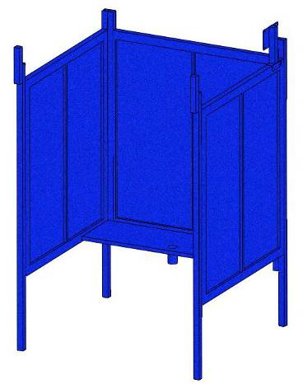
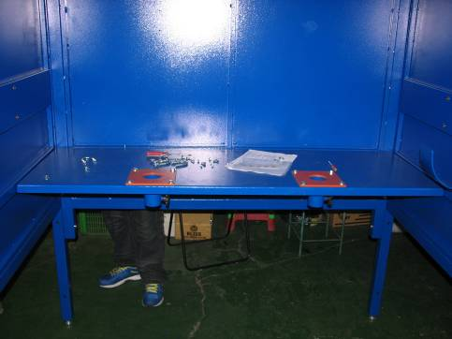
6.

7.

DO NOT FASTEN BOLTS ON BOOTH BEFORE ADJUSTING WELDING BOOTH FEET TO LEVEL OUT BOOTH WITH GROUND.

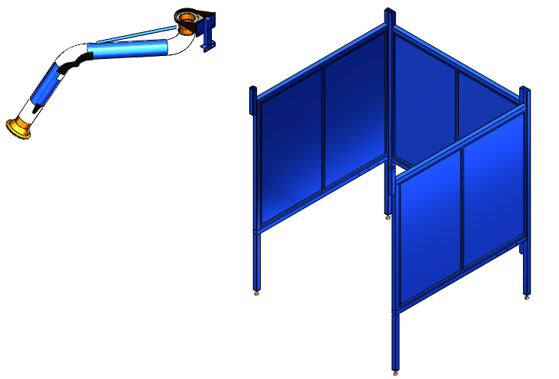
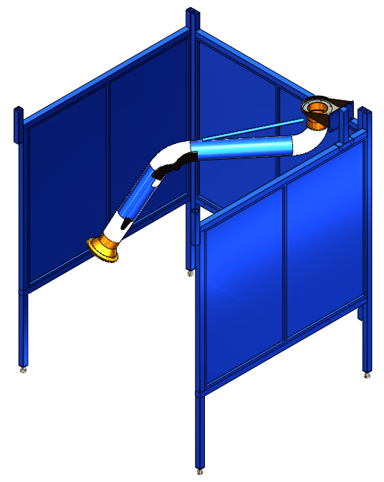

8.
- Installations for WB-1055 (booth side to side).
Take out the number: BS and BL.
- Join BS and BL together with:
Hardware B
Part name | Description | Photos | Q’ty | Grainger  Model #
Hex Screw | 5/16 x 3/4” | 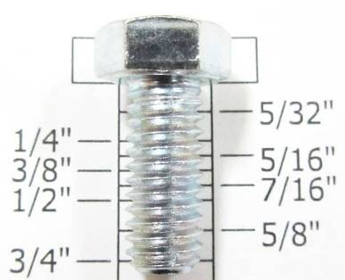 | 2 | 1YU33
Flat Washer | 5/16” x OD23 x 2T | 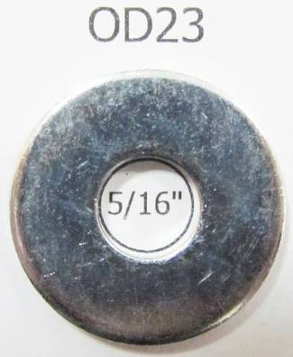 | 2 | *1JY31
(*) Hardware item at similar spec available locally.

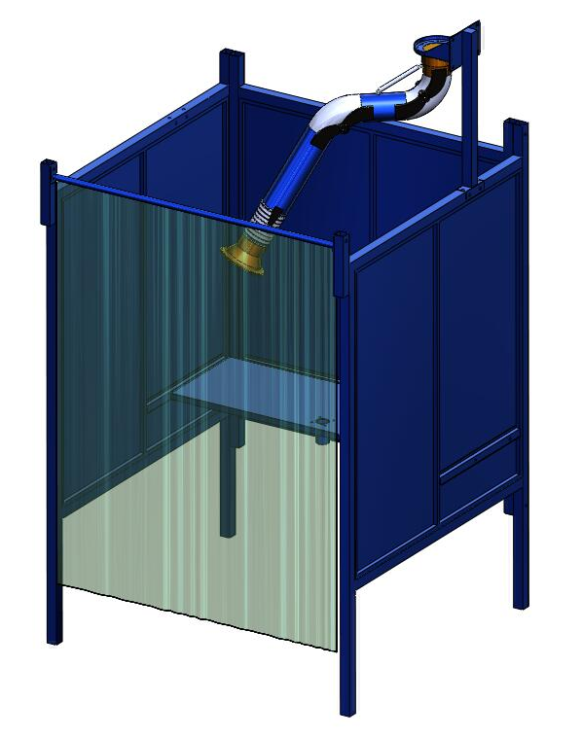
- Installations for WB-1055 (booth side to side).
BS
BL
DO NOT TIGHTEN BOLTS ON BOOTH BEFORE ADJUSTING WELDING BOOTH FEET TO LEVEL OUT BOOTH WITH GROUND.
- Installations for WB-1055 (booth side to side).
Take out the number: BP and SP.
- Join BP and SP together with:
Hardware D
Part name | Description | Photos | Q’ty | Grainger  Model #
Hex Screw | 5/16 x 3” | 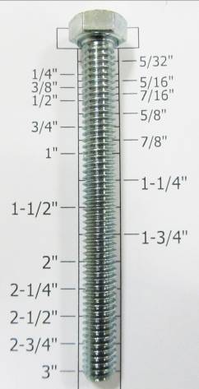 | 2 | 1YU39
Flat Washer | 5/16” x OD23 x 2T |  | 2 | *1JY31
(*) Hardware item at similar spec available locally.

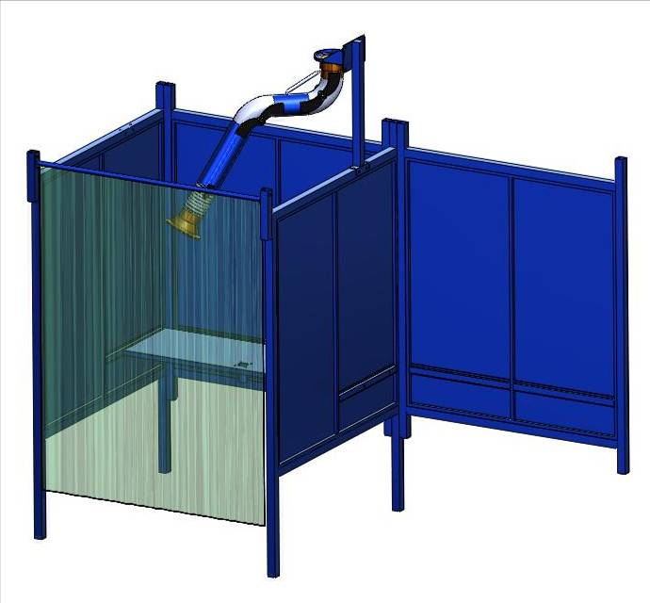
- Installations for WB-1055 (booth side to side).
SP
BP
DO NOT TIGHTEN BOLTS ON BOOTH BEFORE ADJUSTING WELDING BOOTH FEET TO LEVEL OUT BOOTH WITH GROUND.

Take out the number: TA and BP and SP.
- Installations for WB-1055 (booth side to side).
- Join TA to BP and SP together with:
Hardware C
Part name | Description | Photos | Q’ty | Grainger  Model #
Hex Screw | 5/16 x 3/4” |  | 8 | 1YU33
Flat Washer | 5/16” x OD18 x 2T | 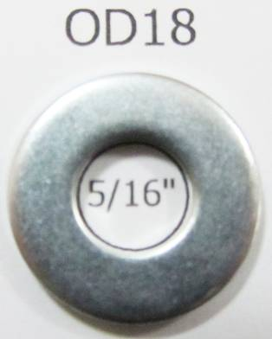 | 8 | *1JY31
(*) Hardware item at similar spec available locally.

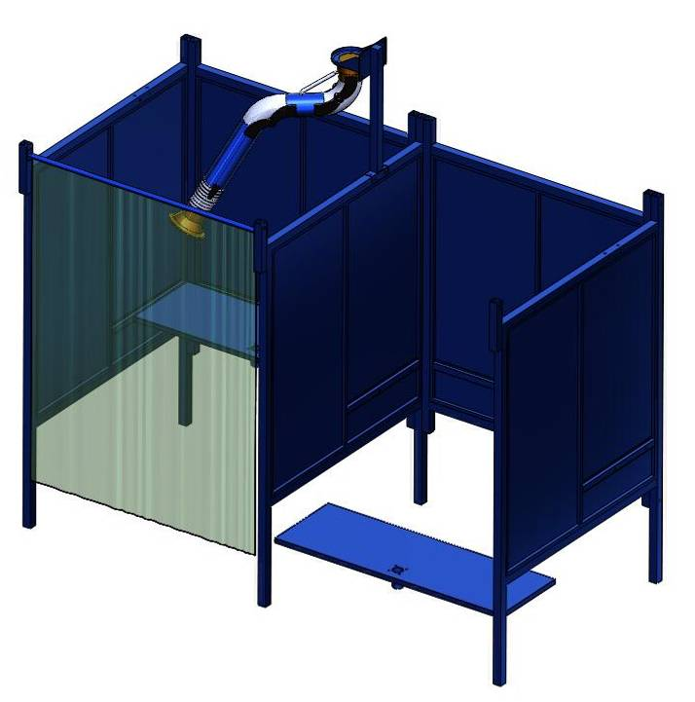
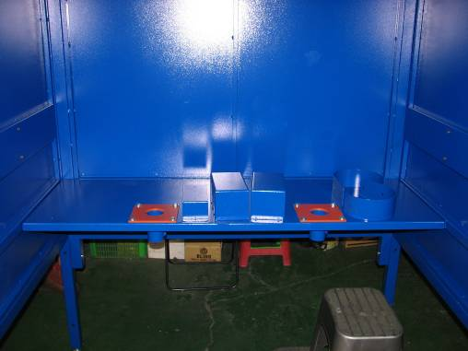
- Installations for WB-1055 (booth side to side).
SP
BP
TA
DO NOT TIGHTEN BOLTS ON BOOTH BEFORE ADJUSTING WELDING BOOTH FEET TO LEVEL OUT BOOTH WITH GROUND.

Take out the number: HOOK (2)
- Installations for WB-1055 (booth side to side).
- Join HOOK(2) to BP together with:
Hardware E
Part name | Description | Photos | Q’ty | Grainger  Model #
Hex Screw | 5/16 x 3/4” |  | 2 | 1YU33
Flat Washer | 5/16” x OD23 x 2T |  | 2 | *1JY31
(*) Hardware item at similar spec available locally.

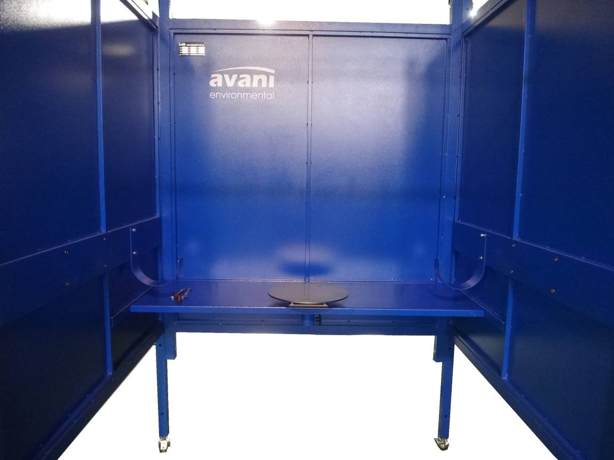
- Installations for WB-1055 (booth side to side).
BP
HOOK
DO NOT TIGHTEN BOLTS ON BOOTH BEFORE ADJUSTING WELDING BOOTH FEET TO LEVEL OUT BOOTH WITH GROUND.
BP

Take out the number: MB and BP.
- Installations for WB-1055 (booth side to side).
- Join MB to BP together with:
Hardware F
Part name | Description | Photos | Q’ty | Grainger  Model #
Hex Screw | 5/16 x 1” | 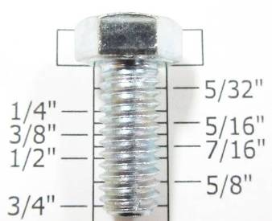 | 4 | 1YU34
Flat Washer | 5/16” x OD23 x 2T | 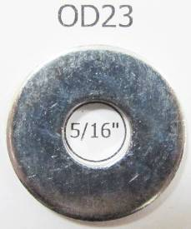 | 8 | *1JY31
Nylon Hex Nut | 5/16” | 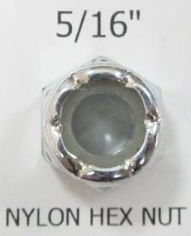 | 4 | 3XTK3
(*) Hardware item at similar spec available locally.

- Installations for WB-1055 (booth side to side).
MB
BP
DO NOT TIGHTEN BOLTS ON BOOTH BEFORE ADJUSTING WELDING BOOTH FEET TO LEVEL OUT BOOTH WITH GROUND.

Take out the number: AS.
- Installations for WB-1055 (booth side to side).
- Join AS to MB together with:
Hardware A
Part name | Description | Photos | Q’ty | Grainger  Model #
Hex Screw | 5/16 x 3/4” |  | 4 | 1YU33
Flat Washer | 5/16” x OD23 x 2T | 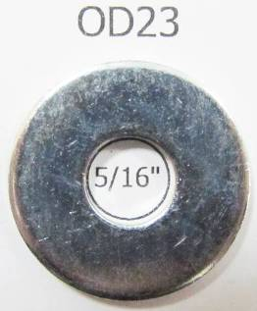 | 4 | *1JY31
(*) Hardware item at similar spec available locally.

- Installations for WB-1055 (booth side to side).
DO NOT TIGHTEN BOLTS ON BOOTH BEFORE ADJUSTING WELDING BOOTH FEET TO LEVEL OUT BOOTH WITH GROUND.
AS
MB
DO NOT TIGHTEN BOLTS ON BOOTH BEFORE ADJUSTING WELDING BOOTH FEET TO LEVEL OUT BOOTH WITH GROUND.

Assembly Hardware
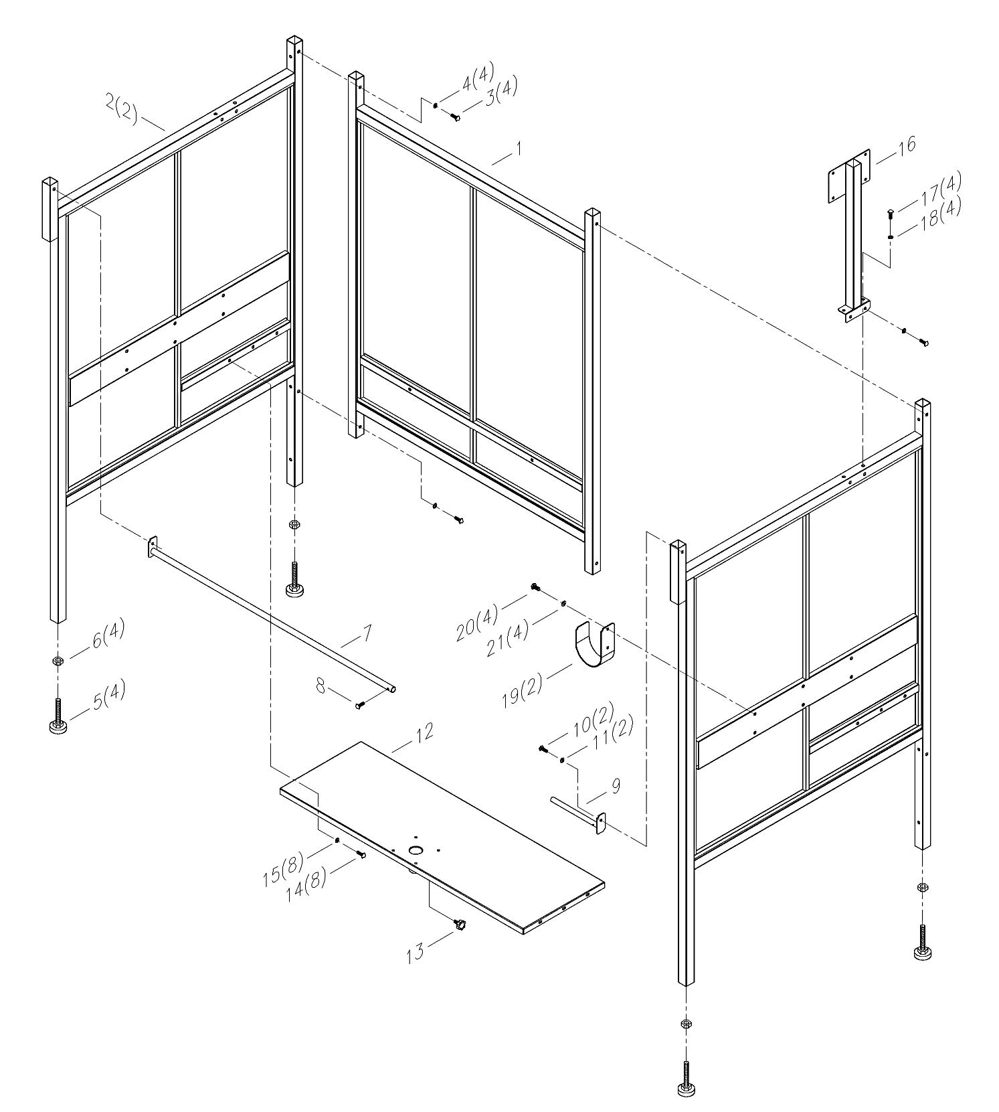

Repair Parts List
Repair Parts List for Welding Booth

Reference Number | Description | Part Number | Quantity
1 | Back Panel | A02-01-WB-5x5S-1 | 1
2 | Side Panel | A02-01-WB-5x5S-2 | 2
3 | Hex Screw 5/16"*3" | A02-01-WB-5x5S-3 | 4
4 | Flat Washer 5/16"xOD23x2t | A02-01-WB-5x5S-4 | 4
5 | Adjustable Feet M16*100 | A02-01-WB-5x5S-5 | 4
6 | Hex Nut M16 | A02-01-WB-5x5S-6 | 4
7 | Curtain Bar (long) | A02-01-WB-5x5S-7 | 1
8 | Phillips Head Sheet Metal Screw 1/4"*3/4" | A02-01-WB-5x5S-8 | 1
9 | Curtain Bar (short) | A02-01-WB-5x5S-9 | 1
10 | Hex Screw 5/16"*3/4" | A02-01-WB-5x5S-10 | 2
11 | Flat Washer 5/16"xOD23x2t | A02-01-WB-5x5S-11 | 2
12 | TABLE | A02-01-WB-5x5S-12 | 1
13 | Knob Screw 5/16"*3/4" | A02-01-WB-5x5S-13 | 1
14 | Hex Screw 5/16"*3/4" | A02-01-WB-5x5S-14 | 8
15 | Flat Washer 5/16"xOD18x2t | A02-01-WB-5x5S-15 | 8
16 | Arm Support | A02-01-WB-5x5S-16 | 1
17 | Hex Screw 5/16"*3/4" | A02-01-WB-5x5S-17 | 4
18 | Flat Washer 5/16"xOD23x2t | A02-01-WB-5x5S-18 | 4
19 | HOOK | A02-01-WB-5x5S-19 | 2
20 | Hex Screw 5/16"*3/4" | A02-01-WB-5x5S-20 | 4
21 | Flat Washer 5/16"xOD23x2t | A02-01-WB-5x5S-21 | 4

Contact Information

Avani Environmental International Inc.
95 Cypress Drive,
Youngsville, NC 27596
Email: info@avanienvironmental.com
www.avanienvironmental.com

Customer Service: info@avanienvironmental.com
Tel: 919-570-2862 ext.5167

Engineering Service: enginnering@avanienvironmental.com
Tel: 919-570-2862 ext.5162

