- Installations for STAND-BM.

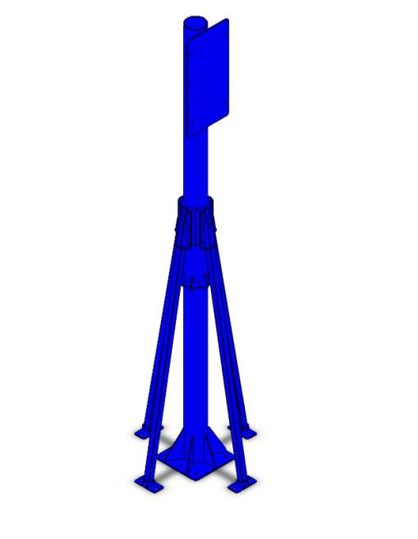
2014 / 06 / 06
- Installations for STAND-BM.

- Take out the number STL.
Fasten sleeve anchors for legs to field bolted if needed
Hardware
Part name | Description | Photos | Q’ty | Grainger  Model #
Sleeve Anchor | 3/4” x 4” | 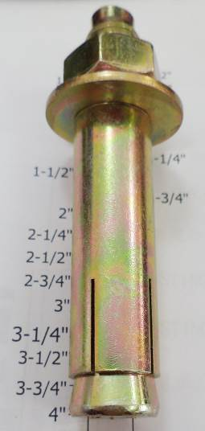 | 6 | 2G524

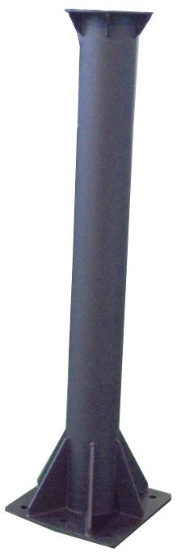
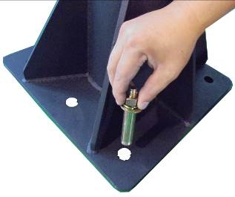
- Installations for STAND-BM.

STL
- Installations for STAND-BM.

- Take out the number STU.
- Join STU to STL together with:

Hardware
Part name | Description | Photos | Q’ty | Grainger  Model #
Hex Screw | 1/2” x 1-1/2” | 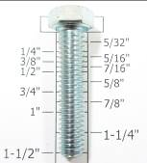 | 6 | 1YU63
Flat Washer | 1/2” x OD28 x 3t |  | 12 | *1JY35
Nylon Hex Nut | 1/2” | 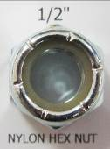 | 6 | 3HDU8
(*) Hardware item at similar spec available locally.


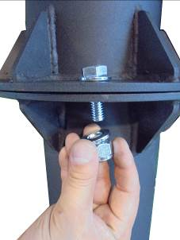
- Installations for STAND-BM.

STU
STL
- Installations for STAND-BM.

- Take out the number SDD .
- Join SDD to STU together with:

Hardware
Part name | Description | Photos | Q’ty | Grainger  Model #
Hex Screw | 1/2” x 1” | 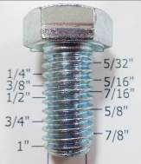 | 24 | 1YU61
Flat Washer | 1/2” x OD28 x 3t |  | 24 | *1JY35
(*) Hardware item at similar spec available locally.

- Installations for STAND-BM.

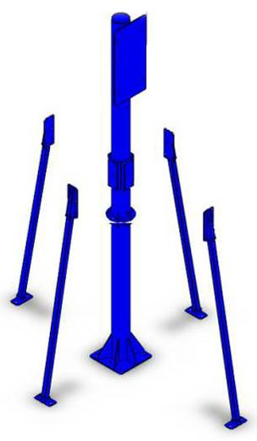
SDD
SDD
STU
SDD
SDD
- Installations for STAND-BM.

Fasten sleeve anchors for legs to field bolted if needed
for SDD
Hardware
Part name | Description | Photos | Q’ty | Grainger  Model #
Sleeve Anchor | 3/4” x 4” |  | 6 | 2G524

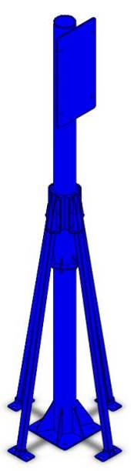
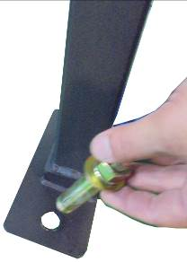
- Installations for STAND-BM.

SDD
