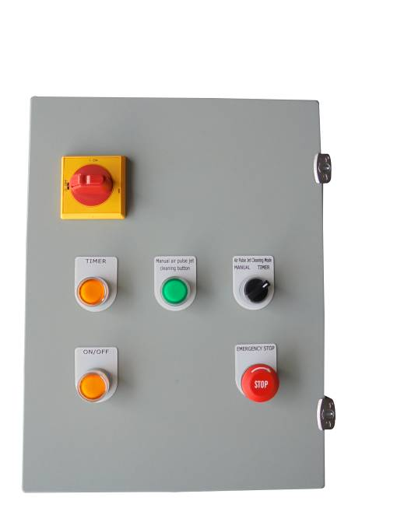
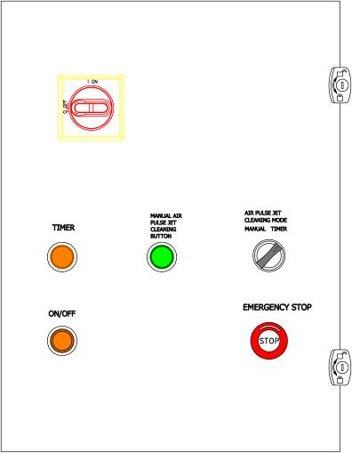
Main Electrical Components for SDC-B-5-2 Control Panel
Main Electrical Wiring for SDC-B-5-2 Control Panel

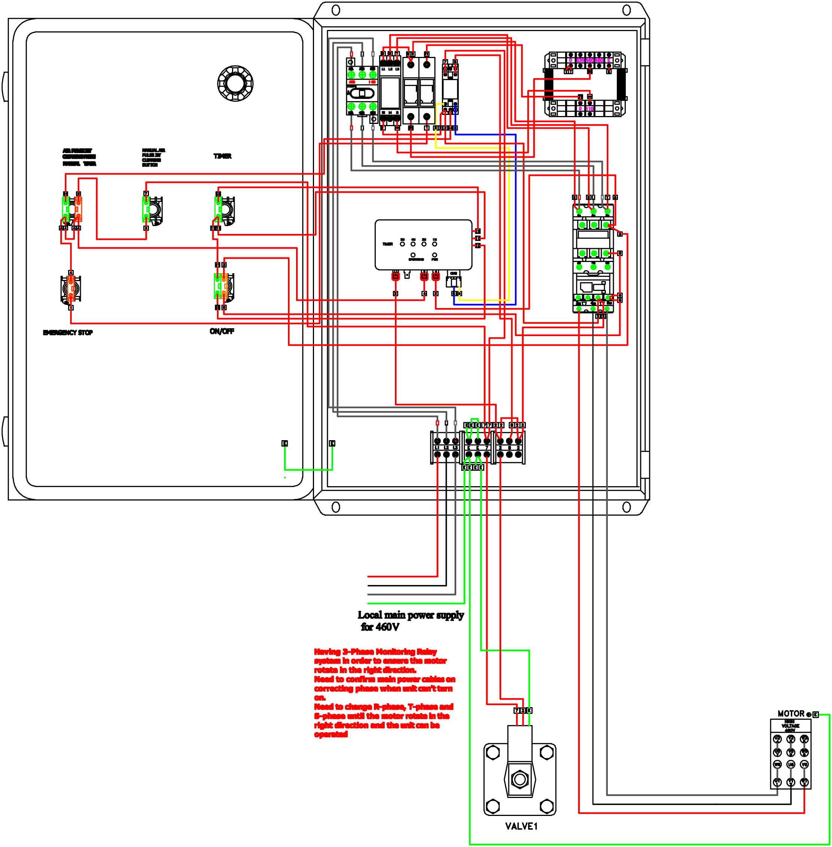

Part-A
Part-B
Part-C
Part-D
Part-C
Part-D
Part-E
Main Electrical Wiring for SDC-B-5-2 Control Panel
Main Electrical Wiring for SDC-B-5-2 Control Panel
Part-A
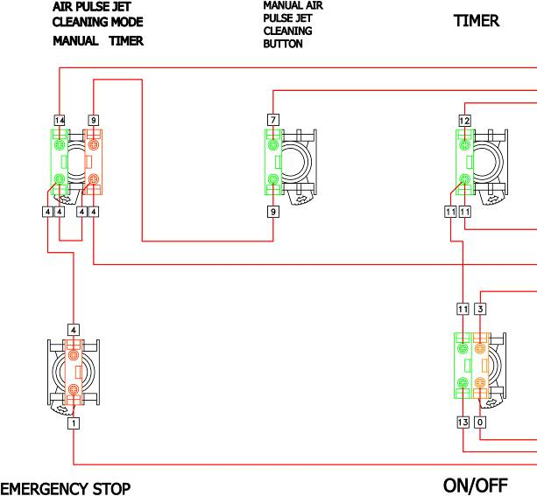
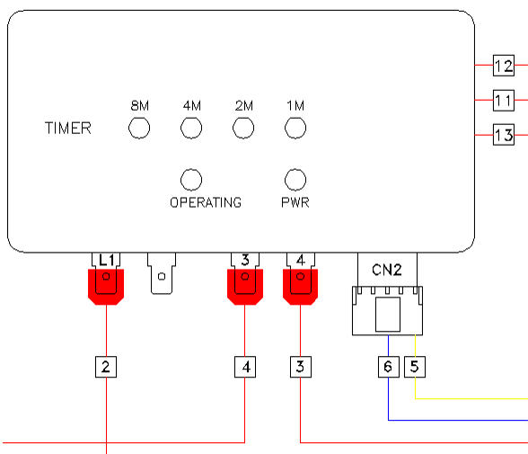
Part-B-1：
IC Board
Main Electrical Wiring for SDC-B-5-2 Control Panel
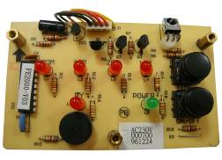
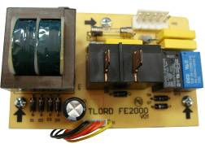
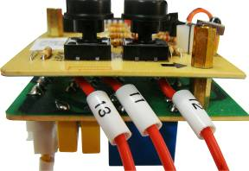
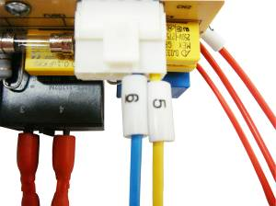
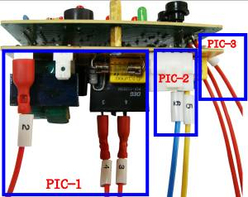
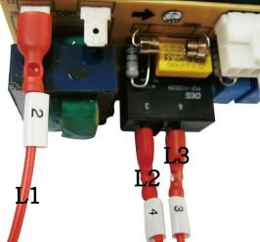
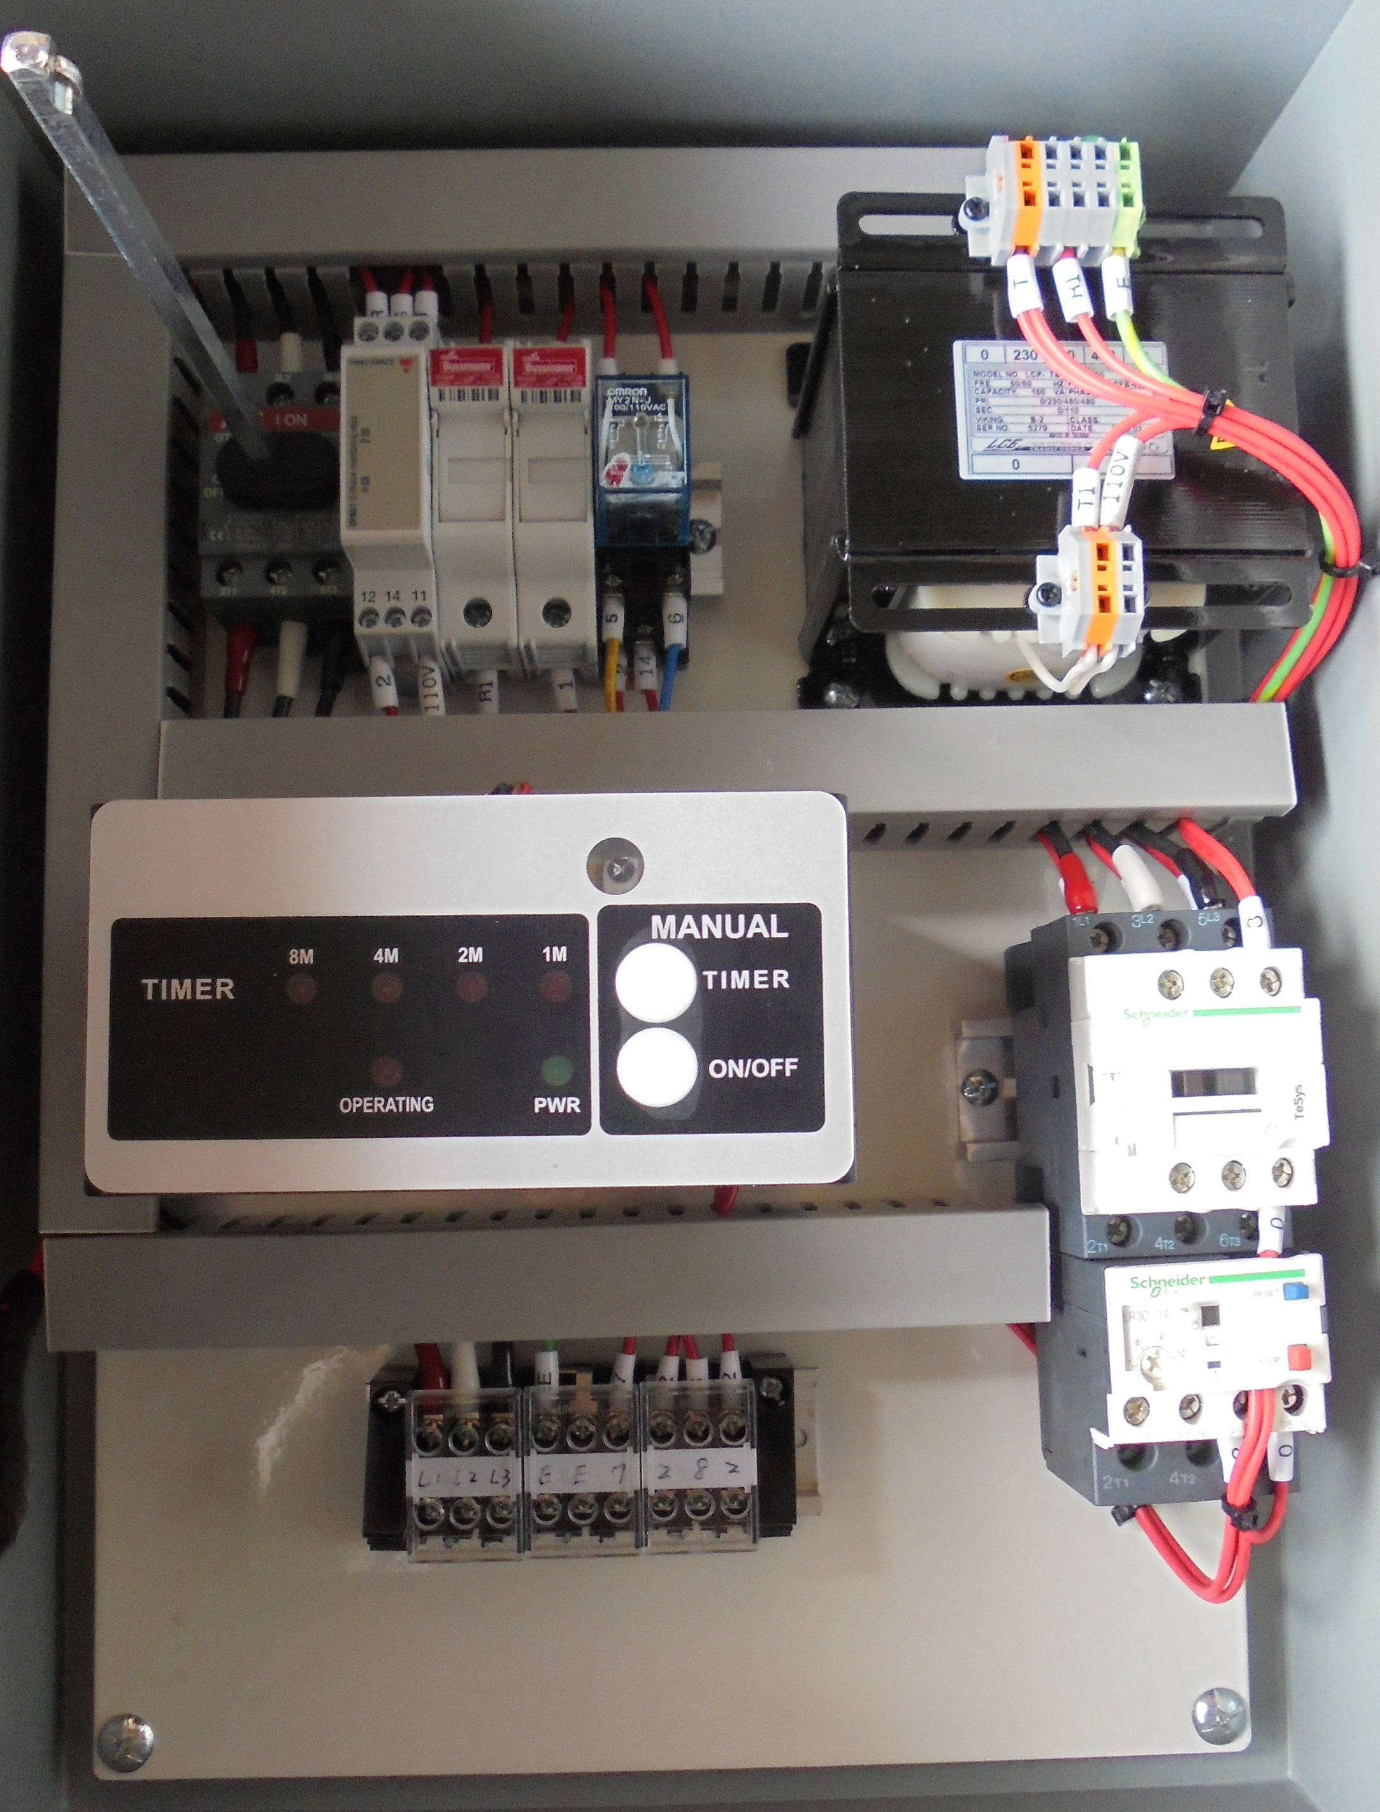
- IC Board (Front)
- IC Board (Back)
- L3：The blower.
- 11：Common Point
- 12：TIMER.
- 13：ON/OFF
- Air pulse jet system.
- L1/L2：The main power.
PIC-1
PIC-3
PIC-2
Part-B-1
Main Electrical Components for SDC-B-5-2 Control Panel
Part-B-2：
Panel disconnect switch.
3-Phase Monitoring Relay.
Fuse bus.
Relay.
Main Electrical Wiring for SDC-B-5-2 Control Panel

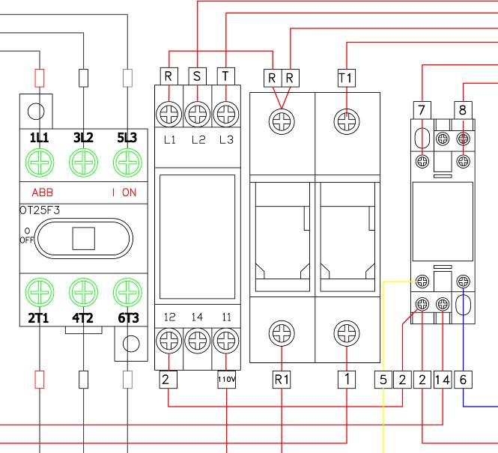
- Panel disconnect switch.
Part-B-2
Main Electrical Components for SDC-B-5-2 Control Panel
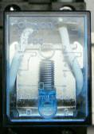
- Relay.

- Fuse bus.
- 3-Phase Monitoring Relay.

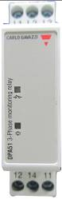
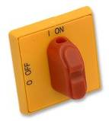
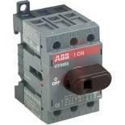
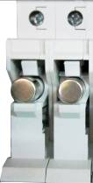

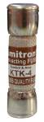
Having 3-Phase Monitoring Relay system in order to ensure the motor rotate in the right direction.
Need to confirm main power cables on correct phase when unit can’t turn on.
Need to change R-phase, T-phase and S-phase until the motor rotate in the right direction and the unit can be operated.
Part-B-3：
Transformer.
Main Electrical Wiring for SDC-B-5-2 Control Panel
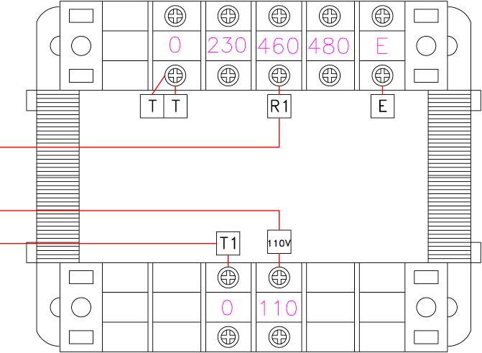
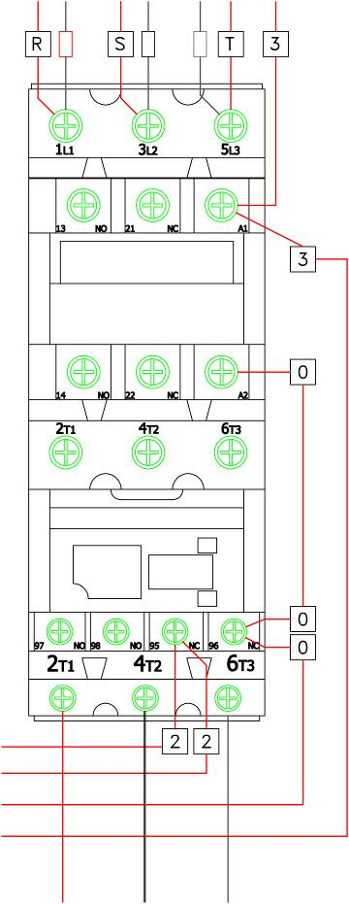
Part-B-4：
Magnetic Contactor.
Thermal Relay.
Main Electrical Wiring for SDC-B-5-2 Control Panel
Part-B-3
Main Electrical Components for SDC-B-5-2 Control Panel
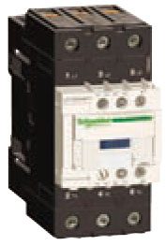
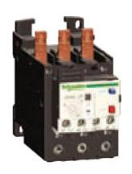
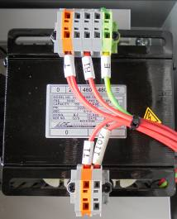
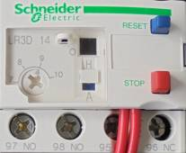
- Transformer for 460V.
- Magnetic contactor.

Part-B-4
- Thermal Relay for motor of 5HP.
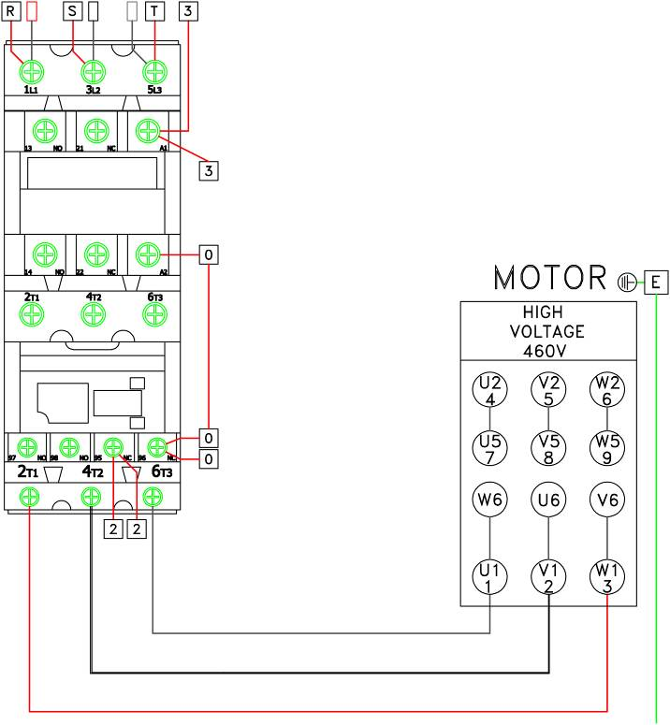
Main Electrical Wiring for SDC-B-5-2 Control Panel
Part-C：
Connect to motor

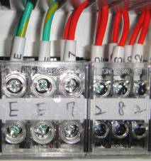
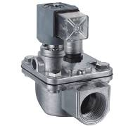
Part-C：
Valve.

Main Electrical Components for SDC-B-5-2 Control Panel
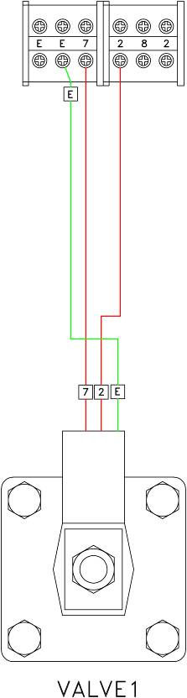
Part-D：
Valve

Main Electrical Wiring for SDC-B-5-2 Control Panel
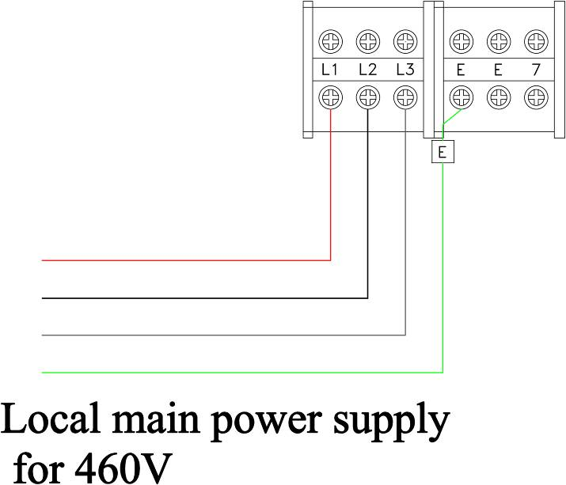
Part-E：
Connect to main power supply for 460V / 60HZ / 3-Phase

Main Electrical Wiring for SDC-B-5-2 Control Panel
