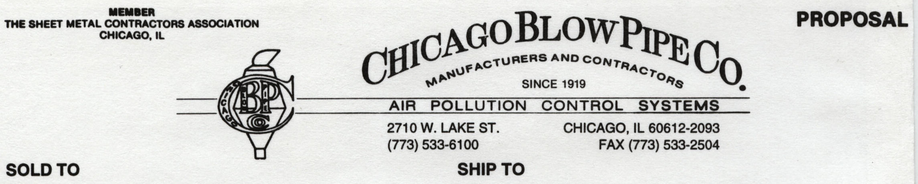
IAQ
708-482-3935
708-482-3931
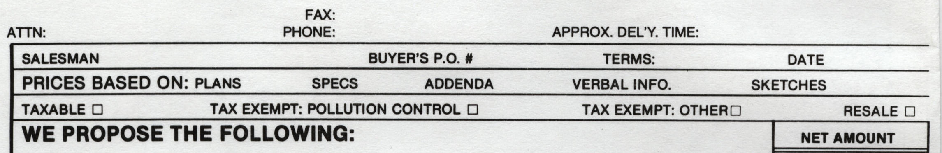
10 DAYS

FRED JOHNSON
DOUG VANERKA 7/31/2026

(1) ALUMINUM RAIN COVER FOR EXPLOSION STACK ASSEMBLY AT BOOKLET BINDING
CO PER SCIENTIFIC DUST COLLECTORS DRAWING B01478 DATED 9/05/08 REV O $1394.00
FOB
CAROL STREAM, IL

TERMS: NET 30 DAYS

