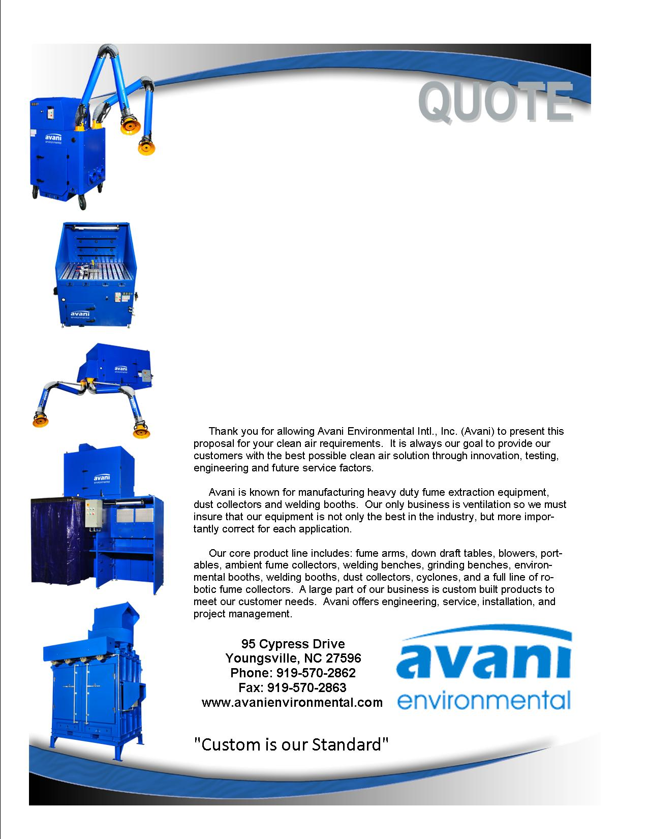

Attn: Tokso Pak

**Altec Industries, Inc.**

**Quote #: AE-003545**

Quote by: **Kirke Blenkhorn (for Ed Sithes)**

Email: kblenkhorn@avanienvironmental.com

March 19, 2012

**Avani Environmental Intl., Inc.**

**95 Cypress Drive**

**Youngsville**, **NC 27596**

Phone: 919-570-2862 Fax: 919-570-2863

**Quote #: AE-003545** March 19, 2012

ATTN: Tokso Pak, tokso.pak@altec.com

**Altec Industries, Inc.**

1550 Aerial Avenue

Creedmoor, NC 27522

Tokso

Here is a revised quote for installing the 4 drops off the existing trunkline.

|  |  |  |  |  |  |
| --- | --- | --- | --- | --- | --- |
| **Product Name** | **Product Description** | **Product Picture** | **Quantity** | **Unit Price** | **Total Price** |
| Duct & Materials | Flanged spiral ductwork package. Complete with straight duct, branch transitions, and elbows and branches. Package includes:  - (4) Roof Curbs and Curb Caps  - (4) Intake Elbows (dirty air)  - (4) Return Elbows (clean air return)  - Cut-in for Trunkline  - Ductwork Stands, Unistrut, Mastec and Hardware  - **Please Note:** Flashing of Curbs and Stand to be done by others |  | 1 | $19,770.00 | $19,770.00 |
| Installation - Avani | Mechanical Installation: Labor to install and assemble.  (Excludes: lift rental, electrical wiring, drain plumbing, fire suppression, demolition work or holiday work - unless otherwise stated) |  | 1 | $7,240.00 | $7,240.00 |
|  |  |  |  | **Grand Total:** | **$27,010.00** |

**Total does not include shipping cost**

Additional Product Options:

|  |  |  |  |  |
| --- | --- | --- | --- | --- |
| **Product Number** | **Product Description** | **Quantity** | **Unit Price** | |
| Shipping: | Pricing does not include shipping; Please note that shipping will be added |  |  | |
|  |  |  |  | |
|  |  |  |  |

Thank you for looking to Avani concerning this project. Please be in touch with any questions.

Feel Free to Review the Avani Product Line: CLICK HERE.

Sincerely,

**Ed Sithes**

**President**

Phone: (919) 570-2862, Ext-202, M: (919) 971-2017

E-Mail: esithes@avanienvironmental.com

**Kirke Blenkhorn**

**Territory Manager, Eastern NC**

Phone: (919) 570-2862, Ext-218, M: (919)-896-3165

Email: kblenkhorn@avanienvironmental.com

**Terms and Conditions**

**General:**

1. The price does not include sales tax, duties, custom fees or any other cost associated with the sale or delivery of this product.
2. Payment Terms: Noted in the body of the quote. All quoted prices and payments are in US dollars.
   1. Customized products: 35% down with PO, 35% prior to shipment and 30% net 30.
   2. International Orders: 40% down with PO, 40% prior to shipment and 20% net 30.
   3. New Customers: 35% down with PO and 65% net 30.
3. Quotation price does not include actual shipping costs. All products are shipped FOB from manufacturer. If requested by Buyer, Avani can supply an estimated shipping cost(s). The estimated shipping cost is only an estimate and actual charges can be different from estimated charges.
4. Late payments and any charges associated with the Late payment begin incurring charges 30 days after standard payment terms are due.

**Shipping and Delivery Time:**

1. All products are FOB Manufacturer
2. Shipping times: Stock items – 1 week, Non-stock items –8 weeks, Customized products –10 weeks. If deposits and/or signed drawings are required for specific job; shipping time begins after Avani has received these items.
3. Unless otherwise stated on the purchase order Avani will ship Best Way Prepay and Add.
4. All products that are shipped via Truck will be shipped with standard pallets and shipping material. If needed or requested by the buyer the product(s) can be completely crated for an additional cost.
5. The Buyer is responsible for inspecting the Product(s) immediately when they are delivered and must state upon delivery if the Product(s) is damaged or has missing parts. If not, the Product(s) are acknowledged as being complete and satisfactory.

**Warranty and Return:**

1. All New Products come with a standard 1 year warranty. Other warranties and terms are available and must be approved by an Avani personnel.
   1. Warranty covers replacement parts for 1 year.
   2. Does not cover labor or charges incurred for removing and installing new parts.
   3. Not responsible for loss of use or downtime.
2. Returns product(s) must be approved by Avani before being sent back.
   1. Must have an RGA and Case # when the product(s) is shipped back.