
山貿科技有限公司 SAN MAO TECHNOLOGY CO., LTD
台中市神岡區大明路191巷92號 No.92, Lane 191, Daming Rd., Shengang District, Taichung City 429, Taiwan
Tel: +886-4-2526-9689 Fax: +886-4-2526-9860
E-mail: sales@smartvent-technology.com Website: http://www.smartvent-technology.com

October 14, 2011

ORDER CONFIRMATION
INVOICE NO. P-1001005-001 (Revised I)
PO NO. 3645
INVOICE of Large Dust Collectors, Blowers, Fume Arms, Booms and Parts
For account and risk of Messrs. AVANI ENVIRONMENTAL INTL. INC.
95 Cypress Drive, Youngsville, NC 27596
Shipped by: SAN MAO TECHNOLOGY CO., LTD.
From: Taiwan to USA

Fumes, Booms and Parts
FOB TAIWAN
Cordero Mine Company (via Airgas)
Warehouse – 748 T-7 RD
22 Miles SE of Gillette
Gillette, WY 827160000
Item | Model | Description | Unit Price | Q’ty |  | Total
1 | ARM 2040  A02-03-FE-M2040 | Hanging Fume Arm  Spec: Dia. 8” x 14’  Including: Hose Connector  Arm Color: Avani Blue | 479 |  | 6 | 2,874
2 | BM-8020  A02-01-BM-8020 | Extension Boom:  - Ø8” x 20’ long (length does not include base length)  - Entire boom is constructed from heavy gauge steel and powder coated.  - comes complete with:  - a 3’ high base with wall mounted hooks  - 8” dia. Outlet  - flexible pipe and hose (attached to top side of boom)  - 8” dia fume arm bracket  **Reference: BM-8020 (8inch x 20') submittal 2010.01.29 | 1,386 | 6 |  | 8,316
3 | LK-100x  A02-03-LK-110 | LIGHT KIT  Voltage: 110V / 50 WATT  Include: Light Bulb, on/off Switch, Cords  Plug & on/off switch  Light kit cover piece: tempered glass  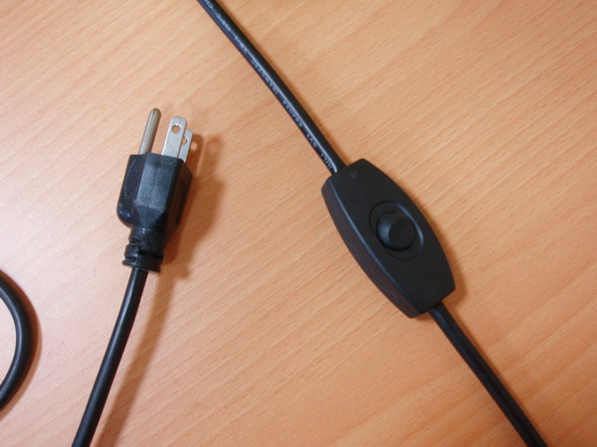 | 30 | 6 |  | 180
SUBTOTAL: US$ 11,370.00

1.
2.
3.
Kindly be advised that:
8” x 20’ Single Boom
4.
- Boom base will be standardized as point 1, 2, and 3.
Boom length for BM-8020 will be produced as point 4.

SDC large cartridge collectors, blowers
FOB TAIWAN
Cordero Mine Company / Airgas
Warehouse – 748 T-7 RD
22 Miles SE of Gillette
Gillette, WY 827160000
Item | Model | Description | Unit Price | Q’ty | Total
4 | SDC-10-8MDF | Include:  - SDC-8MDF cartridge collector x 1 pc  - DBN-100 blower on the machine top x 1 pc  - DBN-100C control box x 1 pc
 | SDC-8MDF  OC04-01-SV-10-8MDF | Cartridge Collector (dust filtration only), Drawer Type w/ Feet  - Inlet: 14"  - cartridge filter: Ø325mm x 1320mm x 8pcs (Dia. 12.8" x 52" x 8pcs)  - Material: Polyester with TEFLON coating.  - Filter Area: 19m2 x 8 = 152m2 (1635.52 ft2)  - Pleat Depth: 48mm  - Horizontal Positioned Filters  - UL certified control panel, wiring conduits, and solenoids.  - Continuous Welded Seams  - Gasket and Latched Doors  - Powder Coated Paint and Reverse Jet Pulse Cleaning  - Include:  - Filter Chamber  - Inlet Square Pipe (need dimensions)  - Fan/motor combinations  - No. of Valves: 2  - Inlet Air: 3/4"  - Compressed Air Requirement: 90 PSI  - Compressed Air Reservoir: 7.9 gallon  - Dimension: 46.3" x 81.9" x 163" (1176 x 2077.5 x 4136.8mm)  - Construction: 13 Gauge for panel; 11 Gauge Steel Cabinet  - Paint Color: Blue  - Logo: Avani  **1” connector welded to the right side of the collector  ***Blower Outlet: dia. 15.8” (square to round transition made at dia. 16” for fan outlet provided)  ***with Feet underneath the machine.  **Reference: SDC-10-8MDF submittal 2011.10.14 | 9,050 | 1 | 9,050
 | DBN-100 | 10 HP / 4 Pole (on the machine top)  230/460V / 60Hz / 3Ph  (connect to: 460V) | 2,700 | 1 | 2,700
  Connecting Dust Collector
  CFM @ Dust Collector Inlet
  @ 8” sp
  4400
 | DBN-100-C | UL Control Panel for 10HP blower & SDC-8MDF  Blower Control Box 460V / 60Hz / 3Ph: With transformer. Blower box located inside the building.  Pulse Control Box:  run off of 120V, 1- phase, No transformer. Pulse box located outside on the collector. | 610 | 1 | 610
SUBTOTAL: US$ 12,360.00

TOTAL AMOUNT for CORDERO: US$ 23,730.00

Remark:
- PAYMENT: 35% down payment remitted before shipment; another 35% wire transferred when the container is approaching to US; 30% balance cleared one month after ETA date of the container.
- SHIPMENT: 45 days after confirmation of O.C. With any available container closer to the delivery time.
- VALIDITY: 6 months.
- PACKING: Our standard packing

Bank:
MEGA INTERNATIONAL COMMERCIAL BANK CO., LTD FENG YUAN BRANCH
519 CHUNG CHENG ROAD FENG YUAN, TAIWAN, R.O.C
TEL: 886-4-25285566 FAX: 886-4-25206431

SWIFT ADDRESS: ICBCTWTP 035
Account NAME: SAN MAO TECHNOLOGY CO., LTD
Account NO. 035-585-46208

SAN MAO TECHNOLOGY CO., LTD AVANI ENVIRONMENTAL INTL. INC.

CHARLES CHENG CHARLES SITHES
General Manager Product Manager

