January 24 2012

AGFA Inc.
5975 Falbourne Street
Mississauga ON
L5R 3V8

Attention: Tim Dagnall

Quotation Number: 240112

Thank you for the current business and the opportunity to present a long-term solution.

Unit pricing 2012 is the same as 2011.

Replacement Parts have a small increase.

The following are the 2012 prices for the ODF1000 you currently are purchasing plus the ODF800 which is the less expensive unit.

ODF1000 Painted AGFA Colour
Pricing based on Order of 15 units $9,599.00

ODF800 OPTION 1

ODF800 Painted AGFA Colour c/w Control Panel
Pricing based on Order of 15 units $6,089.00

ODF800 OPTION 2
ODF800 Painted AGFA Colour NO CONTROL PANEL
Pricing based on Order of 15 units $4,700.00

Replacement Filters

Stage 1 92110606 Filter S10B/595 $899.00 Stock Absolent
HEPA 92630606 HEPA TRSA/595 $450.00 Stock Absolent
Charcoal Filter 2” X 24” X 24” $169.00 Special Order

Replacement parts from Absolent, stocked Absolent Warehouse Chesapeake VA and will be shipped within 48 hours of receipt Purchase Order.

Charcoal Filter is special to Agfa and requires 3 weeks for delivery.

TECHNICAL DATA for MIST COLLECTORS

ODF1000 Painted AGFA Colour
Pricing based on Order of 15 units $9,599.00

Design Criteria:
The following criteria are the base for the recommended equipment.
• Required Airflow: 50 - 150
• Contamination: Oil ( off gasing from drying ink on polyester material), water vapour
• Inlet Load: 26 mg/cu.m.
• Type of Machine: Aquajet printer Model 3324WBT

Absolent Package (Based on 15 Units):

Absolent ODF-1000S Mist & Smoke Collector $5350.00 Powder coated in Agfa custom colour
Absolent ODF-1000S 10” Leg Extensions w/ Stabilizer $ 55.00
- Drilled out to allow for ¼ -20 Bolt and Lock-Nut Inside
Custom Color Powder Coat:
Protech Chemical Powder as per Agfa specifications $ 185.00
- Absolent ODF-1000S
- Absolent Leg Extensions
Tri-Star Coatings as per Agfa specifications $ 330.00
-Charcoal filter plenum -Control panel -I duct

Control Panel (Sieman Contactor and Overload) $1389.00
- Field Connections Taken to Terminals
- Wire ferrules will be utilized
-15/5 15’ SO Cable with Flying Head
-Assembly can be listed for CUL and UL 508A
Charcoal Filter Plenum $ 692.00
-Designed with Carbon Tray Slot (2” x 24” x 24”) Carbon tray shipped in plastic bag.
-Latches for filter access door.
Carbon Cell (2” x 24” x 24”) $ 163.00
- Zeolite, Alumina and Carbon Blend. Carbon tray shipped in plastic bag.

Mechanical Materials:
Drain Assembly (Steel Elbow) $30.00
- Pipe and 45 degree Valve
Brass Fitting and Pressure Gauge $ 144.00
I Duct Clamp Together Ducting for ODF System $388.00
-Clamps to be unpainted
Custom Painting/ Electro Coating (Avani Warehouse): $330.00
- Tri-Star Coatings as per Agfa specifications
-Charcoal filter plenum
-Control panel
-I Duct Package
Custom Crate & Packaging (International Stamp): $ 253.00
- Completely Enclosed
- 32” x 38” x 90”
Avani Mechanical Labor and Handling: $290.00
1. Uncrate ODF-1000 from Sweden
2. Cut and Install leg extensions (10”) over existing stub legs. Drill through to allow for a ¼ - 20 bolt to be placed and a lock-nut to be placed inside and record
3. Remove filter cassettes and verify fiber one (S10B3/ 595). Remove Absolent part numbers and identifications (remove plates, rivets) Replace with decals or new plates provided from Agfa. Remove owner’s manual and replace with Agfa manual. Agfa label in the center of the upper door and record.
4. Stand ODF upright to remove junction box.
5. Install ventilation collar over the hole on the LEFT side of the unit using self tapping screws. Seal any possible holes and record.
6. Install steel elbow and 45 degree valve for drainage with a downward slant for better drainage and record.
7. Install new electrical box and make all necessary connections. Ensure that 15’ 14/5 wire is attached to the electrical box via proper stain relieves for on site connection.
8. Install the vent hood onto the unit using a thin bead of clear silicone on top outside of provided screw holes. Use 16M 5 x 14 screws and nuts using large washers (5/8”) and use a small amount of Blue 425 medium strength Loctite on each screw. Place a small bead of silicone on the inside upper portion of the vent hood and record.
9. Install duct assembly.
10. Connect unit to electrical power.
11. Check fan rotation and record.
12. Check for vibration and record.
13. Check amps and record.
14. Hypot test unit and record.
15. Check control panel on/off, lights, disconnect and overall appearance and record.
16. Check the Absolent gauges and record Static Pressure.
17. Check Static Pressure on I duct adjust fresh air damper to correct reading and record.
18. Test and record Airflow and record.
19. Check for air leaks and record.
20. Check fit and finish of complete unit and record.
21. Bubble-wrap the collector while standing.
22. Lay collector into new crate. Insert I duct assembly. Raise sidewalls and assemble. Band collector crate to insure stability for freight carriers.
23. Provide complete check-list upon completion.
Nov 2008 Jan 2011
Total Cost Per Unit & Ducting Complete: $9599.00

ODF800 OPTION 1

ODF800 Painted AGFA Colour c/w Control Panel
Pricing based on Order of 15 units $6,089.00

ODF800 OPTION 2
ODF800 Painted AGFA Colour NO CONTROL PANEL
Pricing based on Order of 15 units $4,700.00

The cfm presently required is 110cfm as tested June 2011.

An ODF800 is sufficient to give us the required air volume and efficiency.

Changes will be required for this unit to work. They are:
- Unit will need to be mounted on the printer. Frame required.
- New ductwork.
- Smaller charcoal filter.
- Smaller static pressure gauge.
- Change to the drain.
- Change to the crate.

Below are the estimated cost (less the stand) for the ODF800.

Design Criteria:

The following criteria are the base for the recommended equipment.

Required Airflow: 110cfm
- Contamination: Oil ( off gasing from drying ink on polyester material), water vapour

Inlet Load: 26 mg/cu.m.
- Type of Machine: Aquajet printer Model 3324WBT

Recommended Equipment:

Absolent ODF-800 Fiber Bed Mist & Smoke Collector
Configuration: Vertical
Motor: (1) 0.85 HP (Direct Drive Fans)
Dimensions: L 13.8 " x W 24.4" x H 39"
Inlet: Ø4.9”
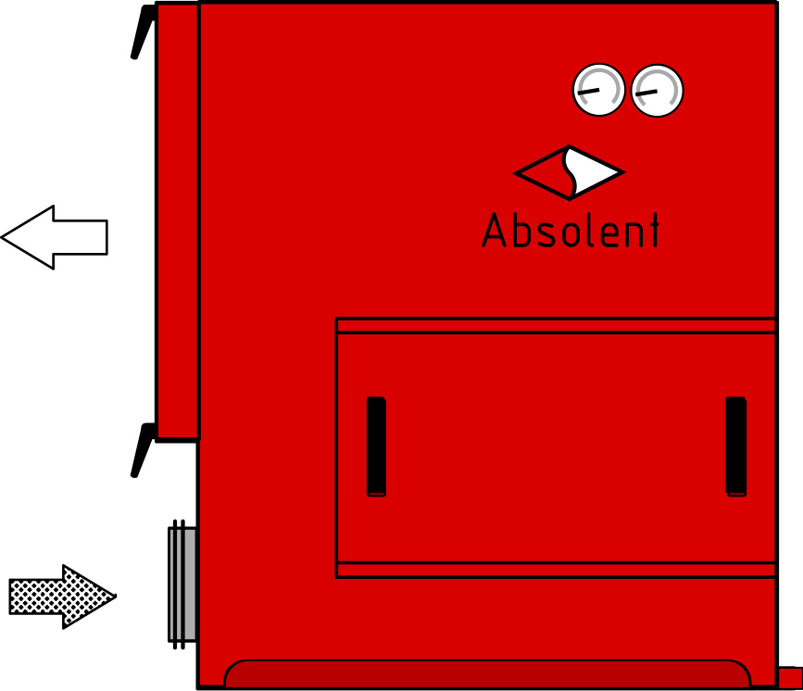
Weight: 165 Lbs.
Air Volume: 200 CFM
Noise Level: 63 dBA @ 3 Meters from Outlet Grille
Electrical: 254/480V, 3-Phase, 60Hz (Junction Box)
Filtration: 1 Each Fiber Bed 1: 83 Sq. Ft.
1 Each Absolute Filter: 73 Sq. Ft.
Drainage: Inlet Plenum with Drain
Filter access: Front Load Filter Accessibility
Gauges: Magnehelic Gauges/ 0-5": (2 Total)

Option 1 with Control Panel

Absolent Package (Based on 15 Units):

Absolent ODF-800 Mist & Smoke Collector $3,050.00 Powder coated in Agfa custom colour

Custom Color Powder Coat:
Protech Chemical Powder as per Agfa specifications $185.00
- Absolent ODF-800

Tri-Star Coatings as per Agfa specifications $ 190.00
-I duct

Control Panel (Sieman Contactor and Overload) $1389.00
- NEMA 12 Wall Mount Enclosure (10” x 8” x 4”)
- 3 pole ABB non-fused disconnect interlocked with door
-1 AMP Fuse Terminal
- 3 Pole Contactor
- Overload Relay
- Field Connections Taken to Terminals
- Wire ferrules will be utilized
-15/5 15’ SO Cable with Flying Head
-Assembly can be listed for CUL and UL 508A

Charcoal Filter Plenum Filter to be placed under exhaust grill $119.00

Carbon Cell (2” x 12” x 13.5”) $149.00
- Zeolite, Alumina and Carbon Blend. Carbon tray shipped in plastic bag.

Mechanical Materials:

Drain Assembly (Steel Elbow) $30.00
- Pipe and 45 degree Valve

Brass Fitting and Pressure Gauge $144.00
I Duct Clamp Together Ducting for ODF System $290.00 - QF Pipe, Adjustable Nipples, Elbows, Branches
-Clamps to be unpainted

Custom Crate & Packaging (International Stamp): $ 253.00
- Completely Enclosed
- 32” x 38” x 90”

Avani Mechanical Labor and Handling: $290.00
- Uncrate ODF-800 from Sweden
- Remove filter cassettes and verify fiber one (S3B/1300). Remove Absolent part numbers and identifications (remove plates, rivets) Replace with decals or new plates provided from Agfa. Remove owner’s manual and replace with Agfa manual. Agfa label in the center of the upper door and record.
- Stand ODF upright to remove junction box.
- Install ventilation collar over the hole on the LEFT side of the unit using self tapping screws. Seal any possible holes and record.
- Install steel elbow and 45 degree valve for drainage with a downward slant for better drainage and record.
- Install new electrical box and make all necessary connections. Ensure that 15’ 14/5 wire is attached to the electrical box via proper stain relieves for on site connection.
- Connect unit to electrical power.
- Check fan rotation and record.
- Check for vibration and record.
- Check amps and record.
- Hypot test unit and record.
- Check control panel on/off, lights, disconnect and overall appearance and record.
- Check the Absolent gauges and record Static Pressure.
- Check Static Pressure on I duct adjust fresh air damper to correct reading and record.
- Test and record Airflow and record.
- Check for air leaks and record.
- Check fit and finish of complete unit and record.
- Bubble-wrap the collector while standing.
- Lay collector into new crate. Insert I duct assembly. Raise sidewalls and assemble. Band collector crate to insure stability for freight carriers.
- Provide complete check-list upon completion.

Total Cost Per Unit c/w control panel: $6089.00

Option 2 NO Control Panel

Absolent Package (Based on 15 Units):

Absolent ODF-800 Mist & Smoke Collector $3,050.00 Powder coated in Agfa custom colour

Custom Color Powder Coat:
Protech Chemical Powder as per Agfa specifications $185.00
- Absolent ODF-800

Tri-Star Coatings as per Agfa specifications $ 190.00
-I duct

Charcoal Filter Plenum Filter to be placed under exhaust grill $119.00

Carbon Cell (2” x 12” x 13.5”) $149.00
- Zeolite, Alumina and Carbon Blend. Carbon tray shipped in plastic bag.

Mechanical Materials:

Drain Assembly (Steel Elbow) $30.00
- Pipe and 45 degree Valve

Brass Fitting and Pressure Gauge $144.00
I Duct Clamp Together Ducting for ODF System $290.00 - QF Pipe, Adjustable Nipples, Elbows, Branches
-Clamps to be unpainted

Custom Crate & Packaging (International Stamp): $ 253.00
- Completely Enclosed
- 32” x 38” x 90”

Avani Mechanical Labor and Handling: $290.00
- Uncrate ODF-800 from Sweden
- Remove filter cassettes and verify fiber one (S3B/1300). Remove Absolent part numbers and identifications (remove plates, rivets) Replace with decals or new plates provided from Agfa. Remove owner’s manual and replace with Agfa manual. Agfa label in the center of the upper door and record.
- Stand ODF upright to remove junction box.
- Install ventilation collar over the hole on the LEFT side of the unit using self tapping screws. Seal any possible holes and record.
- Install steel elbow and 45 degree valve for drainage with a downward slant for better drainage and record.
- Install new electrical box and make all necessary connections. Ensure that 15’ 14/5 wire is attached to the electrical box via proper stain relieves for on site connection.
- Connect unit to electrical power.
- Check fan rotation and record.
- Check for vibration and record.
- Check amps and record.
- Hypot test unit and record.
- Check control panel on/off, lights, disconnect and overall appearance and record.
- Check the Absolent gauges and record Static Pressure.
- Check Static Pressure on I duct adjust fresh air damper to correct reading and record.
- Test and record Airflow and record.
- Check for air leaks and record.
- Check fit and finish of complete unit and record.
- Bubble-wrap the collector while standing.
- Lay collector into new crate. Insert I duct assembly. Raise sidewalls and assemble. Band collector crate to insure stability for freight carriers.
- Provide complete check-list upon completion.

Total Cost Per Unit LESS Control Panel: $4,700.00

Warranty and Guarantees

Maintenance free: 6 months
- Manufacturers Warranty: 1 year
- Guaranteed Filter Bed Lifetime: 6 months if load does not exceed recommended value and duct
connections are not changed.
- Separation degree: 99.97 %
- Motor 1 year manufacturer warranty

Terms
- Price in US Funds
- Validity of quotation: 12 months from date of quote.
- Freight Terms: FOB Youngsville NC
- Payment terms: Net 60 Days.

Again, I appreciate the opportunity to present this proposal for your consideration. Please call me if I can be of further assistance. Avani Environmental Int’l looks forward to working with you on this project.

Best Regards,

Bill Strouth
Avani Environmental Int’l

TERMS & CONDITIONS

FREIGHT/FOB: Manufacturer Avani Warehouse, Youngsville, NC Quotation price does not include actual shipping costs. If requested by Buyer, Avani Environmental can supply an estimated shipping cost(s).

SHIPMENT: Approval drawings will be sent approximately 2 weeks after receipt of purchase order and necessary technical details.
After return of signed approval drawings and finalization of all technical details, shipment to be approximately to weeks (not including holidays)

PAYMENT: All Purchase Orders have payment terms of net 30 days after shipment. Unless approved otherwise.OAC

RESTOCKING: There is a 20% restocking / cancellation fee for all Purchase Orders

WARRANTY: Equipment covered by manufacturers’ warranty.
Not responsible for shipping and handling costs for Warranty issues/items.
Warranty only includes replacement parts not labor or any other cost associated with replacing warranty Items.

VALIDITY: This quotation is valid for 30 days from date of issue.

EXCLUDED: This quotation does not include motor starters, assembly & installation, supports, connection to services, or anything not specifically described in the quotation.

CONTROLS: If the equipment furnished with this order requires synchronous operation for proper performance i.e. it constitutes or is part of a "system", and the system controls are not furnished by Avani Environmental Int’l Avani Environmental Int’l cannot be held responsible for improper or inadequate equipment performance, if that performance is the result of improper or inadequate synchronization.

I DISCLAIMER: Avani Environmental Int’l, Inc. suggests that you check with your insurance carrier in regards to installing a fire suppressant and or explosion relief system on the proposed equipment. We at Avani, recommend that you provide air cleaning and dust collection equipment with a fire suppressant and or explosion relief system. If you like for Avani to provide a quote for the lines we represent, we will be happy to provide this as an option.

PERMITS, LICENCES All local regional and government permits, licenses and codes are the responsibility of the buyer unless specifically described in the quote

