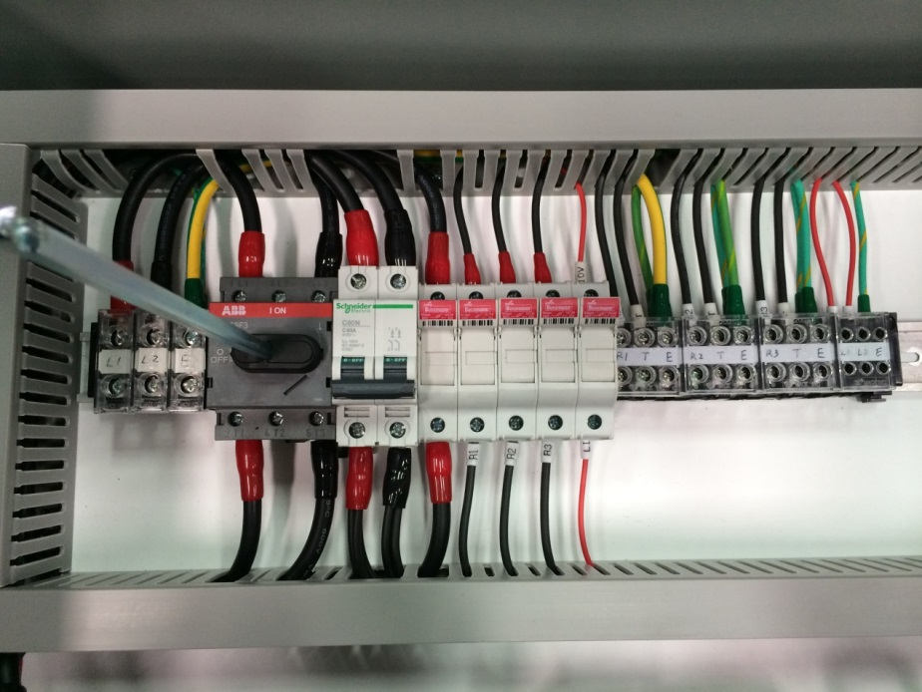

+

Loose the terminal block end barrier in back of the terminal block.

Move four terminal blocks and five fuse holders to right-hand side. (Red squared)

Remove the following wiring connection on Modular circuit breaker.

Disconnect three red wires and blacks wires. Put the earth leakage circuit breaker next to the Modular circuit breaker. Connect the comb busbars to Modular circuit breaker (A to A), (B to B)

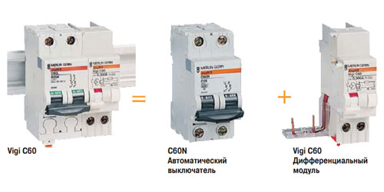

connect

B

A

Comb busbars

B

A

connect

Remove the following wiring connection on Modular circuit breaker.

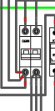 

C

D

Disconnect three red wires and black wires. Connect these three red wires to C position, three black wires to D position.