 

**Truform Equipment Inc.**

14744 S. McKinley Ave. - Posen, IL 60469

[sales@truformequipment.com](mailto:sales@truformequipment.com)

Phone: 708-897-8595 Fax: 708-897-8591

Absolent A-Smoke 40

Procedure for removal and replacement of the Poly-Pad PreFilter (Part Number FM-33381) in the Absolent A-Smoke 40. For Absolent Unit Serial Number **20121137**

**Note: The Poly-Pad PreFilter Must Be Removed and Replaced with a New Filter every (4) Weeks. Re-Order Part Number FM-33381**

1. Turn off the source power to the machine.
2. Standing in front of collector, open the two latches on the lower right side. This allows the lower door to be opened.
3. Open the door.
4. Locate the lowest filter, this is called the Poly Pad Prefilter and is approximately 1” in thickness. See below:

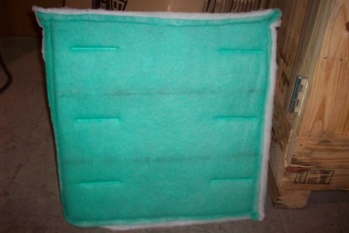

1. Using both hands pull out the poly pad pre- filter and discard in an environmentally safe manner. See below:

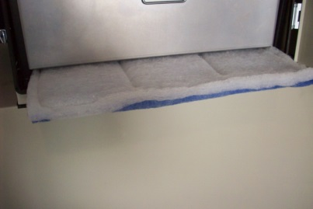

1. Locate new poly-pad prefilter (Part Number: FM-PP33381) and install it in the vacant slot at the bottom of the unit.
2. Close door, secure the two latches at the side of the collector.
3. Collector is now ready to return to use.

**Note: For maximum efficiency the Prefilter 1 ( located above the pre-filter inside door) must be high density (Part number X92110912 ). Reference the part number on the name plate located on the filter**

**Replacement Filters Installed on:**

**_____________________________ ____________________________ ____________________________**

**_____________________________ ____________________________ ____________________________**

**_____________________________ ____________________________ ____________________________**

**_____________________________ ____________________________ ____________________________**

**_____________________________ ____________________________ ____________________________**

**_____________________________ ____________________________ ____________________________**

**_____________________________ ____________________________ ____________________________**

**_____________________________ ____________________________ ____________________________**

**_____________________________ ____________________________ ____________________________**

**_____________________________ ____________________________ ____________________________**

**_____________________________ ____________________________ ____________________________**