SCOPE OF WORK FOR MACHINE MOVES AT THYSSENKRUPP PRESTA DANVILLE LLC.
Rev: C
Date: September 20, 2010

TKT-PDI Grinding Machine Relocations:

This is a list of several equipment moves for Grinding Restructure. Other engineers may require quotes of additional equipment moves.

Mechanical subcontracting by others to be included and itemized. All machine cables must be identified / tagged before they are disconnected.

Timing Schedule of start and completion times to follow after coordination with other projects is determined. Tentative rough timeframe is shown below.

First Area
Line 7 & Line 6 Work scheduled for Week 42 Mid October 2010
- Currently we are pulling four (4) Schaudt CF-41 grinders into Line 7 ODR-3000.
- Two (2) of these grinders will be moved to Line 6.
- Currently on Line 6 we are running only one (1) Schaudt M2 grinder.
- Line 6 will net two (2) more from Line 7 and have three (3) grinders.
- If you look at our original install drawing, we provided one extra drop for an additional grinder that is in place. We will need to provide one additional branch in the main line to pick-up the fourth grinder.
Second Area
Line 1 & Line 4 Work scheduled for week 47 November 2010
- Currently Line 1 has six grinders (2 Schaudt CF-41 and 4 Junker) in operation.
- 2 Absolent ODR-3000 filter pull from 3 grinders each (1 schaudt and 2 Junker)
- Two Schautd CF-41 grinders will be moved to Line 4.
- No other grinders will be added to this Line 1.
- Line 4 has two (2) grinders in operation,. Two (2) grinders from Line 1 will be added to make the Absolent ODR-3000 pull from four (4) grinders. This was how it was originally done.
- On the piping drawing for Line 4, there are drops for the two additional grinders that are not currently in use. The branches and drops are in place.

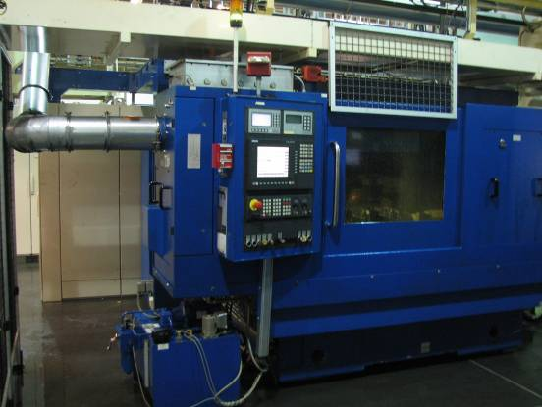
Schoudt CF41 Grinder on Line 1

Third Area
Line 7 & Addition of two (2) Finishing Lines scheduled for week 42 / 45 Mid October to Mid November
- Line 7 will have only two (2) grinders pulling to the ODR-3000. A third M2 grinder will be added in late Jan 2011
- Review the attached powerpoint and see the location and pick-up for two (2) Camshaft Finishing Lines. The oil will be the same as the Schault grinders, but the loading will be much less. At this time the lines do not exist so that a dust Track reading cannot be taken. We will need to see if the additional pick-ups will make it into the one existing ODR-3000 or if additional equipment will be necessary. We will need to look at adding an additional grinder to Line 7 in February 2011.
- There is some concern feeding both finish lines and 3 grinders to 1 ODR-3000. We may consider piping the two finish lines to a ODR-3000 in the north west corner of the building. This Absolent only supports 2 large oil filter systems.

Fourth Area
Line 7 – (New Finish Line 3) Addition of 1 Nagel Polish machine
Date CW 46 or CW47
- Install ducting to connect a new polish machine to ODR-3000 on Grinding line 7
- Machine has 2 6” diameter connections.
- Need to evaluate load on Grinding line 7 Absolent filter system.

