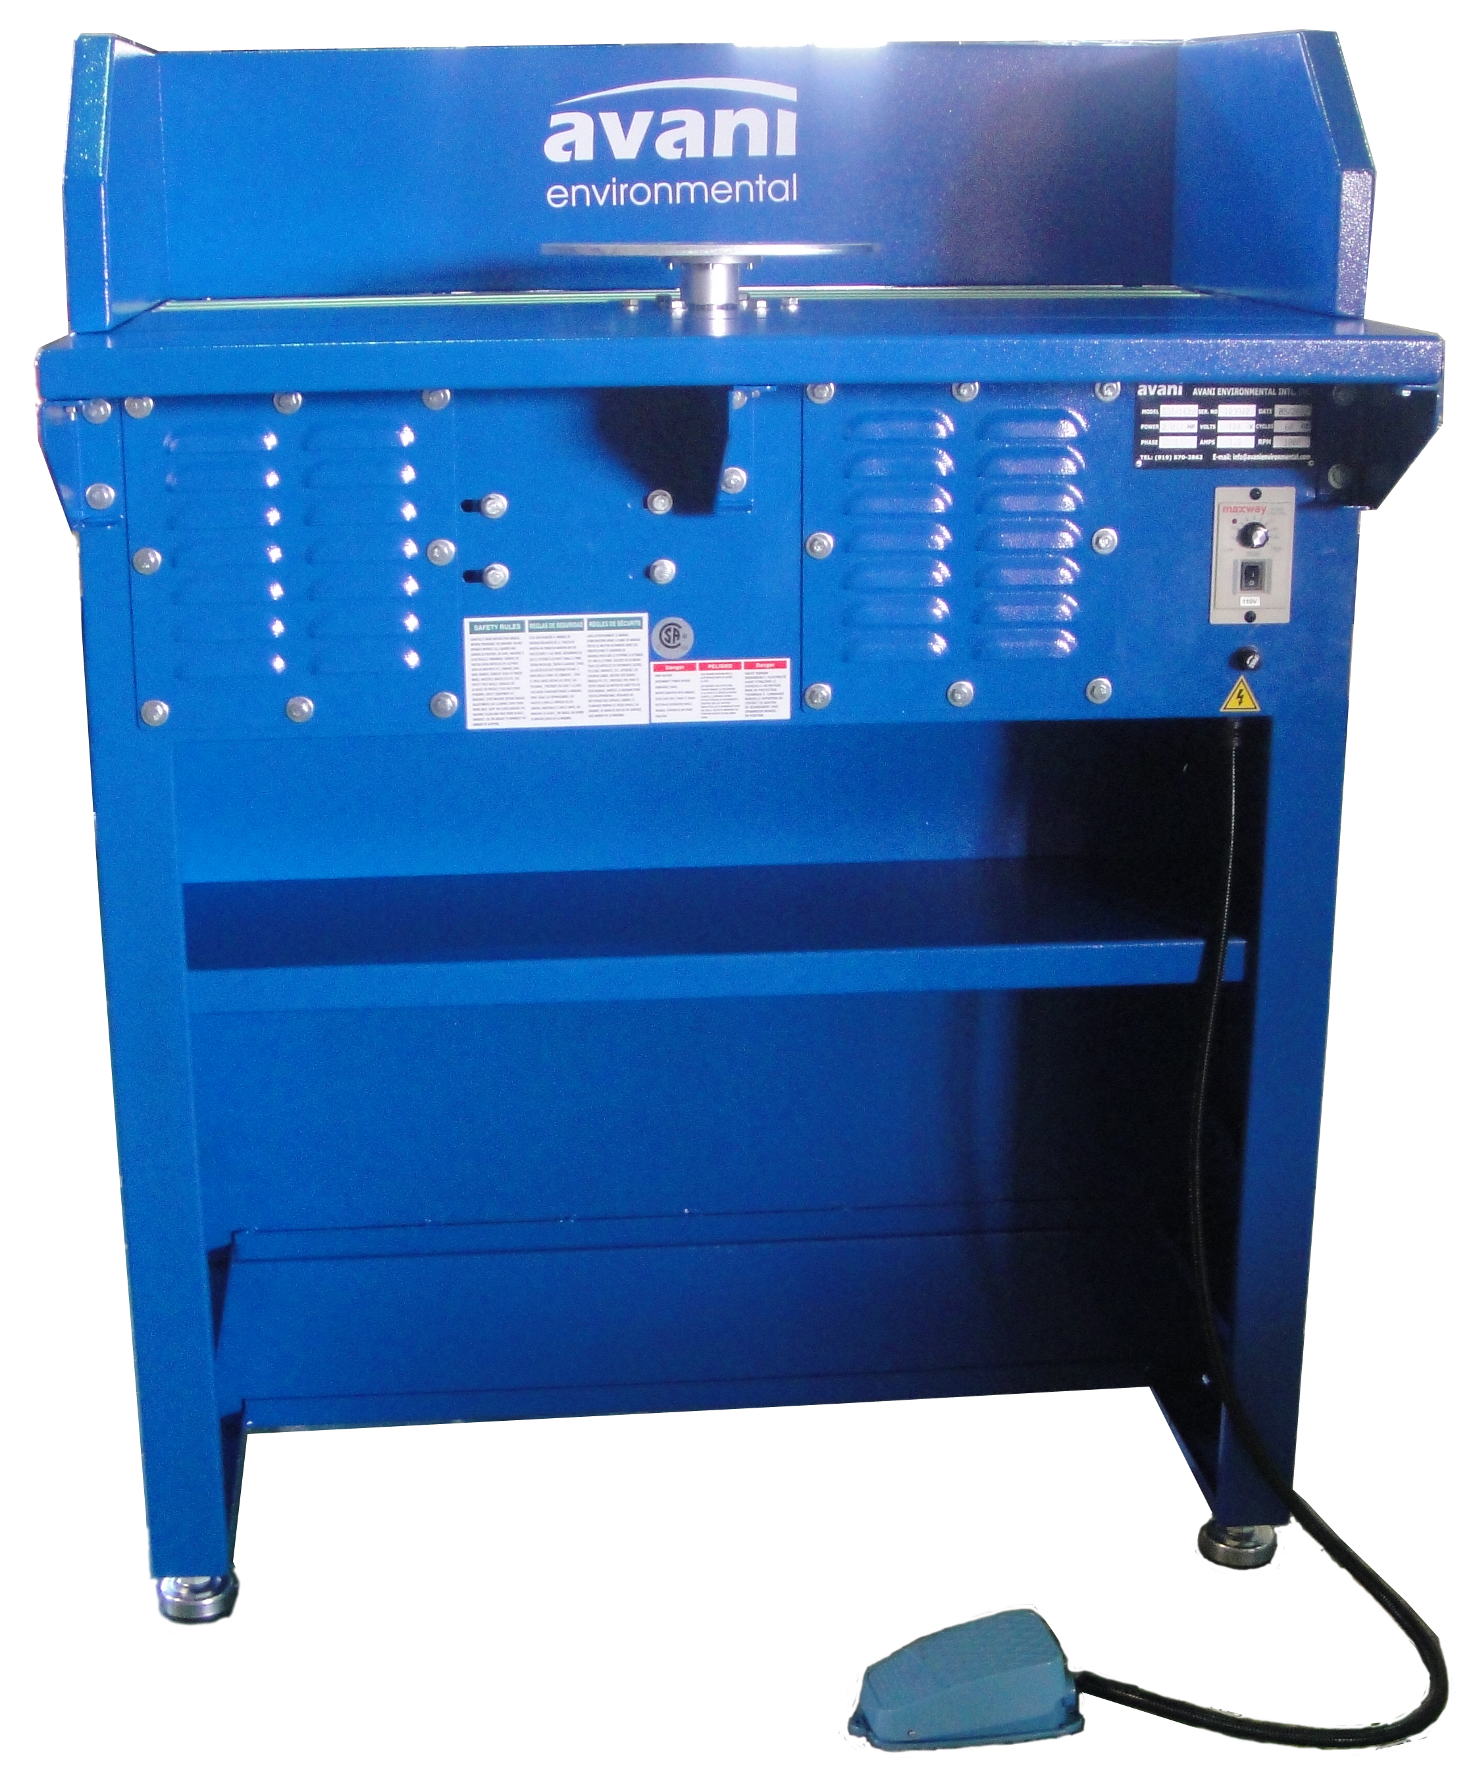

Customer:
Customer PO#:
AVANI SO#: |  | Tested By:
Serial #: | 123922
Ship Date / Install Date:

TABLE OF CONTENT
MACHINE WARNING SIGNS 3
TECHNICAL SPECIFICATIONS 4
SAFETY PRECAUTIONS 5
ELECTRICAL INSTALLATION 6
ELECTRICAL CIRCUIT DIAGRAM 7
SAFETY INSTRUCTIONS 11
OPERATION INSTRUCTIONS 12
AUTOCAD DRAWING 13
Dimensions (in mm/inches) 13
Repair Parts Illustration 14
Repair Parts List 15
Contact Information 18

General Safety Information

MACHINE WARNING SIGNS
 | Indicates an imminently hazardous situation which, if not avoided, will result in death or serious injury.
 | Indicates a potentially hazardous situation which, if not avoided, could result in death or serious injury.
 | Indicates a potentially hazardous situation which, if not avoided, may result in minor or moderate injury.
Used without the safety alert symbol ( ) indicates potentially hazardous situation which, if not avoided, may result in
property damage.
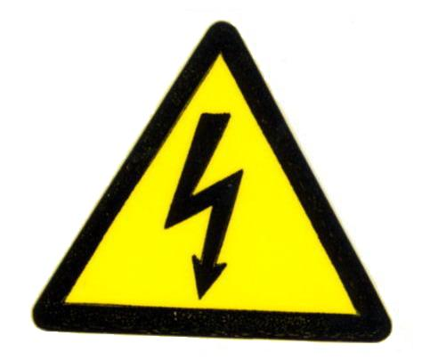 | Warning of electric shock
 | Do not expose the equipment to rain or use in damp locations.

Figure 1

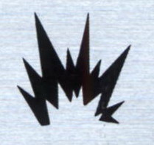 | Do not use the equipment around flammable products, if not avoided, sparks can ignite vapors from flammable products.
 | Read and understand all warnings and operating instructions before using this equipment. Failure to follow all instructions may result in electric shock, fire, and/or serious personal injury or property damage.

TECHNICAL SPECIFICATIONS

Motor Specs: |  | Manufacturer: | SmartVent
Electrical Specs: |  | Manufacturer: | SmartVent
Air Volume:
Inlet Size:
Packing Size:  (L x W x H) | 41.1” x 22.4” x 48”  (104.5 x 57 x 122 cm)
N.W. (machine): | 396.8 lbs (180 kgs)
G.W. (machine): | 463 lbs (210 kgs)

INSTALLATION

SAFETY PRECAUTIONS
Read this Manual carefully before installing and operating the product and maintain a copy on site for reference.

ELECTRIC SHOCK can kill.
- Have a qualified electrician install and service this equipment.
- Do not touch electrically live parts such as internal wiring.
- Insure all source power is turned off and locked out before electrical installation.

- Check that the voltage, phase count and grounding wire match the machine requirements.
- Check that the electrical specifications of this machine meets safety requirements, and that maintenance is carried out by a certified electrician.
- Confirm that the parts/accessories have been fully assembled to insure safe and reliable machine operation.
- Due to the weight of the unit, great care must be taken when moving to avoid injury. Use lifting and transport equipment as necessary.

INSTALLATION

ELECTRICAL INSTALLATION

ELECTRIC SHOCK CAN KILL.
- Have a qualified electrician install and service this equipment.
- Do not touch electrically live parts such as internal wiring.

- Do not disconnect the wiring jack before turning off power!

Electrical installation should be performed within the following conditions:
- Ambient temperature: Between 41°F and 131°F. If the time is over 24 hours, then the ambient average temperature shall not be over 122°F.
- Humidity: Between 30% and 95%
- Altitude: 3,280 feet
- Moving and Storing: -13°F to 131°F. For short-time storage (less than 24 hours), the storage temperature can be up to 158°F.

POWER CONNECTION
- All electrical connections must be performed by a qualified electrician.
- Confirm that the available power supply is equal to the motor and control panel voltage and amperage requirements (see installation-technical specifications)
- Insure that all power supplies are turned off and locked out prior to any connection to the unit.
- Refer to the electrical diagram (next page) for proper connection.

INSTALLATION

ELECTRICAL CIRCUIT DIAGRAM

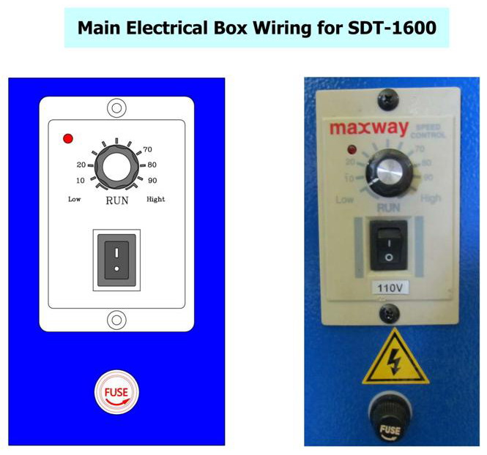
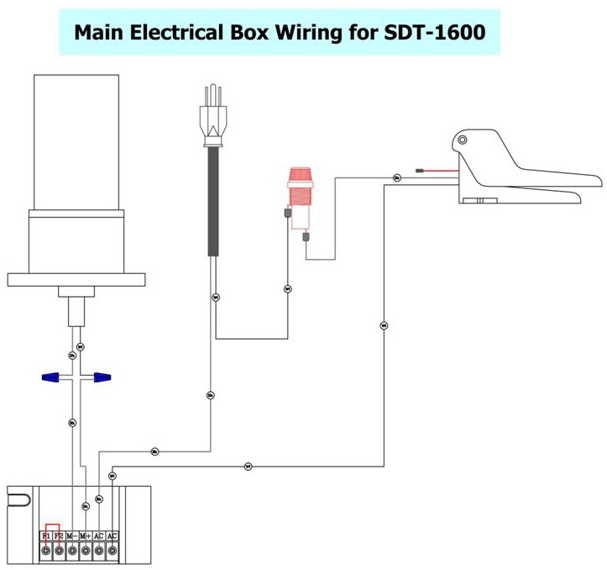

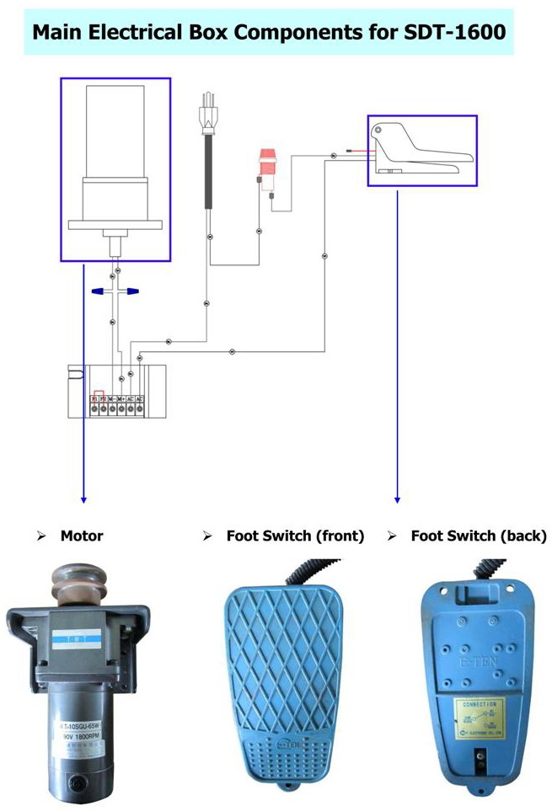
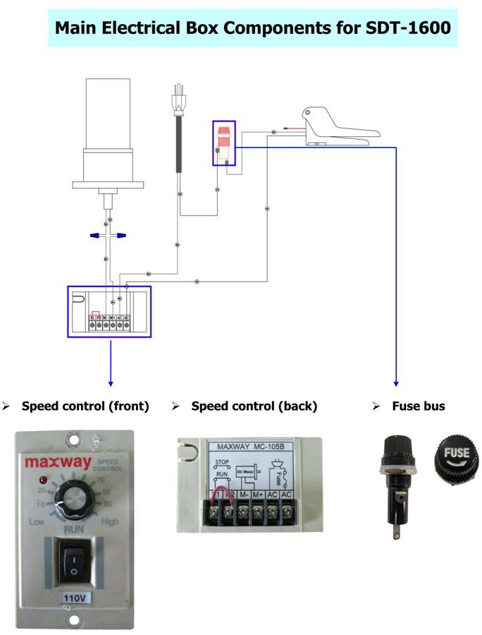

OPERATION

SAFETY INSTRUCTIONS

The Downdraft Table can be dangerous if it is operated incorrectly. Therefore, the product must be used with caution to avoid risk of injury and avoidable hazard or damage. Unnecessary injuries may occur by failing to follow the instructions within Manual. The following components are key to a safe workplace and safe operation of the fume extractor.

- Insure that the working environmental is suitable for using the product.
- Do not store or use flammable gas or liquids near the machine when in operation.
- All non-operating personnel should keep proper distance from the unit when in use, to avoid risk of injury. Keep other persons away from the product, except for the operator, to avoid danger.
- Inspect the electrical wires daily. If wiring is frayed or cut, immediately turn off the unit and turn off the power source and contact a qualified electrician for repair.
- Before replacing parts, turn the machine off and shut off power at the source.
- Do not operate the product near flammable materials, as sparks may ignite these materials and cause an explosion.
- Key components of the machine run at high speeds and can cause injury. Never place hands, body parts or foreign objects near moving parts. Do not wear loose clothing that can become entangled in moving parts.

OPERATION

OPERATION INSTRUCTIONS

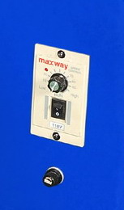
OFF
ON

The Downdraft Table is designed for the filtration of smoke generated during ordinary welding process work. When installed and operated correctly, the machine will effectively collect and screen the smoke yielding a significant improvement in air quality within the working environment.
- Before starting the machine, be sure to read this Manual carefully.
- Before starting the machine, insure that relevant safety protection measures have been taken according to the Manual.
- Before starting the machine, confirm the motor is turning in the direction as labeled on the machine.

AUTOCAD DRAWING

Dimensions (in mm/inches)

Repair Parts Illustration
Figure 2

PARTS

Repair Parts List
Please provide following information:
-Model number
-Serial number (if any)
-Part description and number as shown in parts list

Reference Number | Description | Part Number | Quantity
1 | Machine Body | OS05-02-SDT-1600-1 | 1
2 | Hex Nut | OS05-02-SDT-1600-2 | 4
3 | Adjustable Feet | OS05-02-SDT-1600-3 | 4
4 | Motor | OS05-02-SDT-1600-4 | 1
5 | Gear Motor | OS05-02-SDT-1600-5 | 1
6 | Belt Wheel | OS05-02-SDT-1600-6 | 1
7 | Motor Base | OS05-02-SDT-1600-7 | 1
8 | Cap Screw | OS05-02-SDT-1600-8 | 4
9 | Flat Washer | OS05-02-SDT-1600-9 | 4
10 | Bearing Base | OS05-02-SDT-1600-10 | 1
11 | Bearing | OS05-02-SDT-1600-11 | 2
12 | Rotation Axle | OS05-02-SDT-1600-12 | 1
13 | Bearing Base Cover | OS05-02-SDT-1600-13 | 1
14 | Hex Screw (5/16”*3/4”) | OS05-02-SDT-1600-14 | 3
15 | Belt Wheel | OS05-02-SDT-1600-15 | 1
16 | Clamp | OS05-02-SDT-1600-16 | 1
17 | Hex Screw (5/16"*3/4”) | OS05-02-SDT-1600-17 | 6
18 | Flat Washer (5/16"*OD23*2T) | OS05-02-SDT-1600-18 | 6
19 | Hex Nut (5/16") | OS05-02-SDT-1600-19 | 6
20 | Bearing Base | OS05-02-SDT-1600-20 | 1
21 | Motor Control Panel | OS05-02-SDT-1600-21 | 1
22 | Fuse | OS05-02-SDT-1600-22 | 1
23 | Fuse Nut | OS05-02-SDT-1600-23 | 1
24 | Phillips Head Sheet Metal Screw  (3/16"*3/4”) | OS05-02-SDT-1600-24 | 2
25 | Corrugated Plastic Tubing | OS05-02-SDT-1600-25 | 1
26 | Pedal | OS05-02-SDT-1600-26 | 1
27 | Foam Tape | OS05-02-SDT-1600-27 | 1
28 | Maintenance Door | OS05-02-SDT-1600-28 | 2
29 | Flat Washer (1/4”*OD19*2T) | OS05-02-SDT-1600-29 | 16
30 | Hex Screw (1/4"*3/4") | OS05-02-SDT-1600-30 | 16
31 | Tool Rack | OS05-02-SDT-1600-31 | 1
32 | Drawer | OS05-02-SDT-1600-32 | 1
33 | Foam Tape | OS05-02-SDT-1600-33 | 1
34 | Drawer Lock | OS05-02-SDT-1600-34 | 1
35 | Drawer Handle | OS05-02-SDT-1600-35 | 1
36 | Flat Washer | OS05-02-SDT-1600-36 | 2
37 | Hex Nut | OS05-02-SDT-1600-37 | 2
38 | Table Surface (grated) | OS05-02-SDT-1600-38 | 1
39 | Lazy Susan | OS05-02-SDT-1600-39 | 1
40 | Countersunk Phillips Head Screw  (5/16”*3/4”) | OS05-02-SDT-1600-40 | 4
41 | Wall (rear) | OS05-02-SDT-1600-41 | 1
42 | Side Wall (left) | OS05-02-SDT-1600-42 | 1
43 | Side Wall (right) | OS05-02-SDT-1600-43 | 1
44 | Hex Screw (5/16"*3/4") | OS05-02-SDT-1600-44 | 6
45 | Flat Washer (5/16"*OD23*2T) | OS05-02-SDT-1600-45 | 12
46 | Hex Nut (5/16") | OS05-02-SDT-1600-46 | 6
47 | Hex Screw (5/16"*3/4") | OS05-02-SDT-1600-47 | 8
48 | Flat Washer (5/16"*OD23*2T) | OS05-02-SDT-1600-48 | 8
49 | Outlet Connector (8") | OS05-02-SDT-1600-49 | 1
50 | Hex Screw (5/16"*3/4") | OS05-02-SDT-1600-50 | 6
51 | Flat Washer (5/16"*OD23*2T) | OS05-02-SDT-1600-51 | 5
52 | Power Cord | OS05-02-SDT-1600-52 | 1
53 | Welding Ground Cord | OS05-02-SDT-1600-53 | 1
54 | Extended Table Surface Support (left) | OS05-02-SDT-1600-54 | 1
55 | Extended Table Surface Support (middle & right) | OS05-02-SDT-1600-55 | 2
56 | Hex Screw (1/4"*3/4") | OS05-02-SDT-1600-56 | 6
57 | Flat Washer (1/4"*OD19*2T) | OS05-02-SDT-1600-57 | 6
58 | Extended Table Surface (grated) | OS05-02-SDT-1600-58 | 1
59 | Hex Screw (1/4"*3/4") | OS05-02-SDT-1600-59 | 8
60 | Flat Washer (1/4"*OD19*2T) | OS05-02-SDT-1600-60 | 4
61 | Hex Nut (1/4") | OS05-02-SDT-1600-61 | 4
62 | Hex Screw (1/4"*3/4") | OS05-02-SDT-1600-62 | 2
63 | Flat Washer (1/4"*OD19*2T) | OS05-02-SDT-1600-63 | 1
64 | Hex Screw (1/4"*3/4") | OS05-02-SDT-1600-64 | 4
65 | Flat Washer (1/4"*OD19*2T) | OS05-02-SDT-1600-65 | 4

Contact Information

Avani Environmental Intl. Inc.
95 Cypress Drive,
Youngsville, NC 27596
Email: info@avanienvironmental.com
www.avanienvironmental.com

Customer Service: info@avanienvironmental.com
Tel: 919-570-2862 ext. 5167

Engineering Service: engineering@avanienvironmental.com
Tel: 919-570-2862 ext. 5162

