General Safety Information

MACHINE WARNING SIGNS
 | Indicates an imminently hazardous situation which, if not avoided, will result in death or serious injury.
 | Indicates a potentially hazardous situation which, if not avoided, could result in death or serious injury.
 | Indicates a potentially hazardous situation which, if not avoided, may result in minor or moderate injury.
Used without the safety alert symbol ( ) indicates potentially hazardous situation which, if not avoided, may result in
property damage.
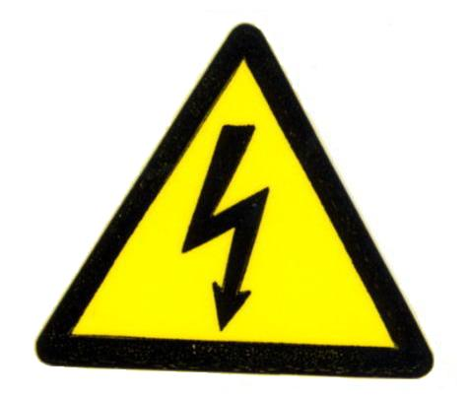 | Warning of electric shock
 | Do not expose the equipment to rain or use in damp locations.

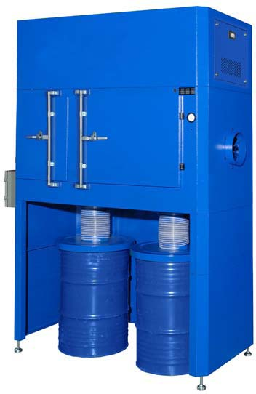
Figure 1
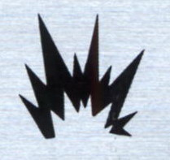 | Do not use the equipment around flammable products, if not avoided, sparks can ignite vapors from flammable products.
 | Read and understand all warnings and operating instructions before using this equipment. Failure to follow all instructions may result in electric shock, fire, and/or serious personal injury or property damage.

TABLE OF CONTENT
MACHINE WARNING SIGNS 1
Specifications 2
ADDITIONAL DUST COLLECTOR SAFETY RULES 4
Assembly 5
Installation 5
ELECTRICAL INSTALLATION 5
Operation 6
Filters 9
Assembly Procedure 11
Control Panel Explanation 14
Accumulated Function: 14
Pulse Cleaning Setting: 15
Repair Parts Illustration 16
Repair Parts List 17
Appendix 1 - Electrical Circuit Diagram 19
Contact Information 24

Specifications

Motor ………………………………………….………..…………………….…... 7.5 HP (5593 W)
…………………………………………………………………………… 230V / 60Hz / 3Ph
Air Volume (C.F.M.) ……………………………………………. 2460 Ft³/Min (69.6 M³/Min)
Inlet Size ……………………………..…………………………….….…..……. Ø 12” (30.5 cm)
Packing Size (L x W x H) …………….. 79.3” x 107.9” x 48” (201.5 x 274 x 122 cm)
Net Weight ……………………………….……………………..……………. 1195 lbs (542 kgs)
Gross Weight ……………………………….………………….………….. 1565.3 lbs (710 kgs)

General Safety Information
(Continued)
Use this product carefully to effectively avoid any possible danger. Observe the following safety regulations to avoid bodily injury due to electrocution during use.

Read this Manual carefully before operating the product and preserve the Operation Manual properly.
- Keep work area clean and organized.
- A disorderly working environment will cause inconvenience and danger during operation.
- Check if the working environment is suitable for using the product.
- Do not use the product in a humid environment.
- Use the product in a good working environment to reduce risks.
- Do not use the product in a flammable gas or liquid environment to avoid danger.
- Keep other persons away from the product, except for the operator, to avoid danger.
- Do not let children get close to the product. All wires used by the product shall be in a safe location to prevent children from touching them.
- All tools shall be safely stored.
- When the tools are not used, please store them in a dry place safely beyond the reach and access of children.
- If the machine breaks down, contact a service technician. Do not attempt to repair and possibly damage the machine.
- When using the product, be sure to put on a suit and mask.
- Use the electrical wires correctly.
- During use, do not drag the electrical wires forcefully. Do not use these wires if fraying or current leakage occurs to avoid injury to the operator.
- Before replacing parts, shut off power to the machine.
- Check that the switch is in “on” or “off” position. Do not attempt the replacement when the machine is running. To replace parts or filter material, make certain that the switch is “off”.
- Use the power cord correctly. The total length of power cord shall not exceed 10 feet to avoid low power due to a drop in voltage and to prevent a possible hazard.
When connecting the product, always follow the instructions in the Operation Manual to avoid injuries.
- Care and Maintenance:
- Confirm that the parts/accessories have been fully assembled and will not adversely affect the machine operation.
- Check if the machine is operated properly.
- Replace damaged parts or accessories according to the instructions of the Manual. If the said instructions are not specified in the Manual, have a professional technician carry out the maintenance or replacement.
- Check that the electrical specifications of this machine meet safety requirements, and that the maintenance is carried out by a professional technician. Use original manufacturer’s parts and accessories to avoid injury.
- If a problem occurs, contact your dealer immediately.

ADDITIONAL DUST COLLECTOR SAFETY RULES
The Dust Collector can be dangerous if it is operated incorrectly. Therefore, the product must be used cautiously to avoid causing a hazard or damage. Unnecessary injuries may occur by failing to follow the instructions of the Safety Rules Manual. Be sure to put on protection equipment or suit that can protect your body, such as helmet and eye mask to avoid injuries from occurring. If any doubts or any unfitness occurs during use, be sure to stop the operation immediately. Keep in mind that the user shall be liable for using according to the specified safety rules and for operating the machine correctly.
- Read this Manual carefully before operating the product.
- Be sure to follow local electrical and safety regulations and observe the electrical safety standards practiced in the relevant area. All electrical wire connections and installation shall be carried out by a professional technician.
- Do not operate the product near flammable materials, as sparks may ignite these materials and cause an explosion. Please confirm there aren’t any flammables near the working site to avoid hazard.
- This product is suitable for collecting smoke and oil gas. Do not use it in collecting iron chips and dust at the same time to avoid producing sparks.
- Before replacement of parts or filter materials, be certain that the switch is disconnected.
- Do not kink the power cord and keep it away from oil, chemicals or flammables.
- Check that the voltage, phase count and grounding wire match the machine requirements.
- When the fan blades are operated at high speed, do not reach hand near these blades to prevent finger from breaking or clothes/necktie from getting caught. Do not put the hand or foreign matter into the air inlet to avoid getting caught in the high-speed rotation of fan blades.
- When not in use, all air inlets of Dust Collector Machine shall be covered.

Assembly
Do not connect the Dust Collector before the assembly is finished and you have read and understood all of the precautions stated in the Manual.
NOTE: For correct assembly, refer to the Illustrations and Parts List on pages 16-18.

Installation
MOVING AND TRANSPORTATION
The net weight of this machine is about 1195 lbs. It CANNOT be handled and transported without the help of lifting tools. For your safety, read all instructions carefully.
Do not move without the help of others to avoid causing danger.

ELECTRICAL INSTALLATION
POWER CONNECTION
- Confirm that the power is properly connected under normal power supply condition. It is recommended to provide manual shutdown device before connecting power.
- It is recommended to protect the control equipment with suitable grade of fuse, and the length of fuse and power cord shall not be over 10 feet.
SHUTDOWN
- Disconnect power by manual method.
- When stopping operation, check if the switch is under off status.
EARTHING WIRE
Connect yellow/green wires to the earthing wire power jack. Confirm that the earthing wire has been properly connected before connecting main power cord to the machine at all times.
Do not disconnect the wiring jack before cutting off power!
POWER INSTALLATION AND STORAGE
The electrical power is configured as following. If conditions are beyond the scope stated below, then it is required to ensure that the power is well arranged and safe.
- Ambient temperature: Between 41°F and 131°F. If the time is over 24 hours, then the ambient average temperature shall not be over 122°F.
- Humidity: Between 30% and 95%
- Altitude: 3,280 feet
- Moving and Storing: -13°F to 131°F. For short-time storage (less than 24 hours), the storage temperature can be up to 158°F.

Operation
PRIOR TO START UP
Purpose: The Dust Collector is specially suitable for treating the smoke generated during ordinary processing work, which can effectively collect and screen the smoke resulting from the work in maintaining the air quality of the working environment.
- Before starting the machine, be sure to read this Manual carefully.
- Before starting the machine, check if relevant safety protection measures have been taken according to the Manual.
- Before starting the machine, watch the motor turning direction according to the instruction of arrow direction.
START UP
- To ensure satisfactory performance for the Dust Collector, please confirm the air volume, power and the matching table of the Dust Collector.
- Connect power according to electrical installation procedure after installing the Dust Collector and the table. Disconnect power according to electrical installation procedure when the machine is not used.
- The Dust Collector shall be turned on and off by pushing I/O button. Under normal operation status, use such I/O button.
Unpacking
The machine should be unpacked carefully. Check if the machine and components are consistent with those indicated in the Parts List. If any doubt arises or when the components are incomplete, contact your dealer.

Dimensions (in mm/inches)

Filters
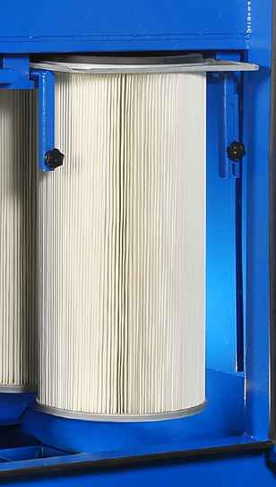
1. cartridge filter
Figure 2 - Filters

- PLEATED CARTRIDGE FILTER that can be cleaned by push-button pulse-jet cleaning of the cartridge filter from an onboard air tank.
- specification: Ø12.8” x 26”
- no. of cartridges installed: 6 pcs
- filtering area: 60 m²

- Cartridge filter replacement procedure:
- Open the front maintenance door.

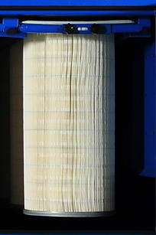
- Loosen the knobs (circled in green). Release the filter handle fixing plates. Slide the filter handle fixing plates.

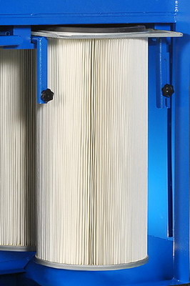
- Pull down the left and right filter handles.
- Take out the cartridge filter set.
- Slide the new cartridge back into the track and push it to the end.

- Push back the left and right filter handles to secure the cartridges in position.
- Pull up the left and right filter handles.

- Attach the filter handle fixing plate upon the left and right filter handles. Adjust and secure them in position. Fasten the plates and handles with knobs (circled in green).

- Close the front maintenance door. Assembly completed.

Assembly Procedure

- 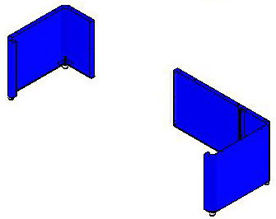

- 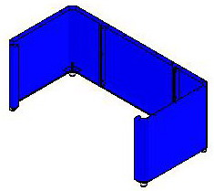

- 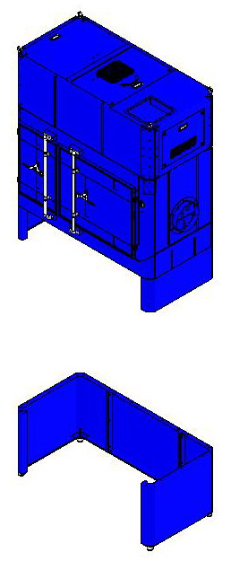

- 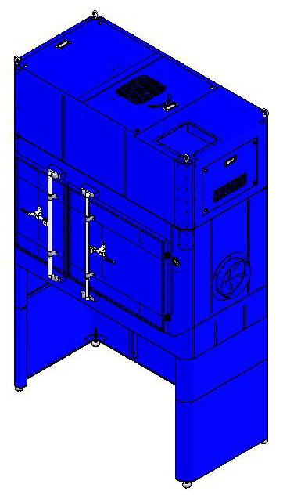

- 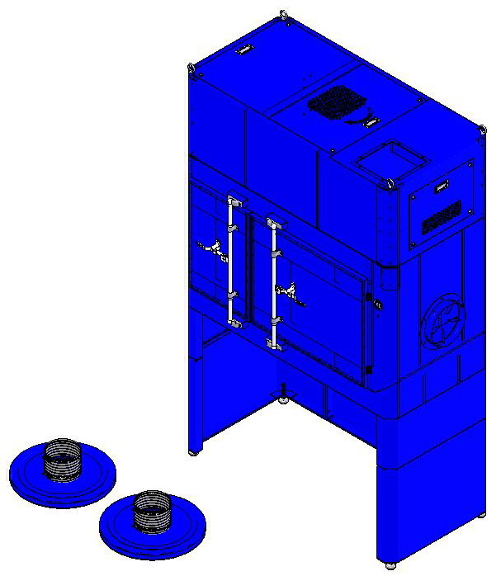

- 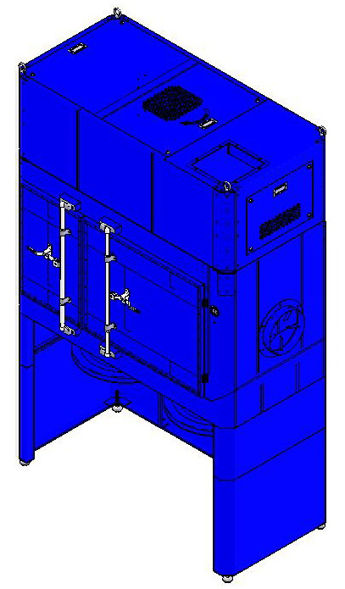

- 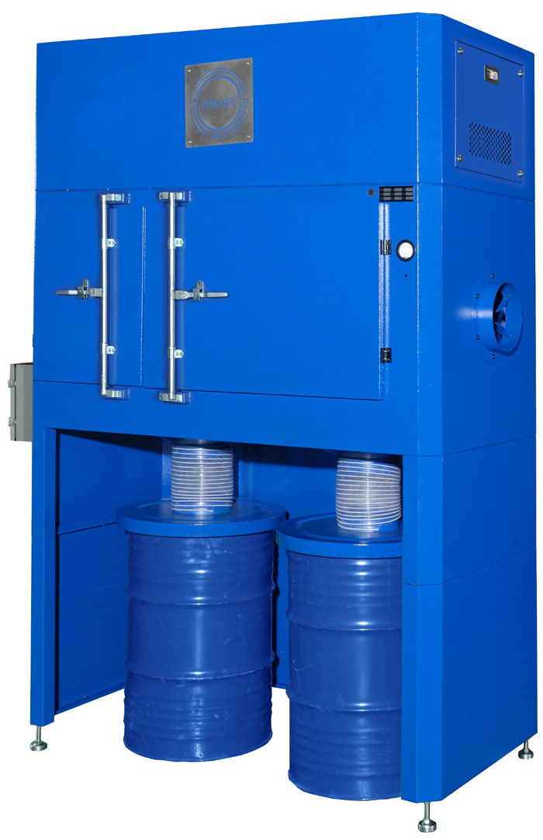

Control Panel Explanation
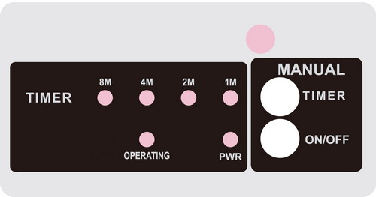
8M/4M/2M/1M: Time setting indicating light (accumulated function)
TIMER: Time adjusting button
ON/OFF: ON / OFF button
PWR: Power indicating light
OPERATING: Operation indicating light

Accumulated Function:
- When operating, timer will automatically set to release air in every 1 minute.
- Press TIMER once, the time setting light will be switched to 2M. Press it one more time, both 1M and 2M lights will be on, so the time is accumulated to clean in every 3 minutes.
- Press TIMER again, the time setting light will be switched to 4M.
- Press it one more time, both 1M and 4M lights will be on and the time is accumulated to clean in every 5 minutes. Press it again, both 2M and 4M lights will be on and the time is accumulated to clean in every 6 minutes. Press it again, the 1M, 2M and 4M lights will be on and the time is accumulated to clean in every 7 mins.
- Following this cycle, the time setting may be adjusted manually to 1, 2, 3, 4, 5, 6, 7, 8, 9, 10, 12 and 15 mins. The maximum allowance time setting would be 15 mins.

Pulse Cleaning Setting:
Timer Operation (Accumulated Function)
Pulse Frequency | 8M | 4M | 2M | 1M
ON
1
2
3
4
5
6
7
8
9
10
11

Repair Parts Illustration

For Repair Parts, call +1-919-570-2862
24 hours a day – 365 days a year
Please provide following information:
-Model number
-Serial number (if any)
-Part description and number as shown in parts list
Figure 3

Repair Parts List
Repair Parts List for Dust Collector

Reference Number | Description | Part Number | Quantity
1 | Machine Body | A02-01-FE-2100J-76-1 | 1
2 | Motor Chamber | A02-01-FE-2100J-76-2 | 1
3 | Impeller | A02-01-FE-2100J-76-3 | 1
4 | Motor Base | A02-01-FE-2100J-76-4 | 1
5 | Motor | A02-01-FE-2100J-76-5 | 1
6 | Silencer | A02-01-FE-2100J-76-6 | 1
7 | Z-Shaped Silencer | A02-01-FE-2100J-76-7 | 1
8 | Valve (1-1/2”) | A02-01-FE-2100J-76-8 | 2
9 | Dehumidifier | A02-01-FE-2100J-76-9 | 1
10 | Access Maintenance Door (back) | A02-01-FE-2100J-76-10 | 1
11 | Access Maintenance Door (side) | A02-01-FE-2100J-76-11 | 1
12 | Cover (top) | A02-01-FE-2100J-76-12 | 1
13 | Filter Tray | A02-01-FE-2100J-76-13 | 3
14 | Cartridge Filter | A02-01-FE-2100J-76-14 | 6
15 | Filter Handle (left) | A02-01-FE-2100J-76-15 | 3
16 | Filter Handle (right) | A02-01-FE-2100J-76-16 | 3
17 | Filter Handle Fixing Plate | A02-01-FE-2100J-76-17 | 3
18 | Flat Washer (5/16”) | A02-01-FE-2100J-76-18 | 6
19 | Knob | A02-01-FE-2100J-76-19 | 6
20 | Door (big) | A02-01-FE-2100J-76-20 | 1
21 | Door (small) | A02-01-FE-2100J-76-21 | 1
22 | Base Chamber (left) | A02-01-FE-2100J-76-22 | 1
23 | Base Chamber (middle) | A02-01-FE-2100J-76-23 | 1
24 | Base Chamber (right) | A02-01-FE-2100J-76-24 | 1
25 | Hopper | A02-01-FE-2100J-76-25 | 2
26 | Clamp (9”) | A02-01-FE-2100J-76-26 | 4
27 | Hose (9”) | A02-01-FE-2100J-76-27 | 2
28 | 50 Gallon Drum Lid | A02-01-FE-2100J-76-28 | 2
29 | Connector | A02-01-FE-2100J-76-29 | 1

Appendix 1 - Electrical Circuit Diagram

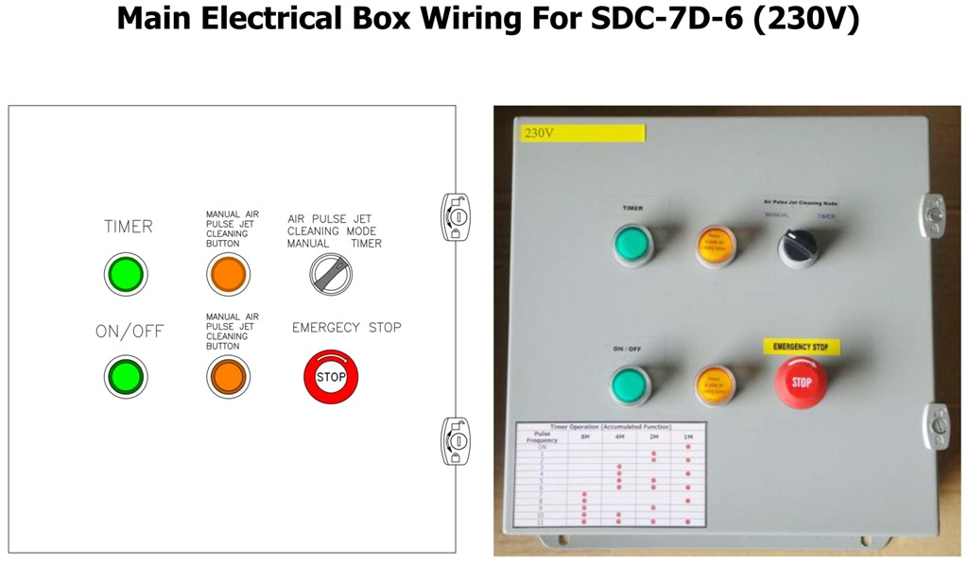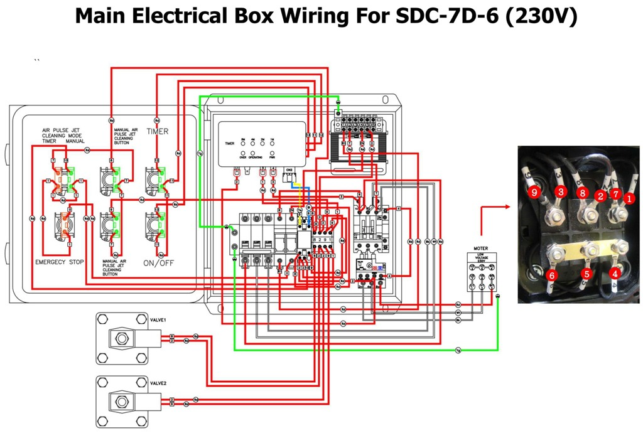

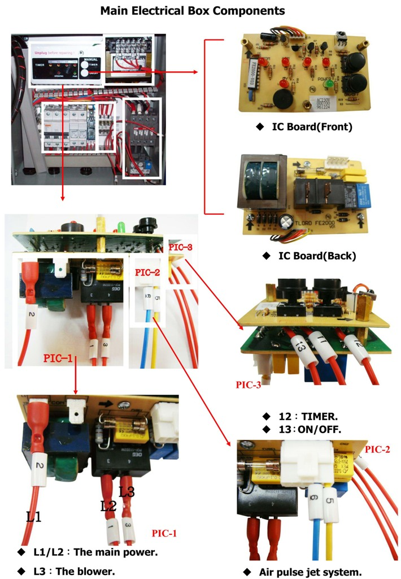
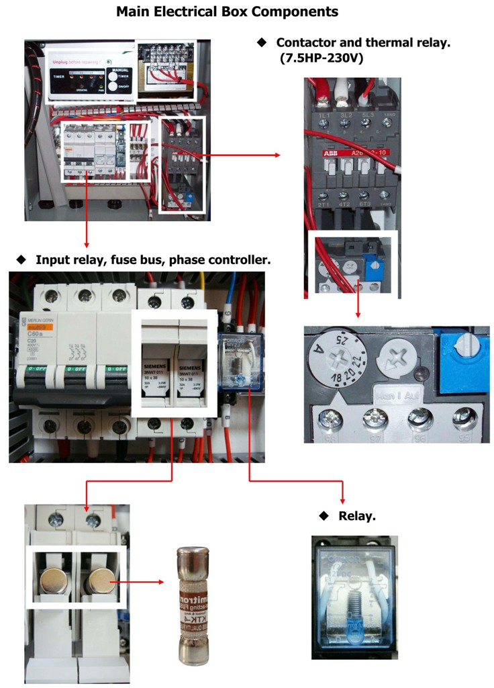
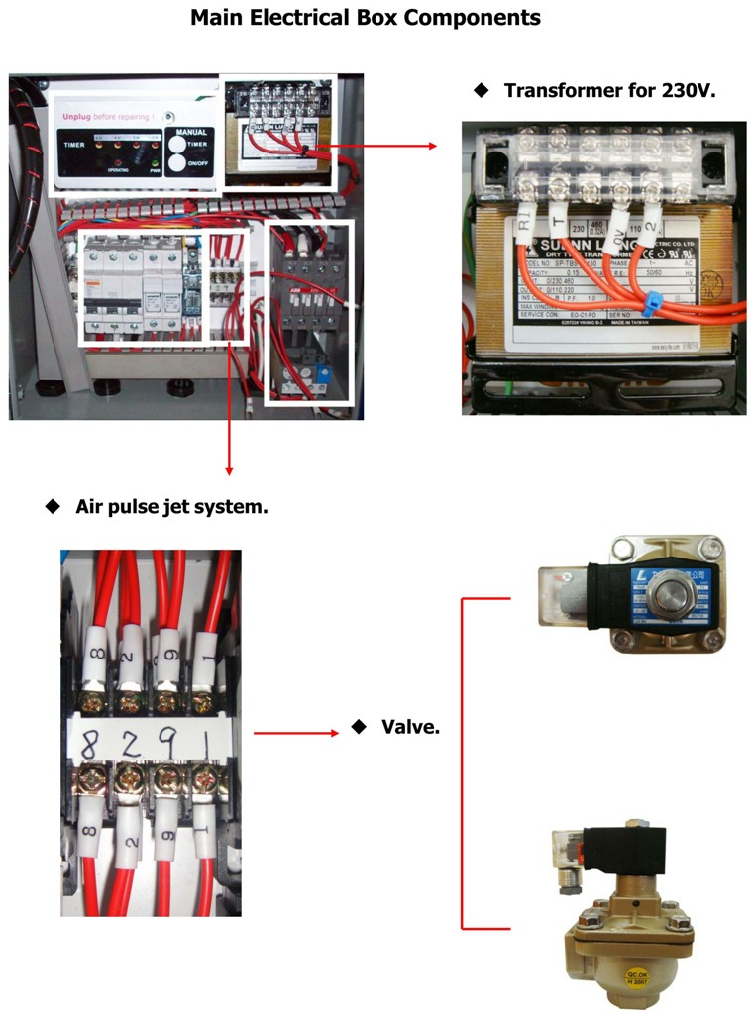

Contact Information

Avani Environmental International Inc.
95 Cypress Drive,
Youngsville, NC 27596
Email: info@avanienvironmental.com
www.avanienvironmental.com

Customer Service: info@avanienvironmental.com
Tel: 919-570-2862 ext. 208

Engineering Service: engineering@avanienvironmental.com
Tel: 919-570-2862 ext. 203

