SBS Modified BitumSBS Modified Bitumen Roofing Membranes
SBS (Styrene Butadiene Styrene)
Johns Manville has developed formulations that enhance the asphalt's overall weatherability by modifying premium-grade asphalts. By combining these modified asphalts with non-woven polyester or glass fiber reinforcements, JM produces waterproofing systems that exhibit tremendous strength, elasticity and weatherability.
SBS is a rubberized modifier that increases the overall performance of the sheet by providing excellent elongation and recovery characteristics. SBS modifiers extend the service range of the product, so that it can be handled in cooler temperatures without cracking or shattering, and in warmer temperatures without softening to the point where it begins to flow.

SBS Modified Bitumen Roofing System — DynaWeld™/DynaGrip™ SD/SA Hybrid System (2FID-SA/HW)
Due to the high demand for Invinsa™ Roof Board in modified bitumen roofing systems, Johns Manville now offers a 2FID-SA/HW specification. The new hybrid specification is a two-ply SBS modified bitumen roofing system over ENRGY 3® insulation and Invinsa. It is installed using a combination of self-adhered and heat-welded application techniques.

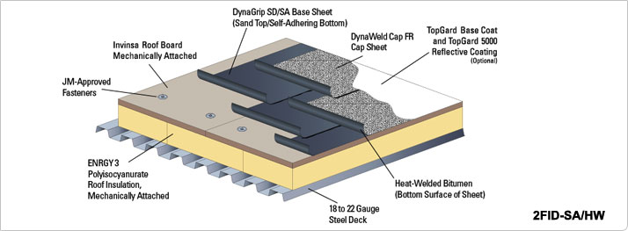

www.specjm.com/commercial/roofing/sbsbituminous.asp
Roofing Contact: Mark @ Marion Green (Office: 443-3244 or Cell: 351-2857)

