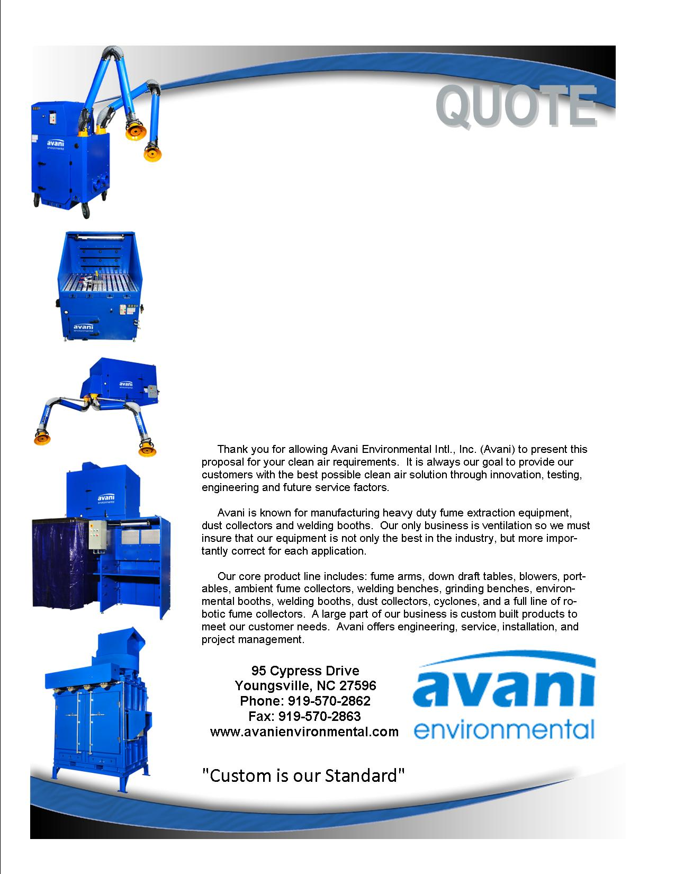

Attn: Andy Albin

**Hi-Cone**

**Quote #: AE-003844**

Quote by: **Fred Johnson**

Email: fjohnson@avanienvironmental.com

April 20, 2012

**Avani Environmental Intl., Inc.**

**95 Cypress Drive**

**Youngsville**, **NC 27596**

Phone: 919-570-2862 Fax: 919-570-2863

**Quote #: AE-003844** April 20, 2012

Quote by: **Fred Johnson**

Attn: Andy Albin

**Hi-Cone**

**1155 N. Fifth Street**

**Charleston, IL 61920**

Dear Andy,

As recently reviewed at your facility last week, we are pleased to provide the following quotation. Our testing showed each grinder hood exhausts a maximum of 500 CFM from each 13” x 26” outlet. To this we have added 100 CFM to keep suction around the perimeter of each hood. There will be a 1” opening around this perimeter hood to not allow all the suction to draw out of the grinder. We will collect only the fines in the exhaust air stream. Each hood will have a 6” connection with a blast gate to control this air flow. We will start with 6” pipe on grinder 1 and increase in duct size to 14” diameter as it enters the dust collector. Note that grinder 5 is not part of this system design. The dust collector will sit next to grinder 8 and exhaust back into the room. The exact ducting route will need to be finalized with you. At this time, we are running the pipe about 7 feet above the grinder outlets and horizontal and a straight run across the room to the dust collector.

|  |  |  |  |  |  |
| --- | --- | --- | --- | --- | --- |
| **Product Name** | **Product Description** | **Product Picture** | **Quantity** | **Unit Price** | **Total Price** |
| Dust Collector by Scientific Dust Collector | Model MP-8 Cartridge Collector with eight vertical cartridges having a total of 1,056 square feet of media with grounding tabs, slidegate and drum lid adapter. Roof mounted will be a Cincinnati Fan, model HDBI-160 with 20 HP motor, a discharge damper is mounted on the fan exhaust Design Volume is 5,600 CFM at a static pressure of 10” WC |  | 1 | $25,905.00 | $25,905.00 |
| Duct by K&B | Pre-fabricated ductwork (clamp together duct). Complete with straight duct, branch transitions, and elbows and branches.  System description noted above |  | 1 | $8,168.00 | $8,168.00 |
| Installation – Avani  Crew of two people for a period of three days, includes travel and living expenses | Mechanical Installation: Labor to install and assemble.  (Excludes: lift rental, electrical wiring, drain plumbing, fire suppression, demolition work or holiday work - unless otherwise stated) |  | 1 | $7,200.00 | $7,200.00 |
|  |  |  |  |  |  |
|  |  |  |  | **Grand Total:** | **$41,273.00** |

**Total does not include shipping cost**

Additional Product Options:

|  |  |  |  |  |
| --- | --- | --- | --- | --- |
| **Product Number** | **Product Description** | **Quantity** | **Unit Price** | |
| Freight Estimate | Dust Collector, fan, Ducting |  | $1,750.00 | |
|  |  |  |  | |
|  |  |  |  |

Let me know if you have any questions and when it would be convenient for you and your staff to begin discussing final terms of a contract.

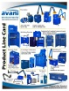 Feel Free to Review the Avani Product Line: [CLICK HERE](http://issuu.com/avanienvironmental/docs/product_line_card_new_2011?mode=window&backgroundColor=%23222222).

Sincerely,

**Fred Johnson,**

Phone: 847-902-2210 Cell

Email: fjohnson@avanienvironmental.com

**Terms and Conditions**

**General:**

1. The price does not include sales tax, duties, custom fees or any other cost associated with the sale or delivery of this product.
2. Payment Terms: Noted in the body of the quote. All quoted prices and payments are in US dollars.
   1. Customized products: 35% down with PO, 35% prior to shipment and 30% net 30.
   2. International Orders: 40% down with PO, 40% prior to shipment and 20% net 30.
   3. New Customers: 35% down with PO and 65% net 30.
3. Quotation price does not include actual shipping costs. All products are shipped FOB from manufacturer. If requested by Buyer, Avani can supply an estimated shipping cost(s). The estimated shipping cost is only an estimate and actual charges can be different from estimated charges.
4. Late payments and any charges associated with the Late payment begin incurring charges 30 days after standard payment terms are due.

**Shipping and Delivery Time:**

1. All products are FOB Manufacturer
2. Shipping times: Stock items – 1 week, Non-stock items –8 weeks, Customized products –10 weeks. If deposits and/or signed drawings are required for specific job; shipping time begins after Avani has received these items.
3. Unless otherwise stated on the purchase order Avani will ship Best Way Prepay and Add.
4. All products that are shipped via Truck will be shipped with standard pallets and shipping material. If needed or requested by the buyer the product(s) can be completely crated for an additional cost.
5. The Buyer is responsible for inspecting the Product(s) immediately when they are delivered and must state upon delivery if the Product(s) is damaged or has missing parts. If not, the Product(s) are acknowledged as being complete and satisfactory.

**Warranty and Return:**

1. All New Products come with a standard 1 year warranty. Other warranties and terms are available and must be approved by an Avani personnel.
   1. Warranty covers replacement parts for 1 year.
   2. Does not cover labor or charges incurred for removing and installing new parts.
   3. Not responsible for loss of use or downtime.
2. Returns product(s) must be approved by Avani before being sent back.
   1. Must have an RGA and Case # when the product(s) is shipped back.