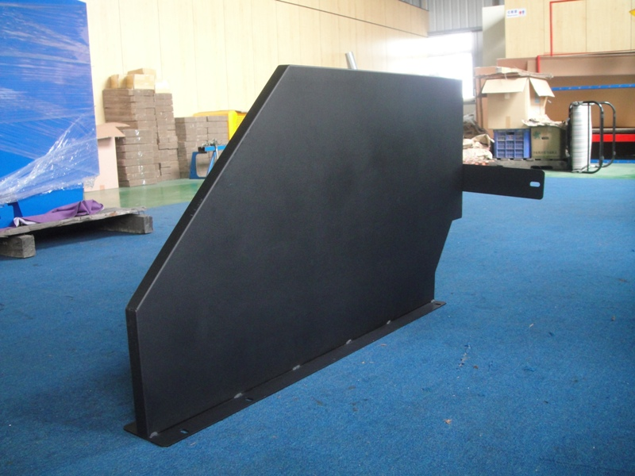
1
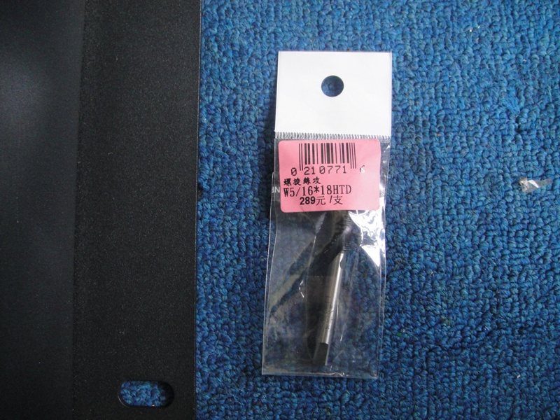
- Use 5/16” x 18 to tap thread the top holes as to fix the partition on the table top.
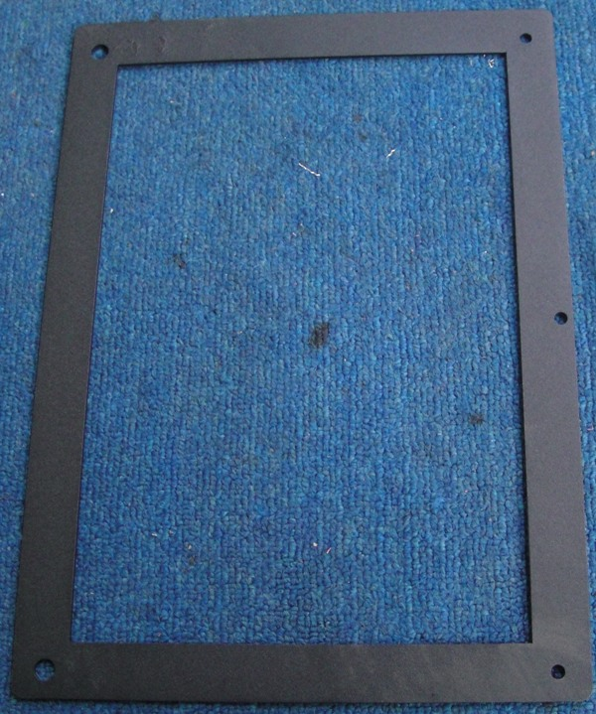
- Attach the fixture at the table back.
- Drill Ø 5.1 mm holes.
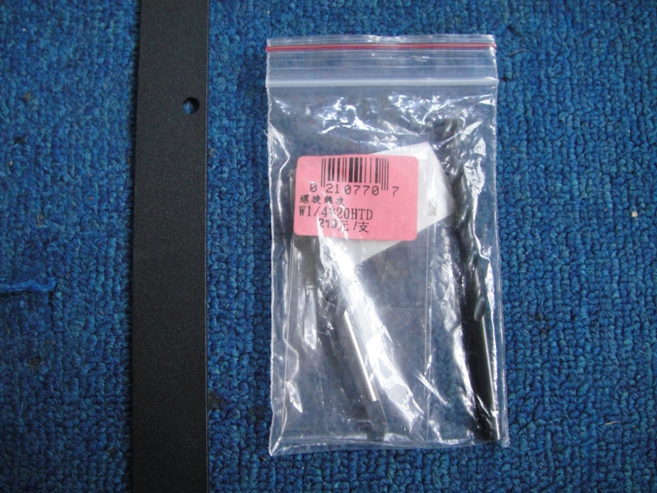
- Tap thread the holes with 1/4” x 20.
- Attach the downdraft table to inlet pipe ducting.

