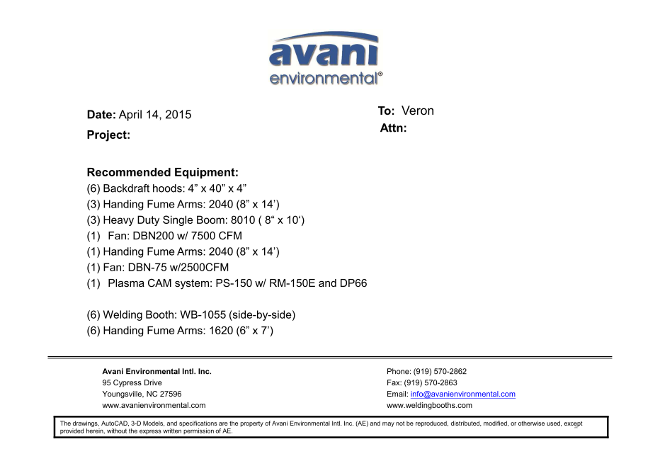

Backdraft Hoods unit cost: US$765 x 6 =US$4,590.-

Heavy duty single boom BM8010 cost: US$1,093 x 3 = US$3,279.-

Fume Arms 2040 cost: US$516 x 3 = US$1,548.-

DBN-200 unit cost: US$3,900 x 1 = US$3,900.-

DBN-200-C unit cost: US$1,000 x 1 = US$1,000.-

Silencer for DBN-200 unit cost: US$350 x 1 = US$350.-

Fume Arms 2040 cost: US$516 x 1 = US$516.-

DBN-75 unit cost: US$2,400 x 1 = US$2,400.-

DBN-75-C unit cost: US$610 x 1 = US$610.-

***Plasma Cam System:***

(SPC-2000+RE-150ME + DDT-PC66) unit cost: US$2,960 x 1 = US$2,960.-

**TOTAL PROJECT COST: USD21,153.-**

**Optional:**

WB1055 unit costs: US$1,269 x 6 = US$7,614.-

Fume Arm 1620 cost: US$332 x 6 = US$1,992.-

**TOTAL PROJECT COST: USD9,606.-**