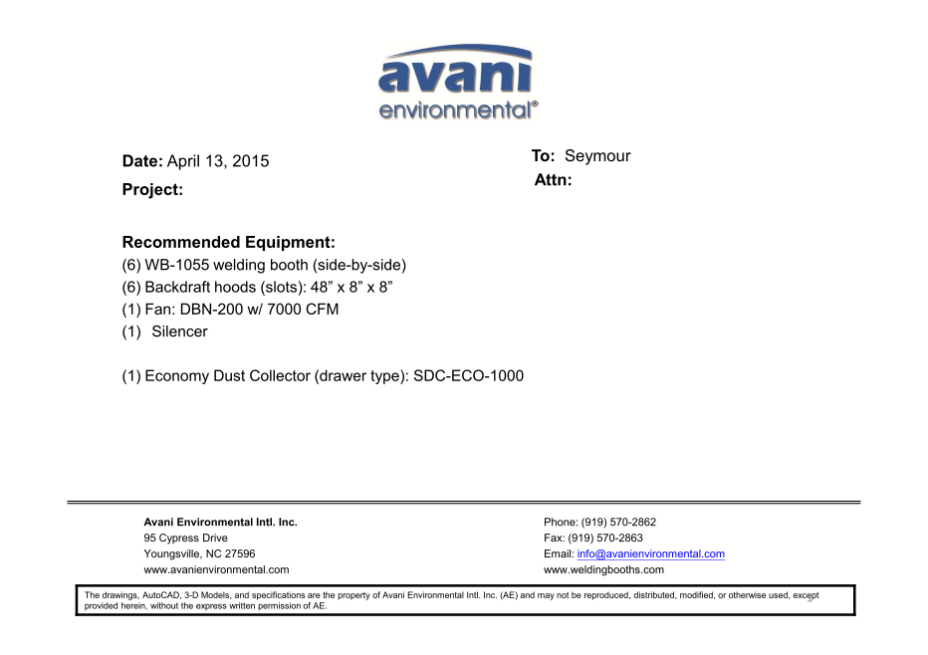

WB1055 Booth unit cost: US$1,241 x 6 = US$7,446.-

Backdraft Hoods unit cost: US$840 x 6 = US$5,040.-

DBN-200 unit cost: US$ 3,900 x 1 = US$3,900.-

DBN-200-C unit cost: US$1000 x 1 = US$1,000.-

Silencer for DBN-200 cost: US$350 x 1 = US$350.-

ECO-1000 unit cost: US$1,657 x 1 =US$1,657.-

**TOTAL PROJECT COST: USD19,393.-**