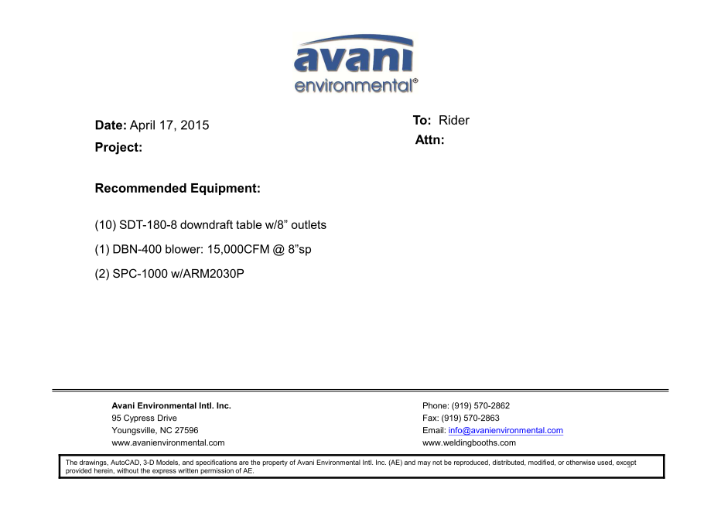

SDT-180-8 unit cost: US$700 x 10 = US$7,000.-

DBN-400 unit cost: US$4,600 x 1 = US$4,600.-

DBN-400-C unit cost: US$1,450 x 1 = US$1,450.-

Silencer for DBN-400 unit cost: US$440 x 1 = US$440.-

SPC-1000 unit cost:US$1,090 x 2 = US$2,180.-

ARM 2030P unit cost: US$458 x 2 = US$916.-

**TOTAL PROJECT COST: USD16,586.-**