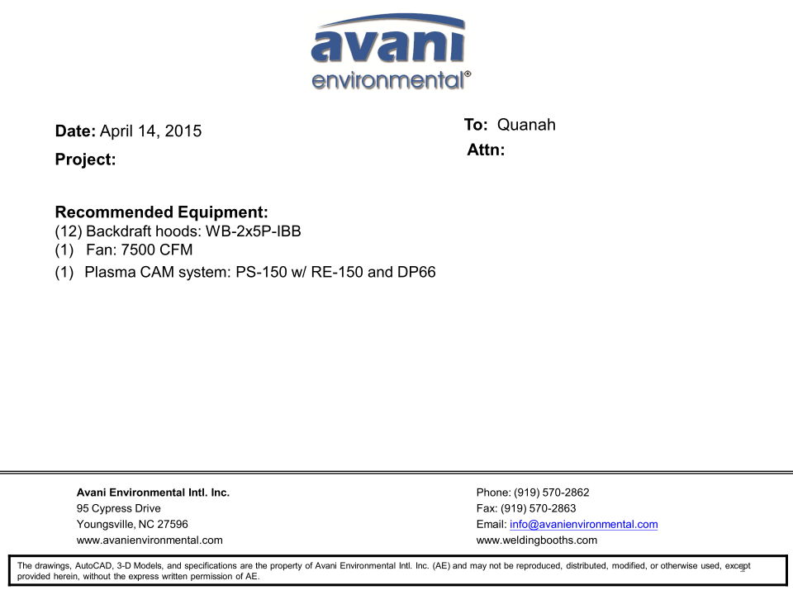

Backdraft Hood unit cost: US$625 x 12 =US$7,500.-

DBN-200 unit cost: US$3,900 x 1 = US$3,900.-

DBN-200-C unit cost: US$1,000 x 1 = US$1,000.-

Silencer for DBN-200 unit cost: U$350 x 1 = US$350.-

***Plasma Cam System:***

(SPC-2000+RE-150ME + DDT-PC66) unit cost: US$2,960 x 1 = US$2,960.-

**TOTAL PROJECT COST: USD15,710.-**