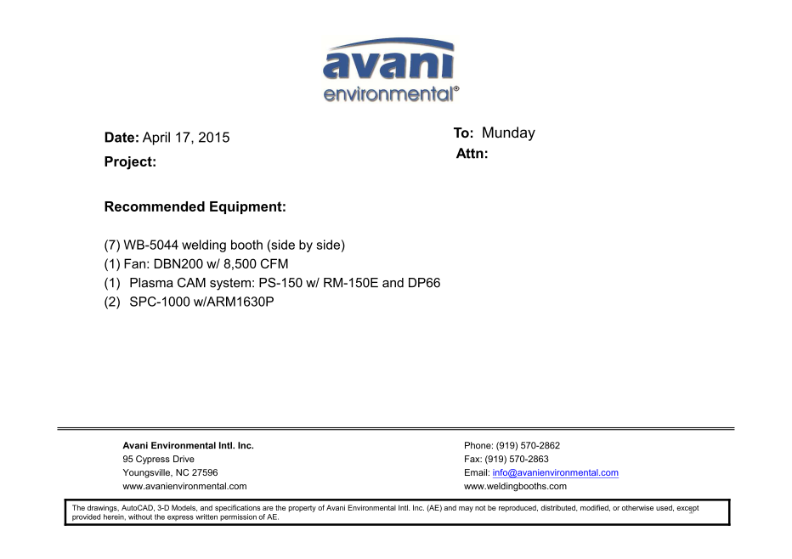

WB-5044 welding booths @ 7sets cost: US$14,457-

WB-5044 back and top draft cost: US$1,486 x 7pcs = US$10,402.-

WB-5044 side panels cost: US$457 x 8pcs = US$3,656.-

CO2 bracket cost: US$57 x 7pcs = US$399.-

DBN-200 unit cost: US$3,900 x 1 = US$3,900.-

DBN-200-C unit cost: US$1,000 x 1 = US$1,000.-

***Plasma Cam System:***

(SPC-2000+RE-150ME + DDT-PC66) unit cost: US$2,960 x 1 = US$2,960.-

SPC-1000 unit cost: US$1,090 x 2 = US$2,180.-

ARM 1630P cost: US$353 x 2 = US$706.-

**TOTAL PROJECT COST: USD25,203.-**