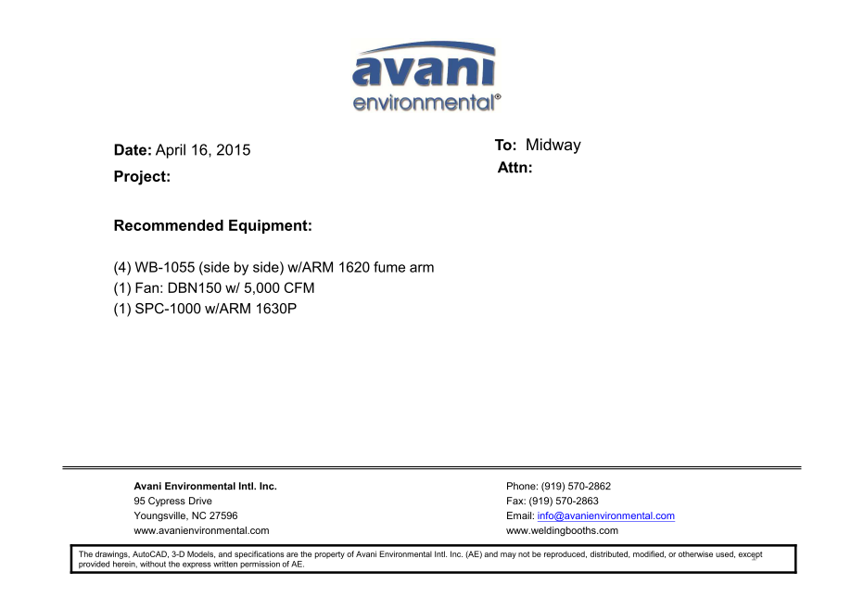

DBN-150 unit cost: US$3,400 x 1 = US$3,400.-

DBN-150-C unit cost: US$900 x 1 = US$900.-

Silencer for DBN-150 unit cost: U$350 x 1 = US$350.-

WB-1055 unit cost: US$1,285 X 4 = US$5,140.-

ARM 1620 unit cost: US$332 x 4 = US$1,328.-

SPC-1000 unit cost: US$1,090 x 1 = US$1,090.-

ARM 1630P unit cost: US$353 x 1 = US$353.-

**TOTAL PROJECT COST: USD12,561.-**