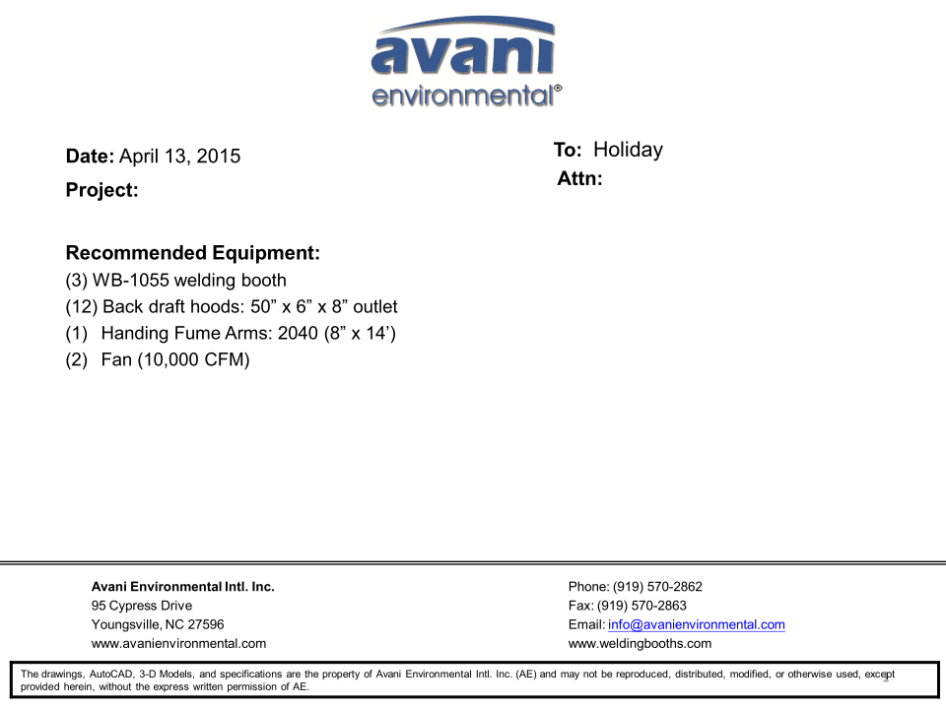

WB-1055 Booths unit cost: US$1,241 x 3 = US$3,723.-

Backdraft Hoods unit cost: US$850 x 12 = US$10,200.-

Fume Arm 2040 cost: US$516 x 1 = US$516.-

DBN-250 unit cost: US$4,300 x 2 = US$8,600.-

DBN-250-C unit cost: US$1,100 x 2 = US$2,200.-

Silencer for DBN-250 unit cost: U$370 x 2 = US$740.-

**TOTAL PROJECT COST: USD25,979.-**