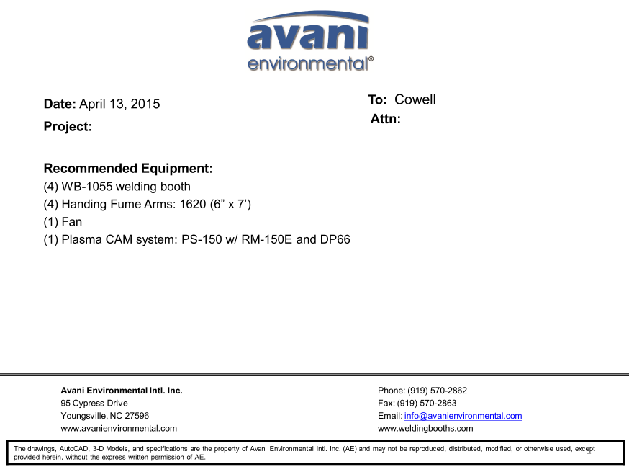

WB-1055 unit cost: US$1,269 X 4 = US$5,076.-

ARM 1620 unit cost: US$332 x 4 = US$1,328.-

***Plasma Cam System:***

(SPC-2000+RE-150ME + DDT-PC66) unit cost: US$2,960 x 1 = US$2,960.-

**TOTAL PROJECT COST: USD9,364.-**