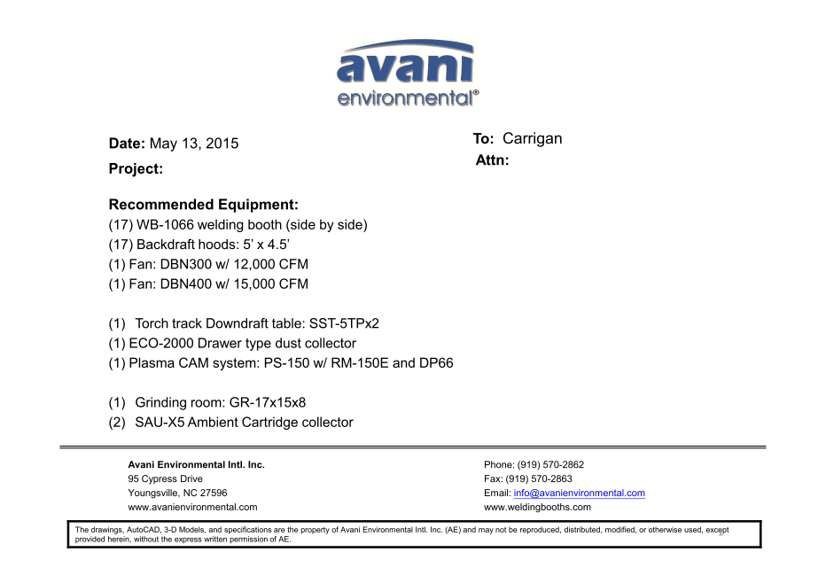

WB-1066 welding booth units cost: US$1,604 x17= US$27,268.-

Backdraft Hoods units cost: US$955 x 17=US$16,235.-

DBN-300 unit cost: US$5,200 x 1 = US$5,200.-

DBN-300-C unit cost: US$1,200 x 1 = US$1,200.-

Silencer for DBN-300 unit cost: US$370 x 1 = US$370.-

DBN-400 unit cost: US$4,600 x 1 = US$4,600.-

DBN-400-C unit cost: US$1,450 x 1 = US$1,450.-

Silencer for DBN-400 unit cost: US$440 x 1 = US$440.-

Torch track Downdraft table SST-5TPx2 cost: US$8,650 x 1 = US$8,650.-

ECO-2000 unit cost: US$2,406 x 1 = US$2,406.-

***Plasma Cam System:***

(SPC-2000+RE-150ME + DDT-PC66) unit cost: US$2,960 x 1 = US$2,960.-

GR-17x15x8 Grinding room unit cost: US$17,350 x 1 =US$17,350.-

SAU-X5 Ambient Cartridge collector unit cost: US$4,650 x 2= US$9,300.-

**TOTAL PROJECT COST: USD97,429.-**