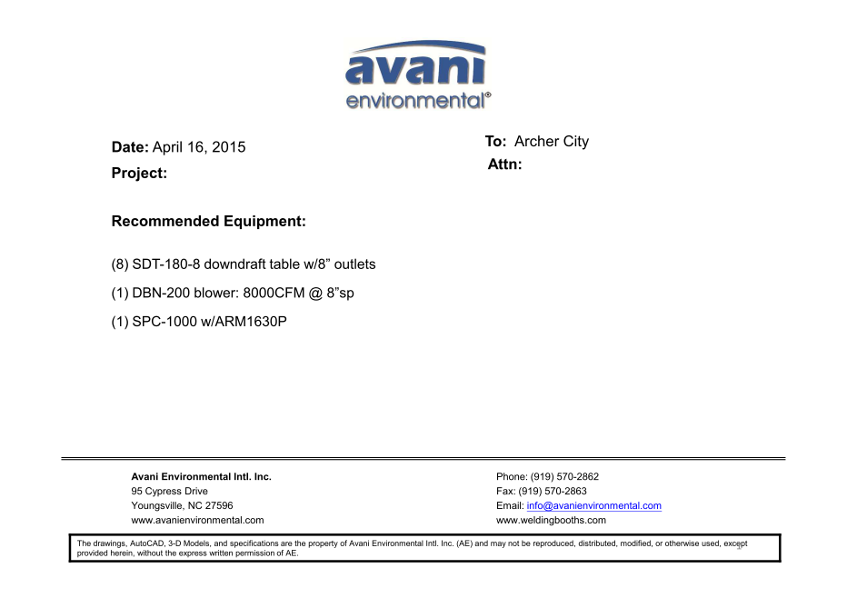

SDT-180-8 unit cost: US$700 x 8 = US$5,600.-

DBN-200 unit cost: US$3,900 x 1 = US$3,900.-

DBN-200-C unit cost: US$1,000 x 1 = US$1,000.-

SPC-1000 unit cost: US$1,090 x 1 = US$1,090.-

ARM 1630P unit cost: US$353 x 1 = US$353.-

**TOTAL PROJECT COST: USD11,943.-**