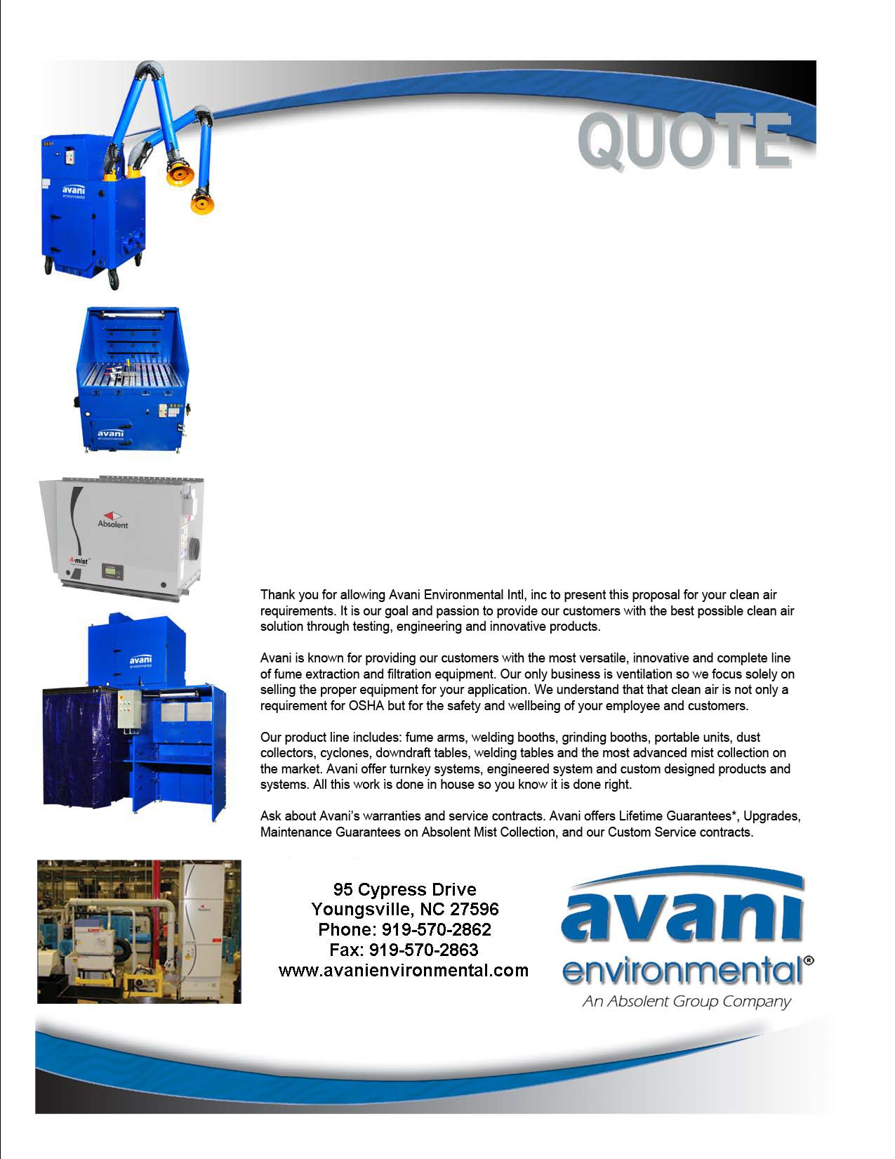

Attn: Mike Riley

**Eaton Automotive**

**Quote #: AE-013046**

Quote by: **Alanna Vimont / Mark Edwards**

Email: avimont@avanienvironmental.com

June 16, 2015

**Avani Environmental Intl., Inc.®**

**95 Cypress Drive**

**Youngsville**, **NC 27596**

Phone: 919-570-2862 Fax: 919-570-2863

**Quote #: AE-013046** June 16, 2015

Quote by: **Alanna Vimont / Mark Edwards**

Attn: Mike Riley

mikelriley@eaton.com

**Eaton Automotive**

2564 Durham Road

Roxboro, NC 27573

Dear Mike,

Please review quote below with items detailed in your set of specifications:

|  |  |  |  |  |  |
| --- | --- | --- | --- | --- | --- |
| **Product Name** | **Product Description** | **Product Picture** | **Quantity** | **Unit Price** | **Total Price** |
| FM-92630906  A Smoke 120 (3 ea) | Absolute filter TRSA 1D-N 1000x914 (HEPA) |  | 3 | $1,342.00 | $4,026.00 |
| FM-92110901  A Smoke 120 (3 ea) | Prefilter 1 S1/914 |  | 3 | $2,041.00 | $6,123.00 |
| FM-92110903  A Smoke 120 (3 ea) | Prefilter 2 S10B3/914 |  | 3 | $2,277.00 | $6,831.00 |
| FM-92630906  A Smoke 40 (1 ea) | Absolute filter TRSA 1D-N 1000x914 (HEPA) |  | 1 | $1,342.00 | $1,342.00 |
| AB-99701008  A Smoke 40 | Manometer VDO, 2300 PA (2 pcs) - ODR 3000 |  | 1 | $134.00 | $134.00 |
| FM-92630606  A Mist 40TF (2 ea) | Absolute FilterTRSA-N 990 595x292 (HEPA) |  | 2 | $470.00 | $940.00 |
| FM-92110600  A Smist 40TF (2 ea) | Prefilter 1 S3/595 - Stage 1 |  | 2 | $458.00 | $916.00 |
| FM-92110603  A Mist 40TF (2 ea) | Filter S3B1/595 |  | 2 | $563.00 | $1,126.00 |
| FM-92630606  A Mist 40TF (2 ea) | Absolute FilterTRSA-N 990 595x292 (HEPA) |  | 1 | $470.00 | $470.00 |
| FM-92630606  A Smoke 20 (1 ea) | Absolute FilterTRSA-N 990 595x292 (HEPA) |  | 1 | $470.00 | $470.00 |
| FM-92110702  A Smoke 20 (1 ea) | Prefilter S1/650 DB |  | 1 | $1,618.00 | $1,618.00 |
| FM-92110705  A Smoke 20 (1 ea) | Prefilter S3B3/650x300 |  | 1 | $1,186.00 | $1,186.00 |
| FM-92630906  A Smoke 40 (1 ea)  A Smoke 40 (1 ea) | Absolute filter TRSA 1D-N 1000x914 (HEPA) |  | 2 | $1,342.00 | $2,684.00 |
|  | **NOT INCLUDED:**  **Freight and transportation charges**  **Customs, duties & taxes**  **Material handling equipment**  **Installation equipment (Cranes, forklift, scissor lift or jig)** |  |  | **Grand Total:** | **$27,866.00** |

Additional Product Options:

|  |  |  |  |  |
| --- | --- | --- | --- | --- |
| **Product Number** | **Product Description** | **Quantity** | **Unit Price** | |
|  |  |  |  | |
|  |  |  |  | |
|  |  |  |  |

Sincerely,

**Alanna Vimont**

Inside Sales Support

Avani Environmental Intl Inc

Email: avimont@avanienvironmental.com

Phone: (919) 488-5192

Websites:

[www.avanienvironmental.com](http://www.avanienvironmental.com)

[www.weldingbooths.com](http://www.weldingbooths.com)

www.absolent.com

**Terms and Conditions**

**General:**

1. The price does not include sales tax, duties, custom fees or any other cost associated with the sale or delivery of this product.
2. Payment Terms: All quoted prices and payments are in US dollars.

**Projects & Custom Orders:** 35% down with PO, 35% upon delivery and 30% net 30 within the continental USA. (Outside the continental USA – 50% down with PO and 50% prior to shipment.

1. Quotation price does not include actual shipping costs. All products are shipped FOB from manufacturer. If requested by Buyer, Avani can supply an estimated shipping cost(s). The estimated shipping cost is only an estimate and actual charges can be different from estimated charges.
2. Late payments and any charges associated with the Late payment begin incurring charges 30 days after standard payment terms are due.

**Shipping and Delivery Time:**

1. All products are FOB Manufacturer
2. Shipping times: Stock items – 1 week, Non-stock items –8-12 weeks, Customized products –12-16 weeks. If deposits and/or signed drawings are required for specific job; shipping time begins after Avani has received these items. These times are estimates only and may be revised at any time.
3. Unless otherwise stated on the purchase order Avani will ship Best Way Prepay and Add.
4. All products that are shipped via Truck will be shipped with standard pallets and shipping material. If needed or requested by the buyer the product(s) can be completely crated for an additional cost.
5. The Buyer is responsible for inspecting the Product(s) immediately when they are delivered and must state upon delivery if the Product(s) is damaged or has missing parts. If not, the Product(s) are acknowledged as being complete and satisfactory.
6. Avani Environmental products are shipped via LTL carrier or common carrier. It is the responsibility of the customer/consignee to provide a material handling equipment. If additional requirements are necessary please contact your Avani sales rep.
7. Fume collection equipment and components, with limited exception, are shipped via freight carriers using enclosed trailers. It is the sole responsibility of the consignee to provide one or more of the following to ensure an expedient and safe offloading of the order. The typical requirements include a loading dock at trailer height with transition platform, forklift, pallet jack or any other industry accepted standard.

**Warranty and Return:**

1. All New Products come with a standard 1 year warranty. Other warranties and terms are available and must be approved by an Avani personnel.
   1. Warranty covers replacement parts for 1 year.
   2. Does not cover labor or charges incurred for removing and installing new parts.
   3. Not responsible for loss of use or downtime.
2. Returns product(s) must be approved by Avani before being sent back.
   1. Must have an RGA and Case # when the product(s) is shipped back.

**Installation/Projects: Exclusions (Avani Environmental is not responsible for the below items):**

1. Demolition (cement walls, roof penetration, sealing, etc.), electrical or other work that requires special permits or licensing is not included in the price.
2. All rental equipment: such as but not limited to forklifts, cranes, scissor lifts, jig, etc.
3. Electrical wiring, compressed airlines or other components that connect to the equipment.
4. Any type of permits required for installation, testing or running the equipment.
5. Unloading of the product when it arrives.
6. Storage and any loss or damaged product as a result of being stored.
7. Rental equipment charges – optional - $1,000 per day.
8. Seismic requirements and/or calculations are not included.
9. Avani does not pull permits or local codes.