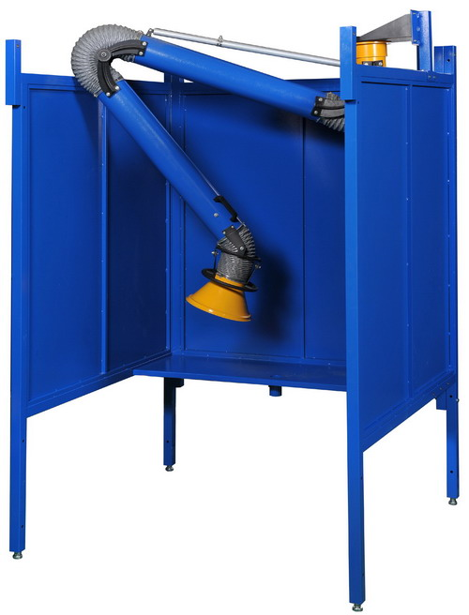

Submittal Dimensions (in mm/inches)

Assembly Procedure

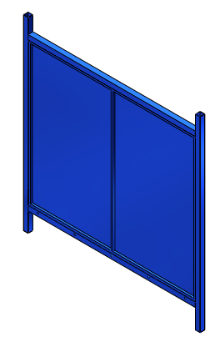

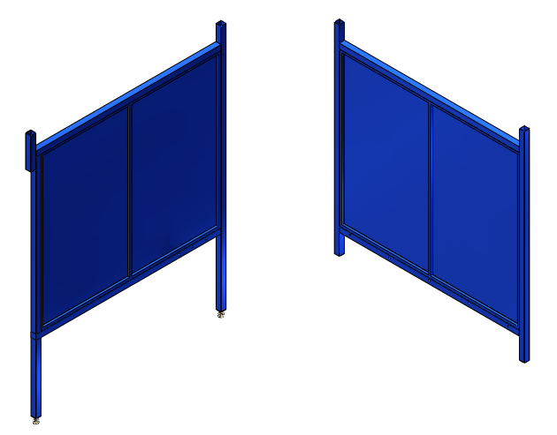

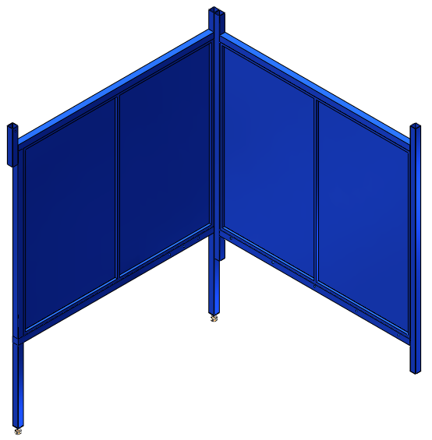

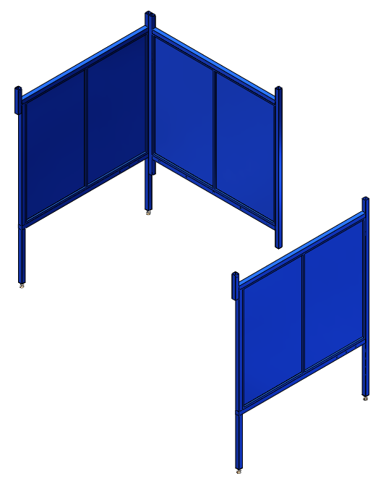

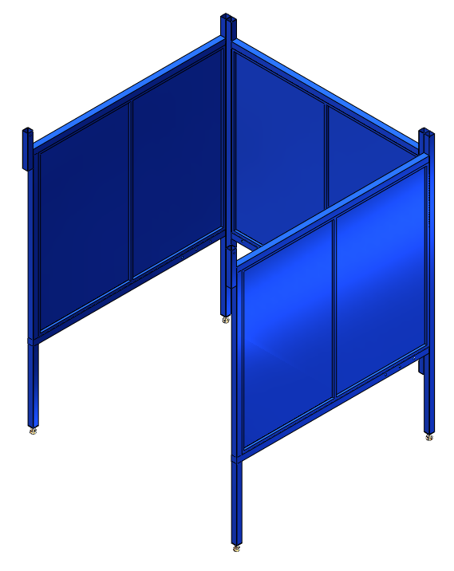

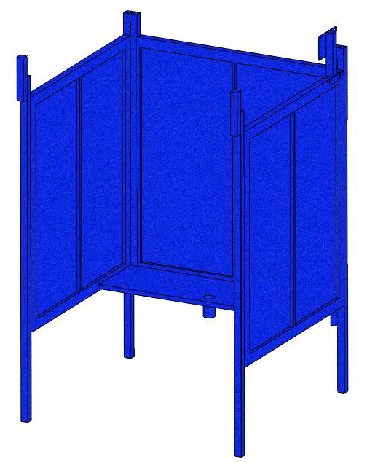

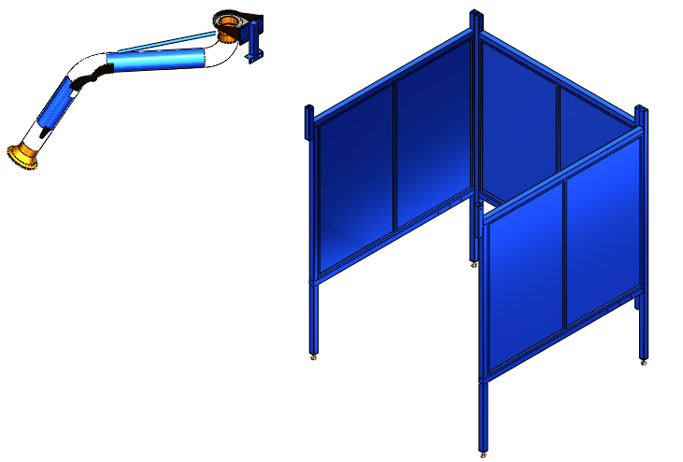

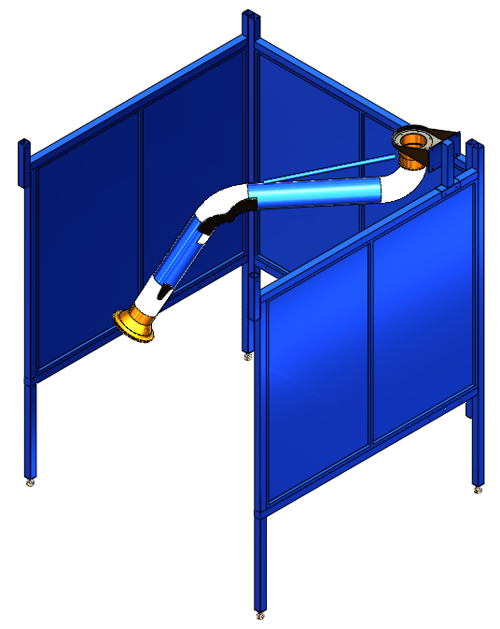

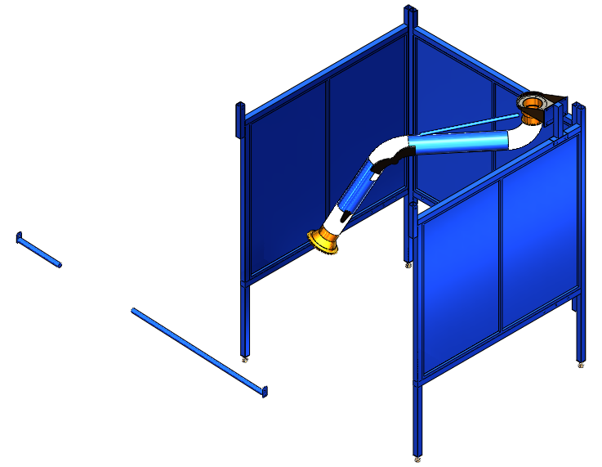

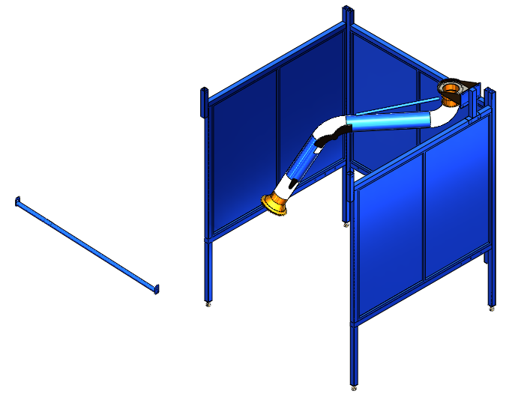

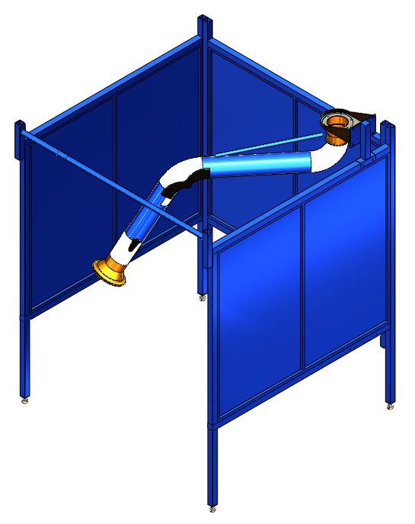

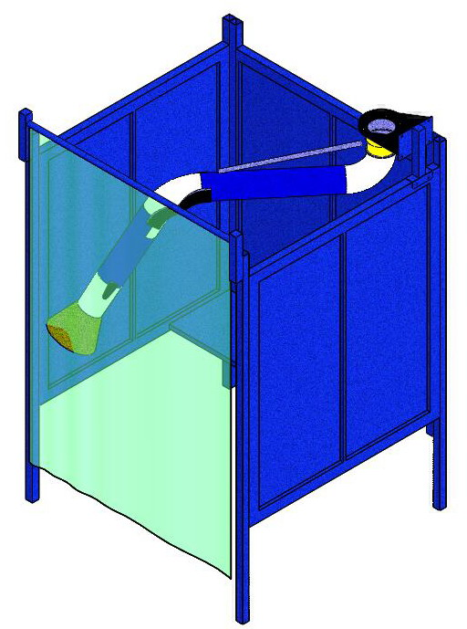

Assembly Hardware

Repair Parts List
Repair Parts List for Welding Booth

Reference Number | Description | Part Number | Quantity
1 | Hex Screw (5/16"*3") | AVANI-WB-5x5S-1 | 4
2 | Flat Washer (5/16"*OD23*2t) | AVANI-WB-5x5S-2 | 4
3 | Back Panel | AVANI-WB-5x5S-3 | 1
4 | Side Panel | AVANI-WB-5x5S-4 | 2
5 | Adjustable Feet | AVANI-WB-5x5S-5 | 4
6 | Table | AVANI-WB-5x5S-6 | 1
7 | Hex Screw (5/16"*3/4") | AVANI-WB-5x5S-7 | 8
8 | Flat Washer (5/16"*OD18*2t) | AVANI-WB-5x5S-8 | 8
9 | Knob (5/16"*3/4") | AVANI-WB-5x5S-9 | 1
10 | Curtain Bar (short) | AVANI-WB-5x5S-10 | 1
11 | Curtain Bar (long) | AVANI-WB-5x5S-11 | 1
12 | Hex Screw (5/16"*3/4") | AVANI-WB-5x5S-12 | 2
13 | Flat Washer (5/16"*OD23*2t) | AVANI-WB-5x5S-13 | 2
14 | Hex Screw (5/16"*3/4") | AVANI-WB-5x5S-14 | 4
15 | Flat Washer (5/16"*OD23*2t) | AVANI-WB-5x5S-15 | 4
16 | Arm Support | AVANI-WB-5x5S-16 | 1
17 | Hex Screw (5/16"*1") | AVANI-WB-5x5S-17 | 4
18 | Flat Washer (5/16"*OD23*2t) | AVANI-WB-5x5S-18 | 8
19 | Hex Nut (5/16") | AVANI-WB-5x5S-19 | 4

