General Safety Information

MACHINE WARNING SIGNS
 | Indicates an imminently hazardous situation which, if not avoided, will result in death or serious injury.
 | Indicates a potentially hazardous situation which, if not avoided, could result in death or serious injury.
 | Indicates a potentially hazardous situation which, if not avoided, may result in minor or moderate injury.
 | Used without the safety alert symbol ( ) indicates potentially hazardous situation which, if not avoided, may result in property damage.
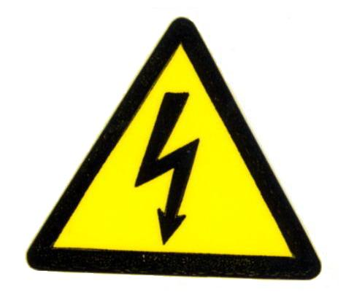 | Warning of electric shock
 | Do not expose the equipment to rain or use in damp locations.
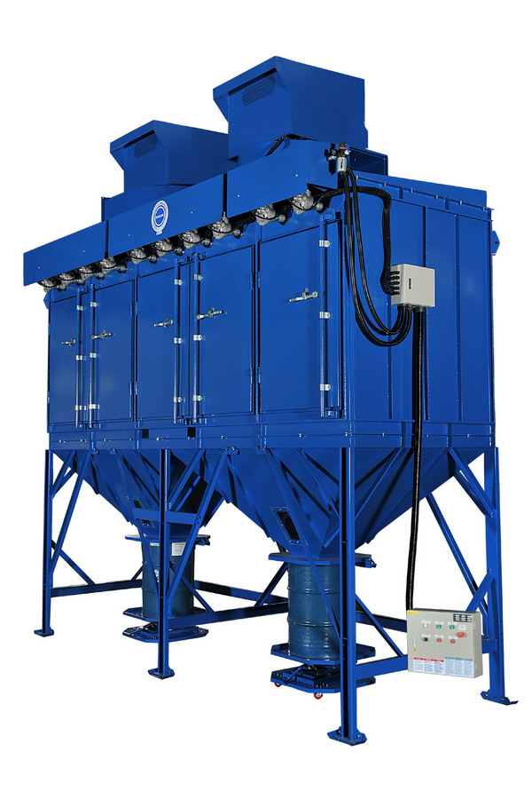
Figure 1

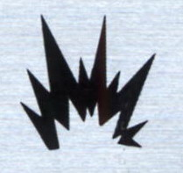 | Do not use the equipment around flammable products, if not avoided, sparks can ignite vapors from flammable products.
 | Read and understand all warnings and operating instructions before using this equipment. Failure to follow all instructions may result in electric shock, fire, and/or serious personal injury or property damage.

TABLE OF CONTENT
MACHINE WARNING SIGNS 1
SPECIFICATIONS 2
ADDITIONAL DUST COLLECTOR SAFETY RULES 5
ASSEMBLY 6
INSTALLATION 6
ELECTRICAL INSTALLATION 6
OPERATION 7
CONTROL BOX 10
CONTROL PANEL 11
ASSEMBLY PROCEDURES 12
APPENDIX 15

SPECIFICATIONS

Motor ………………………………………….………...…………..…… 25 HP x 2 (37300 W)
Air Volume (C.F.M.) ……………………….………..……. 20000 Ft³/Min (33980 M³/Hr)
Inlet Size ………………………..………...…. 2010 x 330 mm (approx. Ø900mm (3ft))
Include Star-Delta Control Box
Cartridge Filter: Dia. 325mm x 1200mm x 40pcs
Material: Polyester with TEFLON coating.
Filter Area: 19m2 x 40 = 760m2
Pleat Depth: 48mm
Horizontal Positioned Filters,
Continuous Welded Seams
Gasket and Latched Doors,
Powder Coated Paint and
Reverse Jet Pulse Cleaning
Include:
- Drum & Jack Lifting Tool
- Filter Chamber
- Hopper
- Inlet Square Pipe (need dimensions)
- Double fan/motor combinations
Noise Level: 84.6 dBA @ 1M
No. of Valves: 10
Compressed Air Requirement: 90 PSI
Compressed Air Reservoir: 39.5 gallon
Inlet Air: 3/4"
Construction: 13 Gauge for panel; 11 Gauge Steel Cabinet
Max. Operating Temp.: 120˚C
Powder Coating: Blue
Dimension (L x W x H) … 203.8" x 68.5" x 224.1" (5172 x 1738.5 x 5687.85mm)
Approx. Weight ………………………….……………………………… 14175 lbs (6430 kgs)

General Safety Information
(Continued)
Use this product carefully to effectively avoid any possible danger. Observe the following safety regulations to avoid bodily injury due to electrocution during use.

Read this Manual carefully before operating the product and preserve the Operation Manual properly.
- Keep work area clean and organized.
- A disorderly working environment will cause inconvenience and danger during operation.
- Check if the working environment is suitable for using the product.
- Do not use the product in a humid environment.
- Use the product in a good working environment to reduce risks.
- Do not use the product in a flammable gas or liquid environment to avoid danger.
- Keep other persons away from the product, except for the operator, to avoid danger.
- Do not let children get close to the product. All wires used by the product shall be in a safe location to prevent children from touching them.
- All tools shall be safely stored.
- When the tools are not used, please store them in a dry place safely beyond the reach and access of children.
- If the machine breaks down, contact a service technician. Do not attempt to repair and possibly damage the machine.
- When using the product, be sure to put on a dust collecting suit and mask.
- Use the electrical wires correctly.
- During use, do not drag the electrical wires forcefully. Do not use these wires if fraying or current leakage occurs to avoid injury to the operator.
- Before replacing parts, shut off power to the machine.
- Check that the switch is in “on” or “off” position. Do not attempt the replacement when the machine is running. To replace parts or filter material, make certain that the switch is “off”.
- Use the power cord correctly. The total length of power cord shall not exceed 10 feet to avoid low power due to a drop in voltage and to prevent a possible hazard.

When connecting the product, always follow the instructions in the Operation Manual to avoid injuries.
- Care and Maintenance:
- Confirm that the parts/accessories have been fully assembled and will not adversely affect the machine operation.
- Check if the machine is operated properly.
- Replace damaged parts or accessories according to the instructions of the Manual. If the said instructions are not specified in the Manual, have a professional technician carry out the maintenance or replacement.
- Check that the electrical specifications of this machine meet safety requirements, and that the maintenance is carried out by a professional technician. Use original manufacturer’s parts and accessories to avoid injury.
- If a problem occurs, contact your dealer immediately.

ADDITIONAL DUST COLLECTOR SAFETY RULES
The Dust Collector can be dangerous if it is operated incorrectly. Therefore, the product must be used cautiously to avoid causing a hazard or damage. Unnecessary injuries may occur by failing to follow the instructions of the Safety Rules Manual. Be sure to put on protection equipment or suit that can protect your body, such as helmet and eye mask to avoid injuries from occurring. If any doubts or any unfitness occurs during use, be sure to stop the operation immediately. Keep in mind that the user shall be liable for using according to the specified safety rules and for operating the machine correctly.
- Read this Manual carefully before operating the product.
- Be sure to follow local electrical and safety regulations and observe the electrical safety standards practiced in the relevant area. All electrical wire connections and installation shall be carried out by a professional technician.
- Do not operate the product near flammable materials, as sparks may ignite these materials and cause an explosion. Please confirm there aren’t any flammables near the working site to avoid hazard.
- This product is suitable for collecting dusts. Do not use it in collecting iron chips and dust at the same time to avoid producing sparks.
- Before replacement of parts or filter materials, be certain that the switch is disconnected.
- Do not kink the power cord and keep it away from oil, chemicals or flammables.
- Check that the voltage, phase count and grounding wire match the machine requirements.
- When the fan blades are operated at high speed, do not reach hand near these blades to prevent finger from breaking or clothes/necktie from getting caught. Do not put the hand or foreign matter into the air inlet to avoid getting caught in the high-speed rotation of fan blades.
- When not in use, all air inlets of Dust Collecting Machine shall be covered.

ASSEMBLY
Do not connect the Dust Collecting Machine before the assembly is finished and you have read and understood all of the precautions stated in the Manual.
NOTE: For correct assembly, refer to the Illustrations on page 11.

INSTALLATION
MOVING AND TRANSPORTATION
The approximate weight of this machine is 14175 lbs. It CANNOT be handled or transported without the help of lifting tools. For your safety, read all instructions carefully.
Do not move without the help of others to avoid causing danger.

ELECTRICAL INSTALLATION
POWER CONNECTION
- Confirm that the power is properly connected under normal power supply condition. It is recommended to provide manual shutdown device before connecting power.
- It is recommended to protect the control equipment with suitable grade of fuse, and the length of fuse and power cord shall not be over 10 feet.
SHUTDOWN
- Disconnect power by manual method.
- When stopping operation, check if the switch is under off status.
EARTHING WIRE
Connect yellow/green wires to the earthing wire power jack. Confirm that the earthing wire has been properly connected before connecting main power cord to the machine at all times.
Do not disconnect the wiring jack before cutting off power!
POWER INSTALLATION AND STORAGE
The electrical power is configured as following. The motors cannot be turned on at the same time due to high electric current.
Please turn on the first motor and wait for approximately 30 seconds before turning on the other motor.
If conditions are beyond the scope stated below, then it is required to ensure that the power is well arranged and safe.
- Ambient temperature: Between 41°F and 131°F. If the time is over 24 hours, then the ambient average temperature shall not be over 122°F.
- Humidity: Between 30% and 95%
- Altitude: 3,280 feet
- Moving and Storing: -13°F to 131°F. For short-time storage (less than 24 hours), the storage temperature can be up to 158°F.

Figure 2 – Electrical Circuit Diagram

OPERATION
PRIOR TO START UP
Purpose: The Dust Collector is especially suitable for treating the dust generated during ordinary dust collecting work, which can effectively collect and screen the smoke resulting from the dust collecting work in maintaining the air quality of the working environment.
- Before starting the machine, be sure to read this Manual carefully.
- Before starting the machine, check if relevant safety protection measures have been taken according to the Manual.
- Before starting the machine, watch the motor turning direction according to the instruction of arrow direction.

START UP
- To ensure satisfactory performance for the Dust Collecting Machine, please confirm the air volume, power and the matching table of the Dust Collecting Machine.
- Connect power according to electrical installation procedure after installing the Dust Collecting Machine and the table. Disconnect power according to electrical installation procedure when the machine is not used.
- The Dust Collecting Machine shall be turned on and off by pushing I/O button. Under normal operation status, use such I/O button.
Unpacking
The machine should be unpacked carefully. Check if the machine and components are consistent with those indicated in the Parts List. If any doubt arises or when the components are incomplete, contact your dealer.

Dimensions (mm & inches)

CONTROL BOX
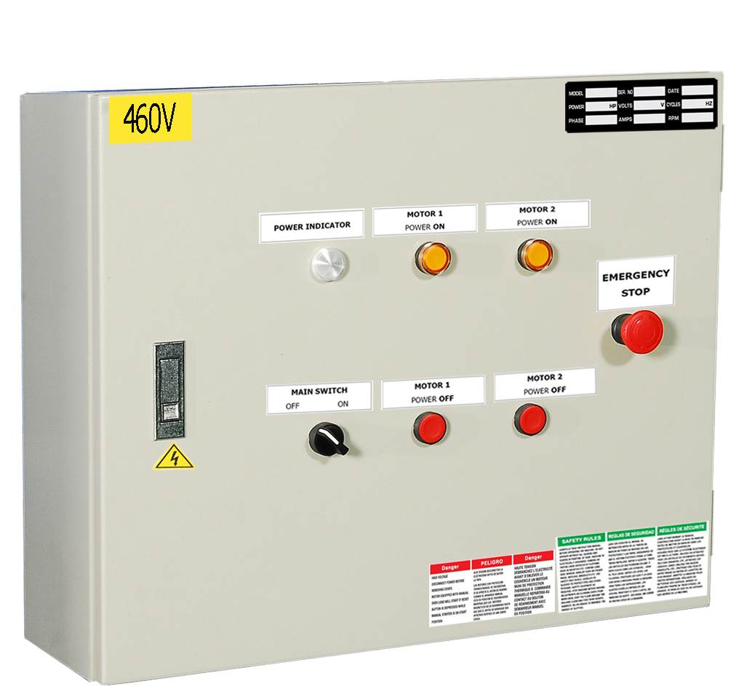

CONTROL PANEL
Time Setting for Valve (Pulse-Jet):
- No. of Valves: 10 (circulation)
- Pulse-jet Time for each Valve: 0.2 sec
- Valve Interval: 5 mins (pulse-jets first cycle when turning on the power and circulate in every five minutes).
- Turn off ONLY the motor power and leave the main power on for approximately 1 hour until ALL cartridges are pulse-jet cleaned. This ensures the cartridge cleaning efficiency when you turn on the power next time.

1
2
10
8
9
6
7
4
5
3
5 Min
Pulse-jet time: 0.2 sec
5M
5M
5M
5M
5M
5M
5M
5M

ASSEMBLY PROCEDURES
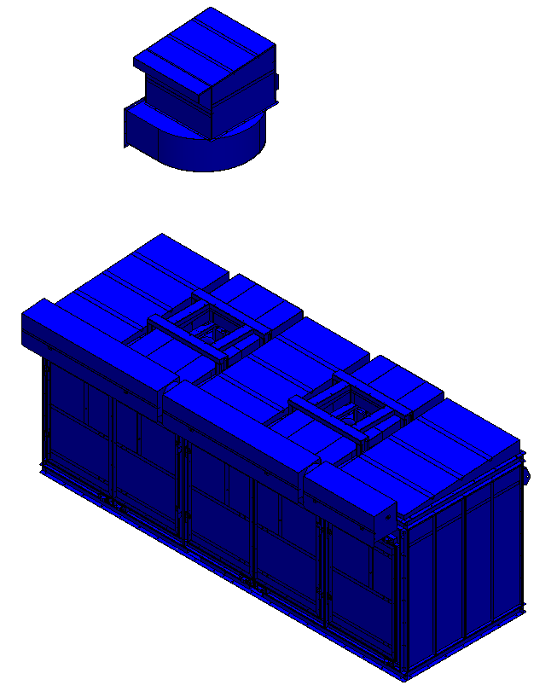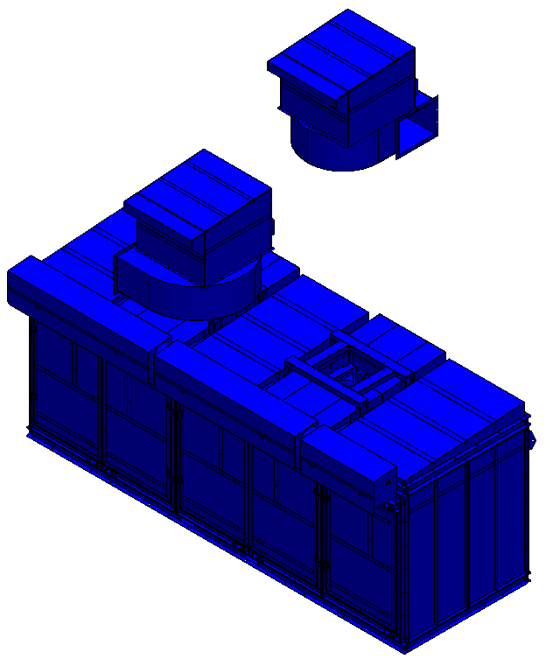
STEP 2
STEP 1
STEP 1 & 2
Assemble the Blowers using:
Parts Name | Specification | Q’ty
Hex Screw | 1/2”*3/4” | 24
Flat Washer | 1/2”*OT25*2T | 24
Spring Washer | 1/2” | 24

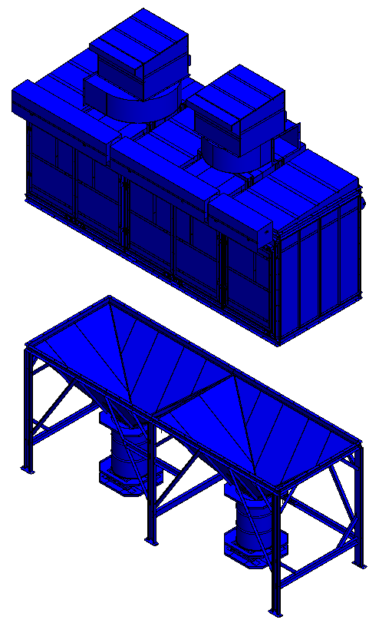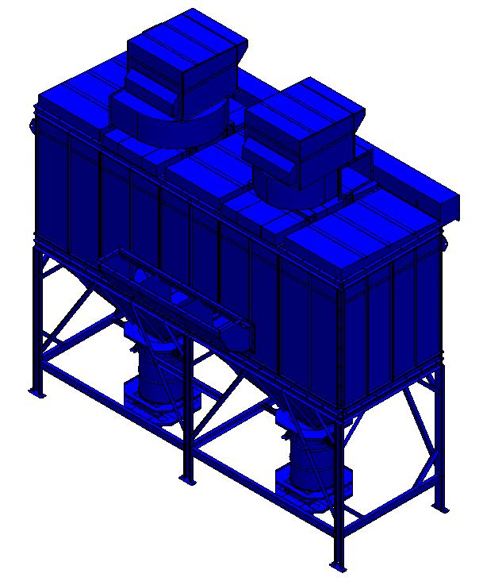
STEP 3
A
B
STEP 4
Back View
STEP 3
Assemble A - Blower & Blower Cover using:
Parts Name | Specification | Q’ty
Hex Screw | 5/16”*3/4” | 18
Flat Washer | 5/16”*OT20*2T | 18

Assemble B – Upper Section & Lower Section using:
Parts Name | Specification | Q’ty
Hex Screw | 3/8”*3/4” | 54
Flat Washer | 3/8”*OT20*2T | 108
Spring Washer | 3/8” | 54
Hex Nut | 3/8” | 54
STEP 4
Assemble the Silencer using:
Parts Name | Specification | Q’ty
Flat Washer | 3/8”*OT20*2T | 26
Spring Washer | 3/8” | 26
Hex Nut | 3/8” | 26

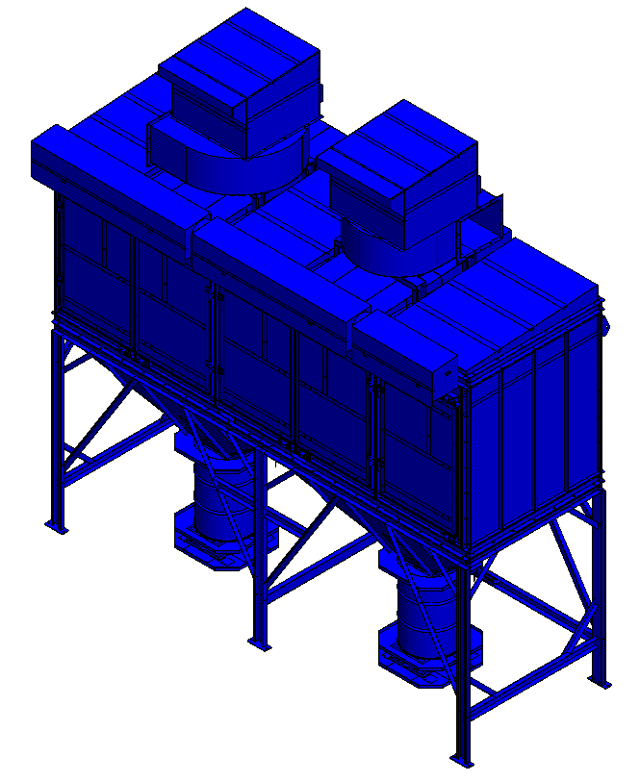
STEP 5
STEP 5
Assembly completed.

APPENDIX
Control Box
The motors cannot be turned on at the same time due to high electric current.
Please turn on the first motor and wait for approximately 30 seconds before turning on the other motor.
Repeater Control Box

