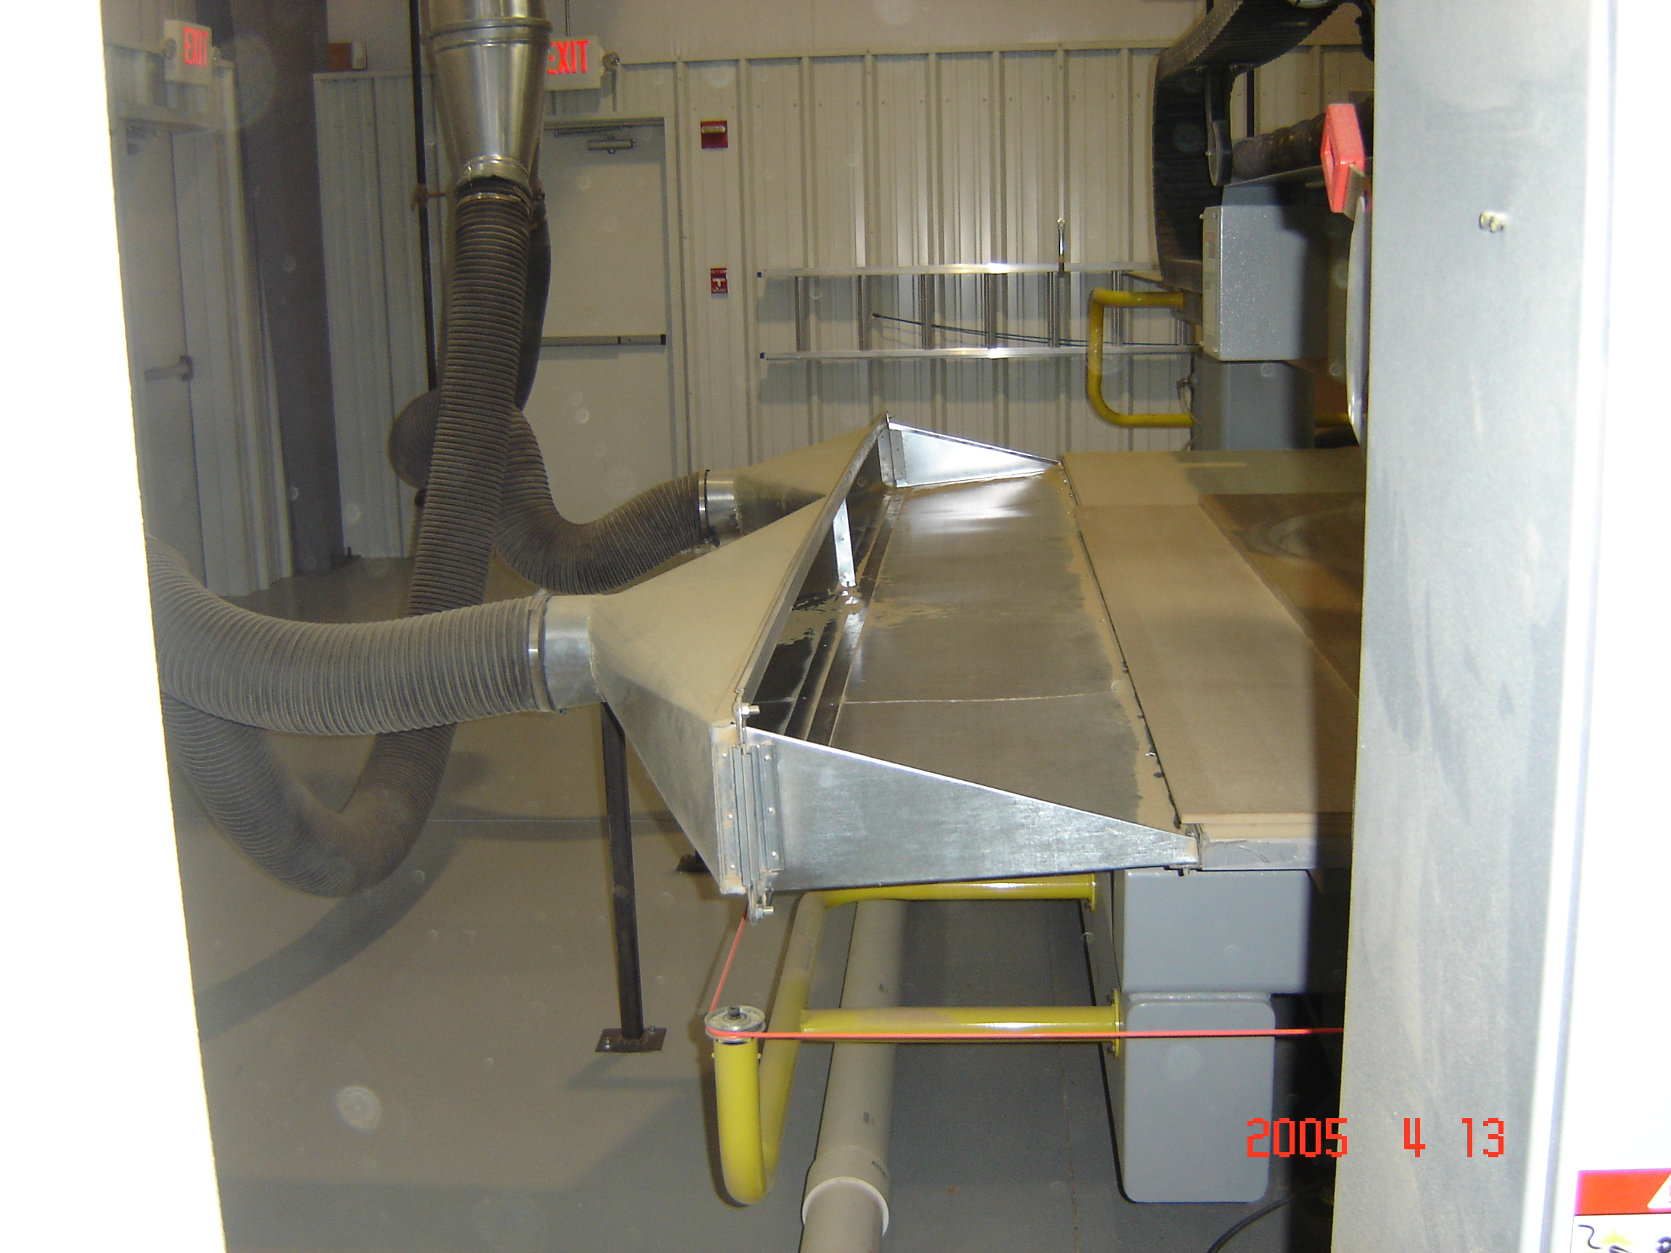

Side view of hood showing the profile, and example of hose lengths
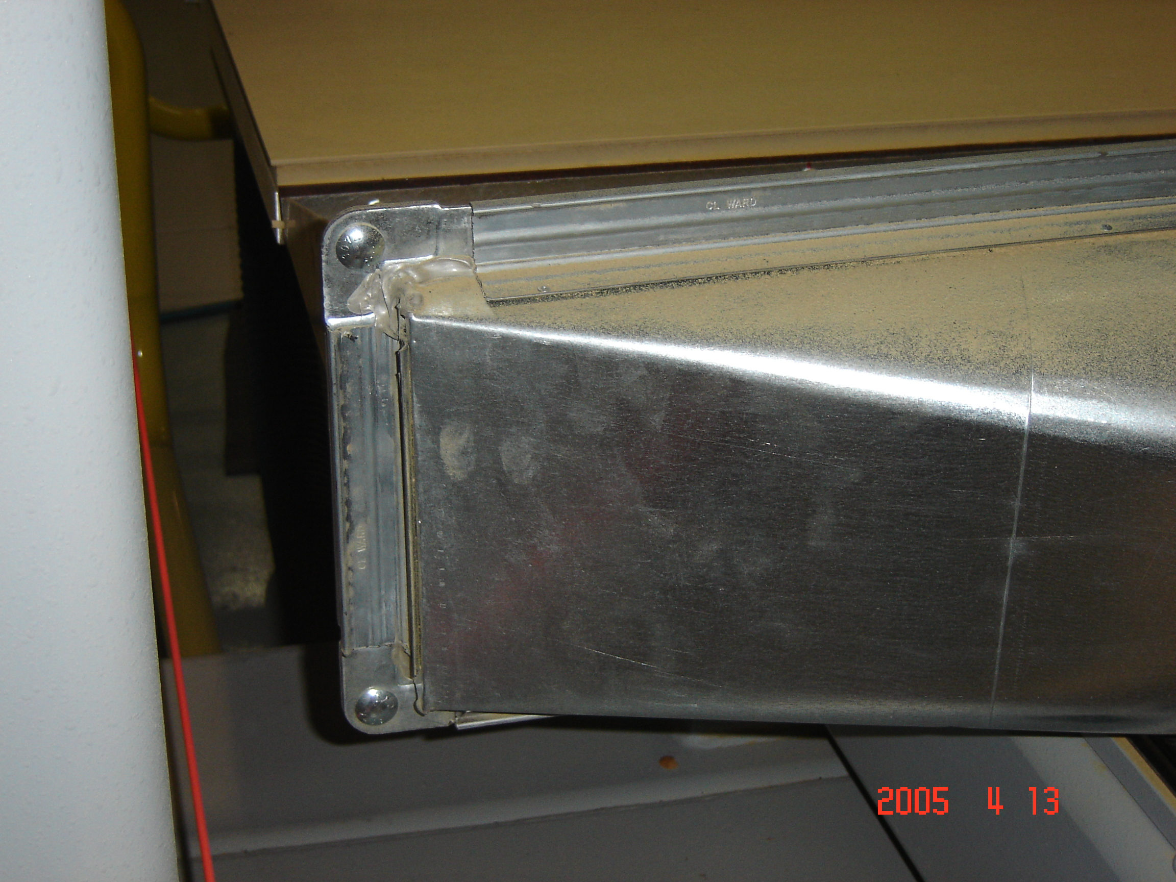
Construction of the duct mate flange, to keep from being to heavy, but yet good strength
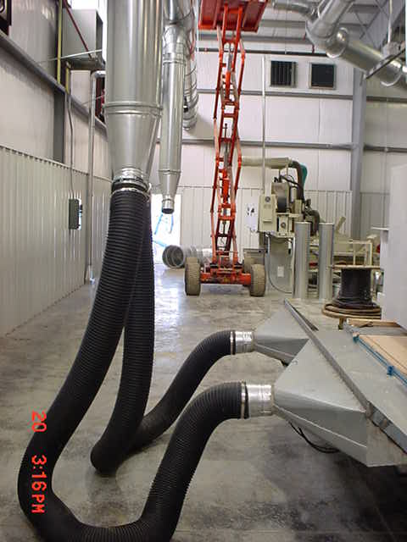

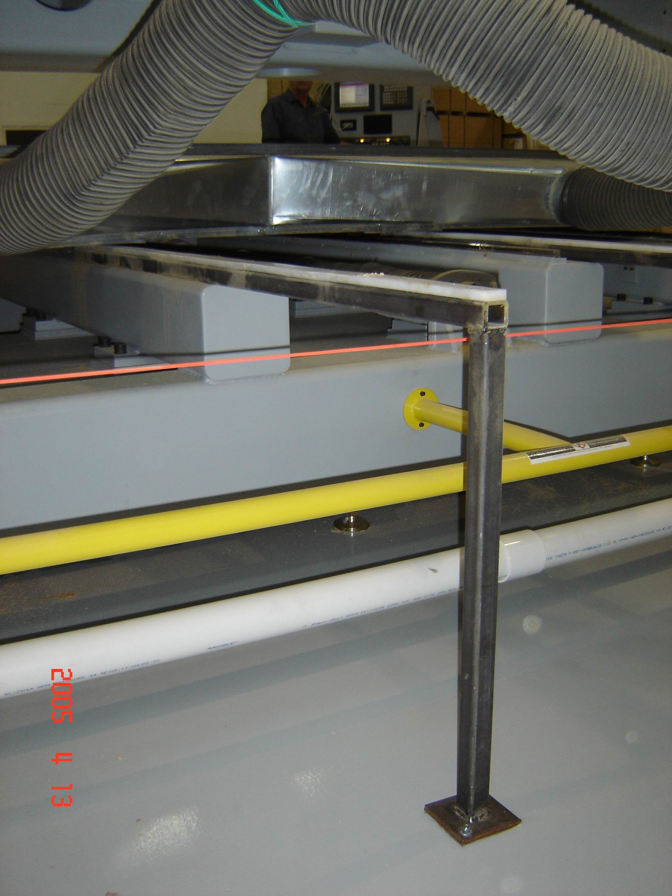
Guide rails made of 1” steel tubing and covered on top with UHMW wear rails

