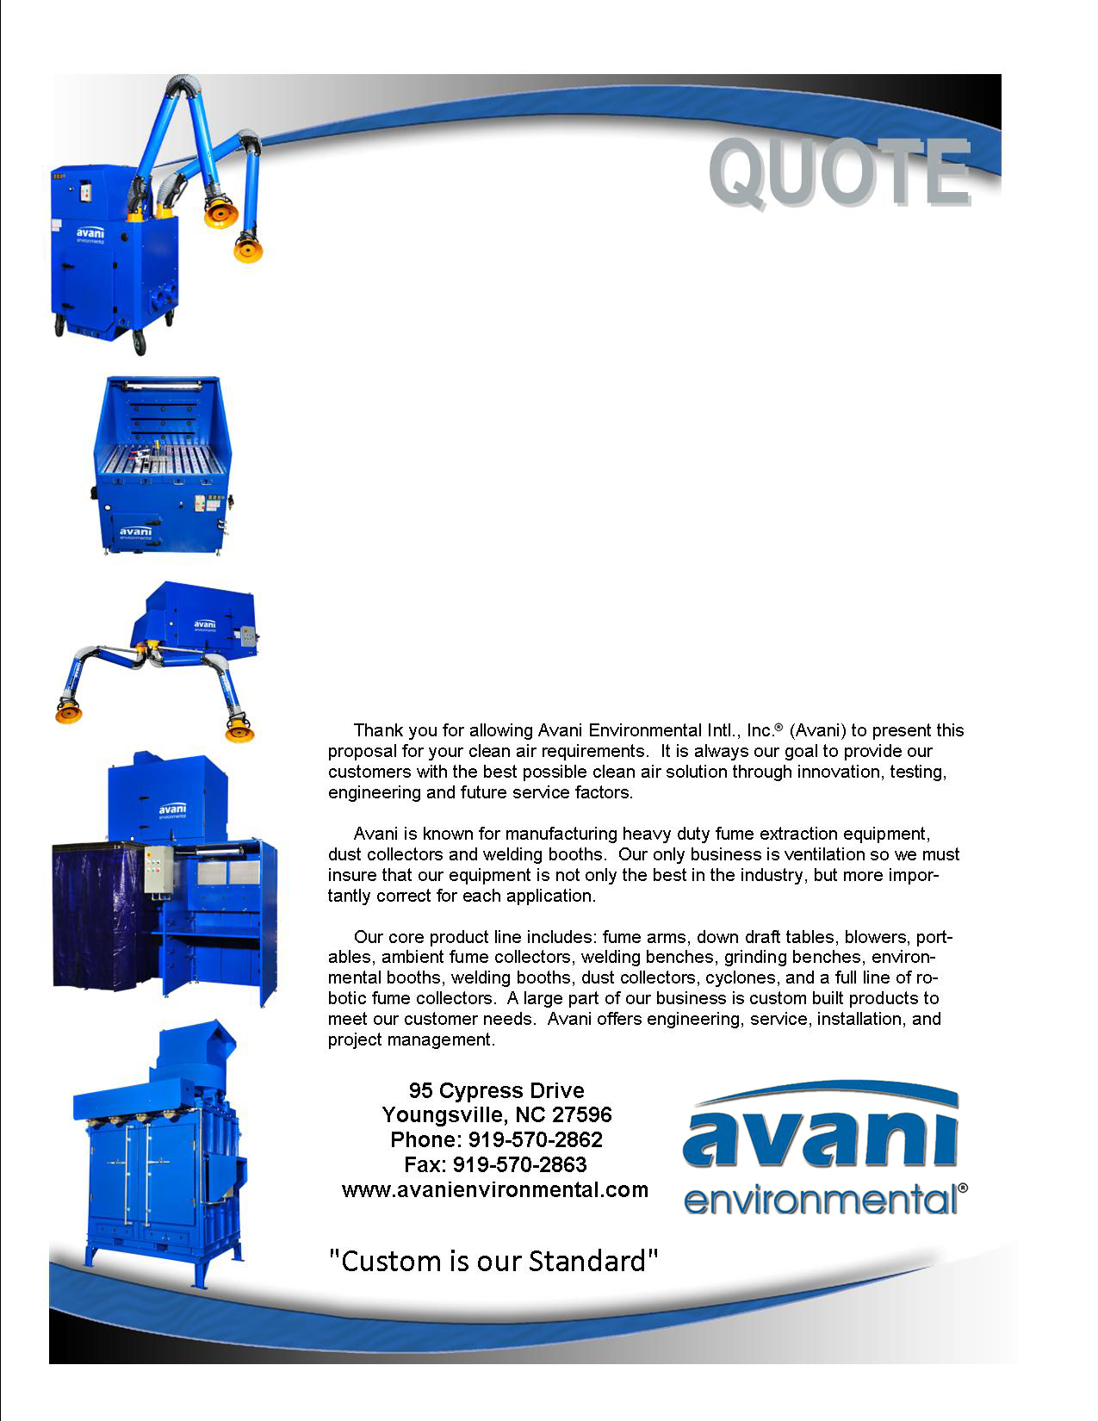

Attn: Marcos Sanchez

**Northeast Texas Community College**

**Quote #: AE-011080**

Quote by: **Richard King**

Email: rking@avanienvironmental.com

October 26, 2014

**Avani Environmental Intl., Inc.®**

**95 Cypress Drive**

**Youngsville**, **NC 27596**

Phone: 512-659-4718 Fax: 919-570-2863

**Quote #: AE-011080** October 26, 2014

Quote by: **Richard King**

Attn: Marcos Sanchez

msanchez@ntcc.edu

**Northeast Texas Community College**

P.O. Box1307

Mount Pleasant, TX 75456

Dear Marcos,

Please review quote below with items detailed in your set of specifications:

|  |  |  |  |  |
| --- | --- | --- | --- | --- |
| **Product Name** | **Product Description** | **Product Picture** | **Quantity** | **Total Price** |
| Custom Back-Draft Hood | Custom slotted backdraft hood.  -2 110V plugs  -Mounted light fixture |  | 25 | Package Price |
| Custom SDT-180 | Grinding Table: Grated top, removable side panels, external dust drawer, spark trap, 6"diameter outlet, and entire unit is powder coated steel.  Dimensions: 38"x28"x51" |  | 4 | Package Price |
| Ducting Package | Pre-fabricated galvanized ductwork complete with straight duct sections, adjustable sleeves, clamps with gaskets, branch transitions, elbows, bends, adapters, inline volume control dampers (as required), flexible hose & clamps (where required), mounting Gripple® hangers, and related accessories. |  | 1 | Package Price |
| Custom 5’ x 5’ Fume Hood | Custom fume hood, 5’ x 5’ hung from ceiling over free-standing oxy fuel station. |  | 2 | Package Price |
| Custom 7’ x 12’ Fume Hood | Fabricated fume hood, 7’ x 12’ hung from ceiling over existing plasma table. |  | 1 | Package Price |
| ARM 1640 | Industrial hanging fume arm c/w external adjustment friction joints, tension spring w/safety cover, inline volume control damper, source capture hood w/deflector, flexible hose joints, powder coated steel tube sections, handle, perimeter grab handle, dimensions 6”D x 14’L w/13”D hood. |  | 14 | Package Price |
| Fan | Centrifugal fan complete with backward inclined steel wheel, flanged inlet/outlet, drain, shaft seal, arrangement #4 (unless specified otherwise), access door, manual opposed blade outlet damper, AEI blue durable paint finish, and related components.  Includes concrete pad. |  | 2 | Package Price |
| Installation - Avani | The installation of the fume extraction system is to be completed during December 8, 2014 – January 12, 2015 and will include: tearing out existing extraction system and existing brick wall grind stations; installation of lighting fixtures for each booth; 2-110v plugs and necessary wiring to each booth; appropriate disconnects, conduit, and wiring; and installation of ducting with all related hardware necessary to operate the system.  All labor to be included. |  | 1 | Package Price |
| Freight | Freight from Avani to Customer |  | 1 | Package Price |
|  | **NOT INCLUDED:**  **Freight and transportation charges**  **Customs, duties & taxes**  **Material handling equipment**  **Installation equipment (Cranes, forklift, scissor lift or jig)** |  |  | **Grand Total:**  **$194,409.00** |

Sincerely,

**Richard King**

Territory Manager

Avani Environmental Intl, Inc

Email: rking@avanienvironmental.com

Phone: 512-659-4718

Websites:

[www.avanienvironmental.com](http://www.avanienvironmental.com)

[www.weldingbooths.com](http://www.weldingbooths.com)

[www.miststop.com](http://www.miststop.com)

*Service-Disabled Veteran-Owned Small Business (SDVOSB)*

**Terms and Conditions**

**General:**

1. The price does not include sales tax, duties, custom fees or any other cost associated with the sale or delivery of this product.
2. Payment Terms: All quoted prices and payments are in US dollars.

**Projects & Custom Orders:** 35% down with PO, 35% upon delivery and 30% net 30 within the continental USA. (Outside the continental USA – 50% down with PO and 50% prior to shipment.

Unless otherwise approved by Ed Sithes, President.

1. Quotation price does not include actual shipping costs. All products are shipped FOB from manufacturer. If requested by Buyer, Avani can supply an estimated shipping cost(s). The estimated shipping cost is only an estimate and actual charges can be different from estimated charges.
2. Late payments and any charges associated with the Late payment begin incurring charges 30 days after standard payment terms are due.

**Shipping and Delivery Time:**

1. All products are FOB Manufacturer
2. Shipping times: Stock items – 1 week, Non-stock items –8-12 weeks, Customized products –12-16 weeks. If deposits and/or signed drawings are required for specific job; shipping time begins after Avani has received these items. These times are estimates only and may be revised at any time.
3. Unless otherwise stated on the purchase order Avani will ship Best Way Prepay and Add.
4. All products that are shipped via Truck will be shipped with standard pallets and shipping material. If needed or requested by the buyer the product(s) can be completely crated for an additional cost.
5. The Buyer is responsible for inspecting the Product(s) immediately when they are delivered and must state upon delivery if the Product(s) is damaged or has missing parts. If not, the Product(s) are acknowledged as being complete and satisfactory.
6. Avani Environmental products are shipped via LTL carrier or common carrier. It is the responsibility of the customer/consignee to provide a material handling equipment. If additional requirements are necessary please contact your Avani sales rep.

**Warranty and Return:**

1. All New Products come with a standard 1 year warranty. Other warranties and terms are available and must be approved by an Avani personnel.
   1. Warranty covers replacement parts for 1 year.
   2. Does not cover labor or charges incurred for removing and installing new parts.
   3. Not responsible for loss of use or downtime.
2. Returns product(s) must be approved by Avani before being sent back.
   1. Must have an RGA and Case # when the product(s) is shipped back.

**Installation/Projects: Exclusions (Avani Environmental is not responsible for the below items):**

1. Demolition (cement walls, roof penetration, sealing, etc.), electrical or other work that requires special permits or licensing is not included in the price.
2. All rental equipment: such as but not limited to forklifts, cranes, scissor lifts, jig, etc.
3. Electrical wiring, compressed airlines or other components that connect to the equipment.
4. Any type of permits required for installation, testing or running the equipment.
5. Unloading of the product when it arrives.
6. Storage and any loss or damaged product as a result of being stored.